Document C : Outline Heritage Skills Training Programme Plan

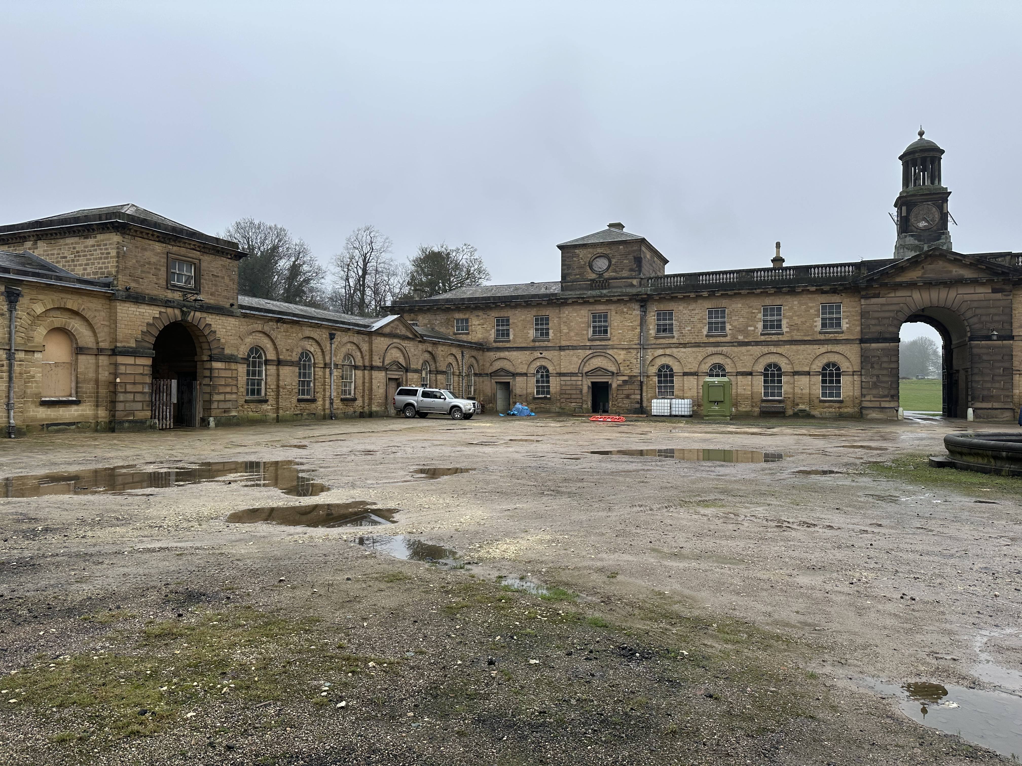


This report has been produced with the support of our partner The World Monuments Fund.
Phase 1 Roadmap: Wentworth Stable Block Mobilisation - MP3A

Wentworth Woodhouse Heritage Skills Programme - Summary

Wentworth Woodhouse is advancing a transformational, place-based Heritage Skills Training Programme anchored in the regeneration of its Grade I listed Stable Block. The programme responds directly to nationally recognised shortages in specialist heritage construction skills while aligning with further education, workforce development, and place-based regeneration priorities.
The proposal establishes Wentworth Woodhouse as a regional anchor institution and ‘House of Skills’, coordinating delivery through the formation of a South Yorkshire Regional Heritage Skills Network (RHSN-SY). This network model connects live capital works with structured training pathways, employer engagement, and further education provision, ensuring investment generates sustained skills capacity beyond individual projects.
Investment is sought to support a phased programme combining: (1) a directly employed Heritage Skills Craft Team; (2) a Regional Heritage Skills Training Hub and Centre of Excellence focused initially on carpentry and joinery; and (3) a coordinated portfolio of training pathways ranging from early engagement and education enrichment to career progression and upskilling for those already working in construction.
The programme is designed to deliver measurable outcomes including increased regional heritage skills capacity, improved progression routes into specialist employment, stronger employer engagement, and enhanced value for money through alignment of capital works with training delivery. It prioritises inclusion, targeting under-represented groups, young people, and those already working in construction seeking to specialise.
A phased investment approach is proposed, allowing funders to support a development phase that de-risks delivery, followed by scalable implementation aligned to live conservation works. By embedding training within a long-term pipeline of works at Wentworth Woodhouse and across South Yorkshire, the programme offers a replicable model with national relevance.
This business case demonstrates how targeted investment will unlock long-term skills resilience, support further education pathways, and contribute to sustainable economic growth while safeguarding the historic built environment.
Purpose: A detailed implementation and 12-month (development phase) investment plan for Wentworth Woodhouse, with clear signposting towards national rollout, fundable activities and engagement with institutions identified as key partners. It includes a step-by-step action plan for transforming the Stable Block Area MP3A into an Internationally Recognised Heritage Skills Training Centre.
Contents
1.0 Introduction and Purpose
2.0 Strategic Framework: From Pilot to National Impact
2.1 Regional Heritage Skills Networks (RHSN) CONCEPT & CONTEXT
2.2 Regional Heritage Skills Networks: A Strategic Solution
2.2.1 The Vision
2.2.2 What Makes RHSN Different to former Regional Historic Environment Forum Networks?
3.0 Establishing WW as a Regional Beacon for Skills Excellence Training Delivery and Coordinated Advocacy
3.1 Recommended Actions for Wentworth Woodhouse allied to RHSN Formation and sustainable National Heritage Skills Growth.
3.2 Initial Ideas / Recommendation for the establishment of Contractor Engagement Charter brokered through the RHSN-SY
3.3 Establishing an Optimised Model for RHSN Engagement
4.0 Mobilisation of an ‘Accelerated Heritage Skills Training Model’ at WW
4.1 Embracing a ‘Skills and People First’ Approach to Skills Training for WW
4.2 Establishing a Two Stranded Foundation for Heritage Skills Engagement at WW
4.3 An Overview of 3 Capital Investment Scenarios for the Programme
4.3.1 CAPITAL INVESTMENT SCENARIO 1: TRANSFORMATIONAL HIGH Investment £ - High Impact – Growth Trajectory
4.4 Statement of Priority Audiences
4.5 Recommendations for Core HS Training Design Components
4.5.1 Category 1 - Taster Opportunities
4.5.2 Category 2 - Volunteer-Led Initiatives and Social Action
4.4.3 Category 3 - Special Interest, Leisure and Informal Courses
4.4.4 Category 4 - Education Enrichment
4.4.5 Category 5 - Government Funded Into-Work Schemes
4.4.6 Category 6 - Career Progression and Development

5.0 Feasibility Study – Outline Heritage Skills Training Delivery Model / Options Appraisal Recommendations
5.1 Vision for the Centre of Excellence in Carpentry and Joinery (Wood Occupations) at Wentworth Woodhouse

1.0 Introduction and Purpose
This section introduces the scope of Document C, which is intended to serve as an Outline Delivery Plan to guide the Development Phase linked to mobilisation of transformational Heritage Skills Training Programme at Wentworth Woodhouse (WW). Whilst the long-term vision is for the Heritage Skills Programme at WW to extend across the whole site in the Medium to long Term – responding to the brief set, the primarily focus of this report relates to the Regeneration Phase of the Stable Block known as MP3A.
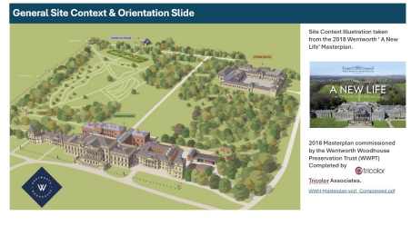

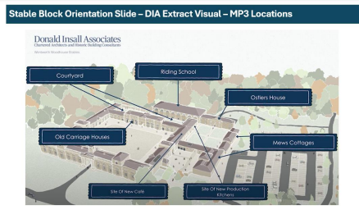
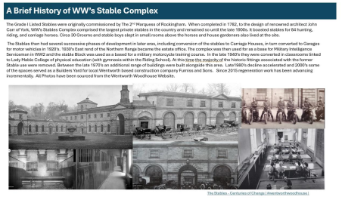

The narrative and recommendations within this report will focus specifically on the Areas of the Site outlined in the diagram below within the Grade I listed 18th Century Stable Block Complex. The vast scale of WW, however, means that there is significant a clear and fundable opportunity to expand the focus of Heritage Skills Training initiatives across the wider site in the future.
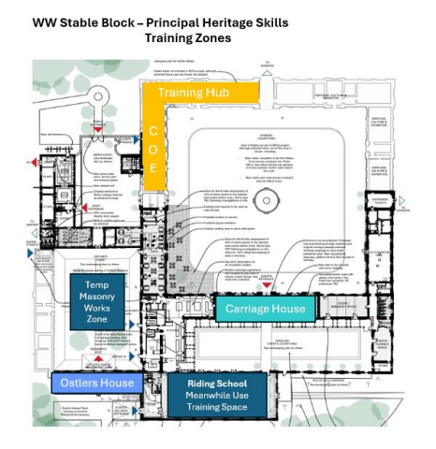
The document outlines a phased approach to implementation, supporting the creation of a Directly employed expanded Heritage Skills Craft Team (HS-CT) at Wentworth Woodhouse, alongside a range/carousel of externally facing wider Heritage Skills Training and Advocacy Programme (HS-TAP). Collectively designed to incrementally build resilience into the fabric of Wentworth Woodhouse itself alongside accelerating pathways toward heritage skills resilience across South Yorkshire. Affirming Wentworth Woodhouse as ‘House of Skills’ and true Beacon for Heritage Skills in the Region’.
It is recognised that the proposals presented within this report in relation to Heritage Skills form one stream of a wider overarching inclusive, ambitious and enduring commitment to a holistic education, skills and learning programme at Wentworth Woodhouse, summarised in the introductory diagram below. That spans both curriculum aligned formal education engagement with four specialist skills Strategy Strands united by interwoven golden threads of supporting Health and Wellbeing and promoting Skills for Life agendas.
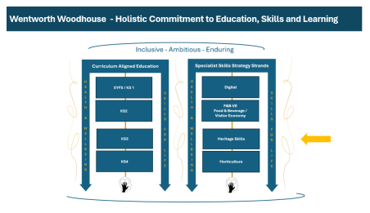At the Client’s request, recommendations within this report are structured across three identified timeframes: NOW, NEXT, and LATER. This phased framing mirrors the strategic approach adopted in Wentworth Woodhouse’s wider Operational Planning and Programming documentation. While the greatest emphasis is placed on the NOW and NEXT phases, the report also provides contextual insight into identified opportunities for the LATER phase, reflecting longer-term ambitions for sustainable heritage skills development at Wentworth Woodhouse, realised through the formation of Collaborative Skills Training Partnerships with possible identified partners.
Stage | Financial  Year | Year of  Programme | Total  No. of  Years | Phase | Level of Focus within Report
Now | FY26/27 | Y.1 | 1 Year | Development Phase | Detailed Focus  & Recommendations
Next | FY27/28 –  FY30-31 | Y.2, Y.3, Y.4, & Y5 | 4 Years | Delivery Years 1 - 4 | Headline  Recommendations
Later | FY31/32 –  2036/37 | Y6, Y7, Y8, Y9 & Y10 | 5 Years | Initial phase completed – Initial live sites complete and CoE and Hub operational – Proposed incremental transition to BAU  Heritage Skills Activity at WW | Outline of Possible  Trajectory / Headline Recommendations

2.0 Strategic Framework: From Pilot to National Impact

An introduction to the Concept of RHSN engagement linked to Live Site Training Programmes
2.1 Regional Heritage Skills Networks (RHSN) CONCEPT & CONTEXT
The establishment of Regional Heritage Skills Networks (RHSNs) with a specific focus on Heritage Skills (HS) is a foundational recommendation of the HESCAPE report (outlined in Document B – Section 3.2 & 3.5). providing a vehicle for connecting defined regional need, resources and energy with national coordination to holistically address Heritage Skills challenges at scale/
2.2 Regional Heritage Skills Networks: A Strategic Solution
2.2.1 The Vision
The establishment of a Regional Heritage Skills Network in South Yorkshire (RHSN-SY), as a vehicle for coordinating sustainable heritage skills training activity in the region, alongside the creation of a direct heritage skills craft team and Centre of Skills Excellence at WW – will deliver measurable outcomes for a more holistic and novel model for transformational heritage skills engagement in South West Yorkshire, than the inception of a single stranded inwards facing capital project integrating heritage skills activities’ alone at WW. Providing a vehicle to move beyond the recognised limitations of time bound Capital Repair projects ‘with heritage skills initiatives embedded’ (outlined in Report B – Section 3.6) that are invariably fail to catalyse a legacy beyond the fixed project delivery programme or sustain positive momentum for training that they ignite.
The national vision for RHSN’s is that they will be locally embedded but nationally coordinated, with action and engagement focussed on influencing and securing a sustainable local skills ecosystem for skills needed to repair, conserve, maintain and retrofit traditional buildings (of pre-1919) construction. As the repair of Pre-1919 buildings is specifically recognised as a specialist area of construction – it will be critical to ensure that the RHSN’s also strive to engage with key mainstream construction and education stakeholders across their regions too – which will deliver measurable outcomes for an important interface for championing the often overlooked inter-relationship between core construction trades and specialist heritage skills pathways in order to more resiliently and holistically build overall national capacity to care for and retrofit our Historic Built Environment.
2.2.2 What Makes RHSN Different to former Regional Historic Environment Forum Networks?
Unlike past national cultural heritage networks that lacked specific focus on traditional building skills or longevity, the RHSN’s will:
- Prioritise specialist heritage construction
- Bring together multiple partners to co-design solutions tailored to a locality • Develop collaborative training models based on real need defined by active Heritage Skills Auditing
- Enable integration with existing Heritage/Construction/Education networks in geographical sub-areas, e.g. CITB Employer Networks (EN) and Training Providers Networks (TPN)
- Allow linkages with wider local employability and training programmes aligned to construction (e.g. those coordinated through South Yorkshire Combined Mayoral Authority) – boosting opportunities to secure blended funding for Heritage Skills initiatives – aligned also with CITB funding remit.
Over the last two years a model for the formation of RHSN’s has been workshopped collaboratively through a series of Historic Environment Forum Workshops and other working groups and is illustrated in the figure below The proposed model clarified that there will be 4 levels of RHSN Governance from L.1 National Coordination to L.4 Regional Coordination. Accordingly, the Level 3 Yorks and Humber RHSN Group would comprise 4 separate RHSN’s reflecting the relevant Local Government Organisation boundaries, with WW geographically sitting within the proposed South Yorkshire RHSN (SY RHSN) Group.
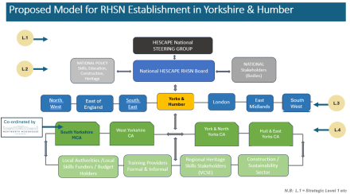
From the Research Undertaken it is considered that WW is well placed to:
- Lead on the coordination of the RHSN for South Yorkshire (RHSN-SY), drawing on its existing partnerships, live capital works, and strategic vision.
- Act as a regional anchor institution for Heritage Skills Training in SY in the context of delivering capital works and strategically coordinating training, whilst also mobilising significant wider impact through establishing itself as an outward facing Centre for Heritage Skills Excellence and beacon for Heritage Skills. The scale of capital investment and ongoing maintenance work required to regenerate WW offers an unprecedented opportunity for extensive work programmes to be delivered at a single nationally significant site over a 30 year period.
- Develop a programme of heritage skills engagement and training that leverages the planned extensive pipeline of works at WW itself with the pipelines of other regional partners through the formation of Collaborative Heritage Skills Training Partnerships mandated through the RHSN.
- Use its Heritage Skills ‘Place Based Skills Acceleration’ Model and own Heritage Skills Training.

Programme to overcome barriers identified in Report B, including:
- Lack of Heritage Skills specific demand articulation (including labour market intelligence)
- Limited data on actual skills gaps at regional level
- Fragmented funding, employment and training landscapes
- Low visibility of heritage career pathways (both for new entrants and for those already engaged in mainstream construction careers)
- Severely limited national and regional offer for specialist and certified heritage skills training that can underpin employment pathways and lead to economic growth.
All of which would also align with the vision for RHNS‘s throughout England’s regions to be connected through a National Level Heritage Skills Coordinating organization /function (Figure below).
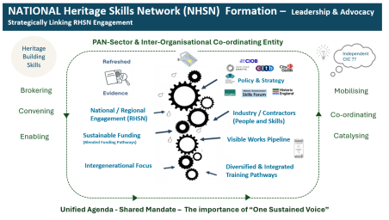

3.0 Establishing WW as a Regional Beacon for Skills Excellence Training Delivery and Coordinated Advocacy
Through this research it has been identified that WW, with its 30 year+ project delivery trajectory, is well placed to serve as a REGIONAL BEACON / HUB for Heritage Skills Excellence at the heart of a newly formed South Yorkshire Regional Heritage Skills Network (RHSN-SY). By simultaneously assuming a leading role in the establishment of RHSN-SY alongside the launch of a dedicated and ambitious heritage skills training programme at WW Stable Block, WW is ideal to serve as a Coordinating Centre for South Yorkshire Heritage Skills Activity.
3.1 Recommended Actions for Wentworth Woodhouse allied to RHSN Formation and sustainable National Heritage Skills Growth.
a) Assume a Leadership role in the establishment of a Regional Heritage Skills Network in South Yorkshire (RHSN-SY)
- Co-lead with other regional stakeholders (e.g. Historic England, local authorities, training providers and contractor employer representatives)
- Ensure representation from contractors, funders, and private owners – working with Heritage Network members in the region to boost impact
- Use Wentworth’s live capital projects to demonstrate training integration and how a training programme – that blends components across all 6 thematic categories of skills training pathways outlined in Historic England’s ‘Pathways into Heritage Construction Index’ will increase the likelihood of legacy impact across multigenerational audiences and actors.
b) Embed dedicated coordination capacity for RHSN-SY into the WW Heritage Skills Programme Model.
- Seek Specific funding for part-time staff resource to launch and then maintain momentum through ongoing engagement (secretariat and coordination resource)
- Align with devolved funding opportunities and LSIP priorities – ensuring that Employer Representative Boards recommendations reflect the vast relevance of Heritage Skills Training as a Specialist Sector of Mainstream Construction – upon which the continued conservation, repair, maintenance and retrofit of South Yorkshire’s impressive legacy of pre-1919 buildings will be dependent.
c) Broker Strategic Partnerships central to the RHSN
- Collaborate with cornerstone delivery partners at a Local, Regional, National and International levels (e.g. World Monuments Fund, Commonwealth Heritage Forum and Commonwealth War Graves Commission (possible International Level collaboration), Volunteer It Yourself, Heritage Crafts and National Construction Livery Council (possible National Level collaboration), extant Construction Skills Groups and Training providers in South Yorkshire (possible regional level collaboration) and FitzWilliam Wentworth Estate (possible local level collaboration). See Figure below
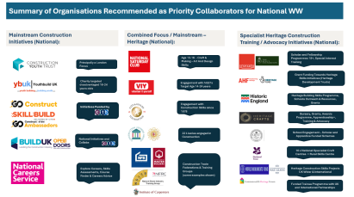
- Model the a clear and fundable opportunity of integrating extensive ‘Live Site focussed training models’ at the heart of revolving capital works delivery programmes. Providing an unrivalled context through which site based mentoring and professional upskilling can happen organically.
d) Model how a Carousel of initiatives within the 6 blended thematic skills training categories can be allied for delivery through individual live projects. Designed to provide enriching learning experiences for both in-house craft teams at WW and external trainees from within the region.
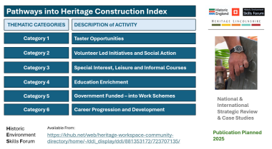
Use Wentworth’s capital works as anchors to host government bootcamps, apprenticeships and SWAPS, align training levels and the complexity of works with conservation priorities, the significance of site fabric and overall project complexity – ranging from master level engagement for complex projects to running focused CPD and general taster events for low risk low complexity projects.
Build partnerships that could extend regional engagement to achieve a national and international impact through the launch of residential international skills exchange initiatives. Possibly linking within existing scheduled run by SPAB, HC, World Monument Fund and the Kings Foundation.
e) Progress next Stage Research and Development linked to Evidence-Based Skills Mapping at a National and Regional Level
- Active engagement with next stage Research and Development linked to a National Heritage Skills Audit Tool could be progressed as part of WW’s holistic proposals for launching its Heritage Skills Programme.
- Initially modelling and piloting the use of the tool in development of a site level pipeline of conservation works model (informed by a running programme of Condition Surveys realised as training and upskilling opportunities themselves in partnership university training schemes for Chartered Architects, Surveyors, Conservation and Construction Professional – link to RIBA, IHBC RICS and CIOB). The initial site level focus could then be upscaled through RHSN Partnerships to run across wider sites in the region with WW Heritage Skills Team playing a leading role in coordinating such engagement though the RHSN.
- WW should also actively embrace emerging opportunities to partner with national stakeholders such as the Palace of Westminster Restoration and Renewal Delivery Authority, Historic England, ICON, Historic Environment Scotland and other National Organisations on funding the next stage workstreams required to refine and pilot the National Heritage Skills Tool Kit. Working in close collaboration with professional organisations such as IHBC, RICS, RIBA, CIOB, the City in Guilds Foundation and Construction Livery Companies.
- Allied to the development of a National Heritage Skills Audit Tool Pilot - work strategically with SYMCA to disseminate regional data (from live site audits) with training providers (and Employer Representative Bodies (ERB) and groups) to inform curriculum development – focussing on securing both in-region direct heritage skills provision and building relationships and partnerships with third party approved training providers to deliver Specialist Heritage Skills Training at Wentworth Woodhouse’s Heritage Skills Training Centre of Excellence and Regional Training Hub – connected to the rolling programme of capital works delivery at the site over the next 30 years.
f) Showcase Heritage Careers
- Engage young people through taster days, job fairs, and national careers education websites both at site and through outreach initiatives delivered in partnership with organisations such as Skills Street in Rotherham, Heritage Crafts, CITB Go Construct, Build UK, The National Saturday Club and the Queen Elizabeth Scholarship Trust and SPAB. This work also importantly aligns with inspirational work of Sheffield Charity Work-Wise that is designed to connect individuals, employers and educators in the interest of supporting Regional Skills Growth.
- Use WW’s national and international visibility to inspire multigenerational learners
- In addition to WW being excellently placed to receive large numbers of school visitors for annual careers events that could be established at the site, it is also recommended that WW commit to a programme of external schools engagement that can be incrementally built through local level partnerships.
3.2 Initial Ideas / Recommendation for the establishment of Contractor Engagement Charter brokered through the RHSN-SY
A further recommendation for WW’s strategic coordination of RHSN-SY, supporting the development of a more resilient heritage skills and crafts ecosystem in the region (essential to supporting WW’s commissioning of future Capital Works and ongoing Conservation Pipelines), would be the establishment of a RHSN-SY Contractor Engagement Charter (mandated through a Memorandum of Understanding (MOU)) through which contractors working in the region construction skills supply chains could collaborate actively on the design and development of skills training delivery programmes (both within the development phase and beyond at WW) - ensuring positive integration of their experiences into the WW working delivery model to ensure practical viability and buy in.
Importantly the charter would need to be designed to allow for inclusive engagement harnessing the experience of the breadth of contractors working in construction, from sole traders and Tier 3 SMEs to larger Tier 2 and Tier 1 contractors. In this context – it would be recommended that documents such as the Traditional Building Skills Training Toolkit produced by the National Heritage Training Group (NHTG) and Churches Conservation Trust and evaluation reports from Historic England’s Building Skills programmed would provide valuable reference points from which future direction, tailored to the specific regional skills needs and project skills profiles, could be developed.
Inviting representatives from organizations such as the South Yorkshire Apprenticeship Hub and Shared Apprenticeship Agencies working in SY to engage with the Development of a RHSN-SY Contractor Engagement Charter is also recommended to support the ambition for WW to form inter-organisational collaborative heritage skills training partnerships that could span multiples sites and projects in a region in the future. The relevance of which has to date been championed with HESCAPE and in an unpublished follow up report specifically commissioned by English Heritage.
There is also positive a clear and fundable opportunity for WW to engage with other RHSN’s nationally (both emerging and those already live) investigating the use of Shared Apprenticeships/Flexi Apprenticeships linked to Heritage Projects, such as the London RHSN (with secretariat provided by the Palace of Westminster Restoration and Renewal Delivery Authority) and the City and Guilds Heritage Skills and Crafts Coalition who are also actively working to develop an optimized model for Shared Apprenticeship Application in the context of regional heritage portfolios. Aligning with research recommendations linked to Shared Apprenticeships commissioned by English Heritage and informed by successful schemes in construction run by organizations such as FUTURE in Cambridge (run by TRAC Apprenticeship Agency) and Cyfle Shared Apprenticeships Scheme in Wales.
Purpose of a RHSN Heritage Skills Contractor Charter / MOU
A Regional Heritage Skills Training Charter would outline a framework for engaging contractors in Regional Heritage Skills Networks (RHSNs), with the aim of fostering sustainable heritage skills development through live project collaboration. As such, the development of a charter would align with the proposed Wentworth Woodhouse Heritage Skills pilot and offers strong a clear and fundable opportunity to help underpin a high-quality training offer.
Recommended Tiered Engagement Model for Contractor Affiliation to SY-RHSN
Bronze Tier
Basic engagement, such as hosting site visits or allowing observation of works.
Silver Tier
Active mentoring of learners on site (in the region), participation in RHSN events and feedback loops.
Gold Tier
Strategic partnership including co-design of training, long-term mentoring, and legacy planning – working in collaboration with WW and a clear and fundable opportunity to coordinating strategic bids for funding of Heritage Skills Training Activities through CITB funding pathways.
Possible Contractor Recognition through RHSN Affiliation
Recognised & showcased commitment to ‘Skills and People 1st’ Model’ RHSN Affiliation– possibly aligned to the establishment of regional award schemes and funding bursary programmes such as those described in Document B (Section 4.5 & 4.6) run by Sussex Heritage Trust and Bury St Edmunds Town Trust.
Access to pre-vetted learners identified from college partnerships and Skills Enrichment Programmes. Possibly incorporating formal partnership and linkage to Heritage Crafts’ matchMAKER work-based training and entry-level employment opportunities Scheme.
Access to WW training infrastructure and live sites for training for upskilling their direct workforce
Provision of holistic advice linked to heritage skills training funding models and mentoring from the Appointed RHSN coordinator linked to WW Scheme • Recognition as Heritage Skills Champion – (proposed scheme to be an output of the RHSN)
Inclusion in national showcases and promotional materials linked to the Historic Environment Skills Forum and other National and Regional Skills Fora.
3.3 Establishing an Optimised Model for RHSN Engagement
An unpublished research report commissioned in 2024 by Historic England in partnership with English Heritage, reviewed a range of a clear and fundable opportunity operating models for the establishment of RHSN in East Anglia and clarified the critical importance of resourced multiyear commitments to support strategic coordination of RHSN Models. Indeed, without such resourced coordination, it is anticipated that the current fragmented status of the heritage skills funding and training would be difficult to resolve. (Report B Section 3.3 and 3.6)
Accordingly, as part of the core recommendations for WW’s Heritage Skills Programme, it is recommended that a dedicated ‘SY-RHSN Strategic Integration Lead’ role is created in WW’s heritage skills team structure to unlock opportunities and build regional infrastructure that will support the RHSN’s. Allowing the RHSN to progress from a coordinated group of interested parties to a regional vehicle central to securing a sustainable heritage skills ecosystem in South Yorkshire. It is also envisaged that the role holder would play a key role in contributing to national fora and working groups engaged with heritage skills through which research and development work is ongoing linked to the development of both a National Heritage Skills [works] Pipeline Tool and further development of the Heritage Skills Audit Tool. Looking beyond WW, the active participation of SYMCA and wider groups and organisations operating in South Yorkshire and Wider Yorks and Humber with an interest in heritage, heritage skills and construction will also be an important objective.
Within Y.1 and Y.2 of WW’s heritage skills programme the initial focus of any collaborative training partnerships that may be formed will be aligned to supporting the imminent conservation of structures within the Stable Block that are classified as at High Risk on the Historic England Heritage at Risk Register (including the Ostlers House & the Carriage House – within the WW Stable Block), both of which have the a clear and fundable opportunity to serve as ‘live sites’ through which South Yorkshire's aspiring heritage skills specialists (with a specific focus on those already working in the construction sector – as defined priority audiences) can hone and develop heritage specific skills, alongside new entrants to the sector who can gain early career experiences and be inspired about the validity of heritage skills for more simulated training models, incorporating a small degree of live site work. Report B (Section 7).
Recommendations for priority TARGET partners for early RHSN-SY collaborations focussed on the WW Stable Block – Ostlers House and Carriage House ‘live sites’ and/or delivered through the establishment of a Heritage Skills Regional Hub at WW include the following national organisations:
- Volunteer it Yourself (VIY) (Category 5.D Government funded Bootcamps, Swaps -and Community Action alignment)
- The Commonwealth Heritage Forum (Category 5.B - Summer School)
- World Monument Fund Britain (WMFB) (Category 5.B - Summer School)
- The Society for the Protection of Ancient Buildings (SPAB) (Category 3.A & 3B - Short Term Courses)
- The National Saturday Club /The Queen Elisabeth Scholarship Trust (QEST) (Category Early Experiential Pre-16 Engagement)
- Kings Foundation (Category 5b- Summer School / Student Placement)
- Heritage Crafts etc (Category 5- Advocacy, Short Courses, Awards and Student Placement)
- CITB, Build UK and Local Contractors (Category 1B- National Open Doors Programme)
As seen from the alignment between listed stakeholders and thematic training types Categories 3 and 5 involve an increased level of engagement with partners in the sector. Therefore, these opportunities exhibit the highest clear and fundable opportunity for replicability and scalability to affect impact domains from site level all the way up to international impact.
Although the first stages of WW’s Heritage Skills Programme and engagement with RHSN SY will focus principally on training opportunities delivered in the context of either ‘live sites’ at WW or those delivered from WW’s Proposed Heritage Skills Centre of Excellence and Regional Training Hub, within a 5 year period the ambition would be for WW to enter into an upscaled level of Collaborative Training Heritage Skills Partnerships with other organisations in the region – such as those managed by other independent heritage charities, Local Authorities, members of Historic Houses and national organisations (National Trust, English Heritage, Historic Royal Palaces and Churches Conservation Trust and Church of England, through which WW could then play a more outward-looking role in the coordination and delivery of a rich range of wider heritage skills training initiatives in other wider areas of the locality and region.
Relevant to which it will be crucial for WW and RHSN-SY to frame the opportunity here for grant funded conservation / regeneration programmes (supported by organisations like National Lottery Heritage Fund (NLHF), Historic England (HE), Architectural Heritage Fund (AHF), Local MCA’s / Central Gov funded place-based regeneration schemes etc) to partner in relation to Skills Training outcomes in order to magnify the impact and connected legacy of separate individual projects and committed spend profiles.
Positively in November 2025 Wentworth Woodhouse partnered with National Charity Heritage Crafts to host their high profile Annual Awards Winners’ Reception at Wentworth Woodhouse, supported by the Royal Mint and Maxwell/Hanrahan Foundation. This partnership represented a was a first major step in clarifying WW’s ambition to become recognised as a ‘House of Skills’ promoting excellence in craft and building skills at a regional, national and international Level. A speech made by Sarah McLeod CEO of Wentworth Woodhouse at the event also clarified WW’s long-term commitments to craft skills across all three heritage skills domains and expressed commitment to position WW as a Heritage Skills Beacon for the region and nation. In the future it is the aspiration that WW will serve as the northern location for the annual ceremony biennially (alternating every other year with a venue in London).
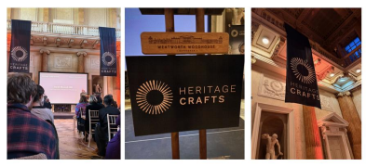
Figure ** Heritage Skills Annual Awards Ceremony – Wentworth Woodhouse – Nov 2025

4.0 Mobilisation of an ‘Accelerated Heritage Skills Training Model’ at WW
This section begins by presenting an overarching Accelerated Heritage Skills Training Model for Wentworth Woodhouse, designed to put ‘Skills and People 1st;. It then explores three a clear and fundable opportunity headline options for delivering capital investment in the regeneration of the Stable Block, aligning these proposals with heritage skills development. Following this, the chapter sets out a clear statement of priority audiences, ensuring that the programme responds to the needs of those who will benefit most. Finally, the section concludes with summary outlines of the core components that underpin the recommended heritage skills training delivery pathways at Wentworth Woodhouse.
All recommendations - will have been influenced by the wide-ranging research conducted as part of this commission, summaries of which are presented within Report B and leafed through Report C.
4.1 Embracing a ‘Skills and People First’ Approach to Skills Training for WW
This business case recommends a multi-component approach is taken to the design, development and launch of a ‘Skills and People 1st’ Heritage Skills Training Programme at WW. The graphic below clarifies the intention of the model to integrate work streams that span construction and conservation, maintenance and repair and retrofit specialist work areas – ensuring holistic coverage of Building and Traditional Craft Skills linked to sustainable management of the historic built environment.
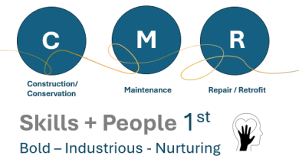
The design of the recommended model has been informed through significant research and active immersive engagement of the authors with heritage skills training advocacy and research over the last 5 years. It also aligns purposively with priority agendas outlined within the HESCAPE Report, including a priority focus on Carpentry and Joinery Skills (alongside other key skills identified within the Skills Audit for the Site’) and the afore discussed mobilisation of RHSN-SY. The relevance of the approach taken that spans both project based and wider regional collaborative action has also been refined through attendance of working groups associated with the Historic Environment Skills Forum, established RHSN’s in London and the East and wider UK national Heritage Skills leadership fora.
The design ensures that formal learning, informal learning and experiential learning (FIE) are Integrated in a manner designed to optimise trainee experiences and promote enhanced skills acquisition as a foundational platform for the establishment of enriching and economically rewarding careers in Heritage Building Skills crafts and trades. The approach taken also ensures that the overall programme maintains relevance across a multigenerational audience and echoes the breadth of entrance points for prospective learners and trainees modelled through Historic England’s Enter, Prepare and Sustain tiers developed as part of their Building Skills Programme (outlined in Report B Section 7.3).
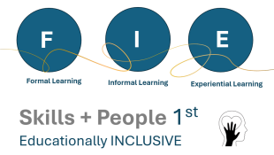
To assist the reader in contextualising the different types of learning and Skills Training Activity that may align with the three respective FIE Learning Pathways – some further examples are provided.
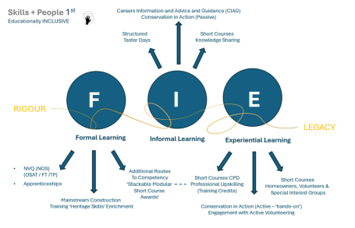
The design of WW’s future approach / engagement with Heritage Skills Training will also need to sustain outcomes of the training (for both skills resilience and people) beyond the duration of the initial funding invested in its development and launch. An objective and trajectory that it is proposed will be significantly aided through strategically linking the programme to the establishment of a RHSN in Yorkshire and from ensuring that the project is designed to benefit from a blend of financial funding streams that can support learners in the region, as well as provide positive opportunities for collaboration at a national and international level.
The heritage skills training model proposed at WW will also seek to blend funding streams and integrate/blend delivery pathways for the heritage skills training. Both of which, alongside active participation in the formation, and future administration of a RHSN-SY will be critical to realising the vision for an ‘Accelerated Heritage Skills Training Model’. A model that exhibits vast, clear and fundable opportunity to unlock local economic growth benefits aligned to Community Wealth Building models, and would allow for progression from sector typical BAU engagement with Heritage Skills that is premised on engagement through individual projects to a more coordinated and collaborative approach.
At High Level the recommendation is made for WW’s Heritage Skills Programme Model to Incorporate two strands of active engagement bridged through WW also assuming a leadership role in the development and sustainment of RHSN-SY:
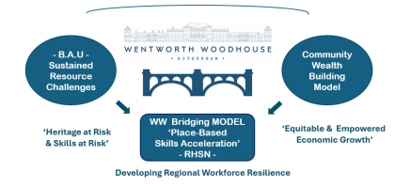
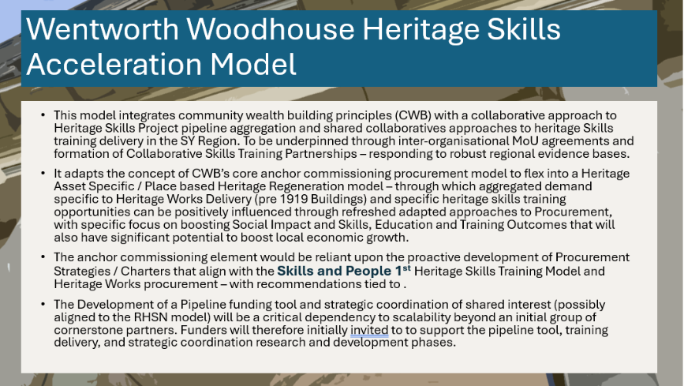
​​
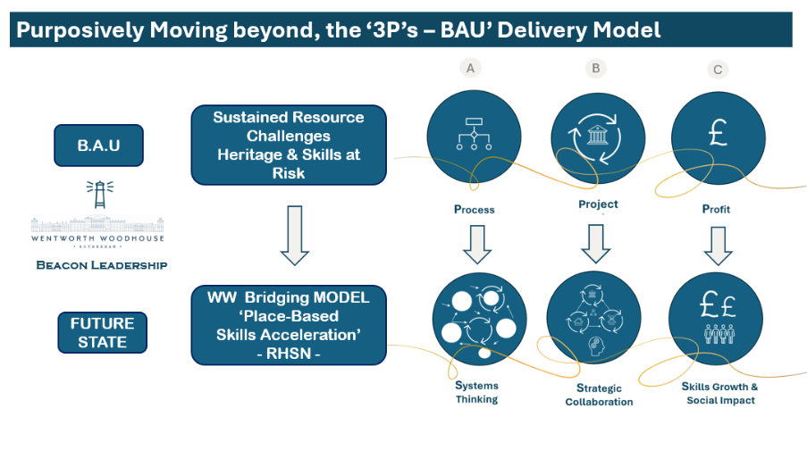

The Model proposed has been designed to unlock opportunities for local people in South Yorkshire through moving beyond the limitations of standard practice BAU Heritage Skills Training Models focussed on time-bound projects, outlined in Report B (Section 9), to embrace a Systematic, Strategic and Social Impact focussed model.

Through adopting a multi-component approach to design of a Heritage Skills Training Programme at WW, it is envisaged that there will be increased opportunity to ensure:
Inclusive Access Across Learner Types / Intergenerational Audience Integration
See Priority Audience Definitions outlined in (Report B Section 7.3) influenced by Regional Assessment and strategic integration and knowledge sharing with SYMCA teams.
Flexible Entry and Progression Routes
Unlike linear single-theme models, a blended approach to skills advocacy will allow multiple entry points and fluid progression. Encouraging and supporting learners to move from bootcamps to OSAT NVQs or apprenticeships based on their readiness and experience to specialist upskilling courses to enhance their professional profile and boost opportunities to engage in specialist work.
Stronger Local Employer Integration into the Training Programme
Through coordination via a RHSN there will be enhanced priority to embed learners into real work environments through shared apprenticeships and Collaborative Training Partnerships linked to NVQ routes assessed through OSAT. Allowing for training to be aligned with live project timelines to improve relevance and job-readiness.
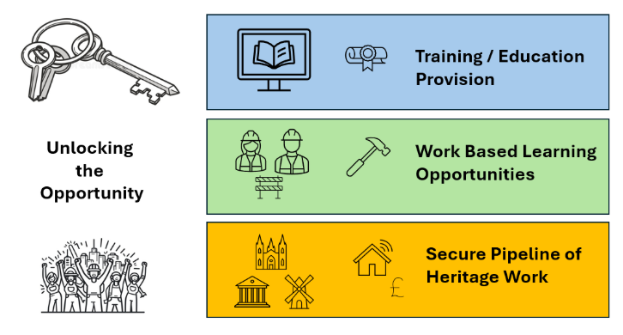
Enhanced Social Impact
Through being responsive to place-based needs, blended models that are regionally administered offer unrivalled a clear and fundable opportunity to engage local communities and address regional deprivation simultaneously. Additionally, they support Community Wealth Building by aggregated demand from confirmed regional heritage project pipelines – stimulating enhanced opportunity for those that engage to progress through placement / employment in the context of other projects on the pipeline horizon.
4.2 Establishing a Two Stranded Foundation for Heritage Skills Engagement at WWT
Following the extensive research undertaken, it is recommended that WW’s Future Heritage Skills initiative has two foundational strands both of which would be bridged through alignment with RHSN-Y in order to realise a transformational place based skills accelleration model for WW and wider South Yorkshire.
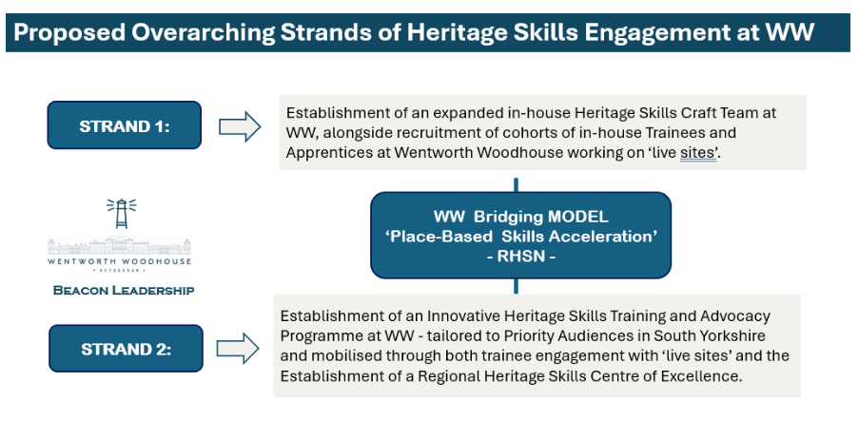
Outline Phased Recruitment Plan for Internal Roles for Heritage Skills Training at WW
An Outline Recruitment Plan linked to the Establishment of both STRAND 1 and STRAND 2 Pathways of WW’s Heritage Skills Strategy is outlined below
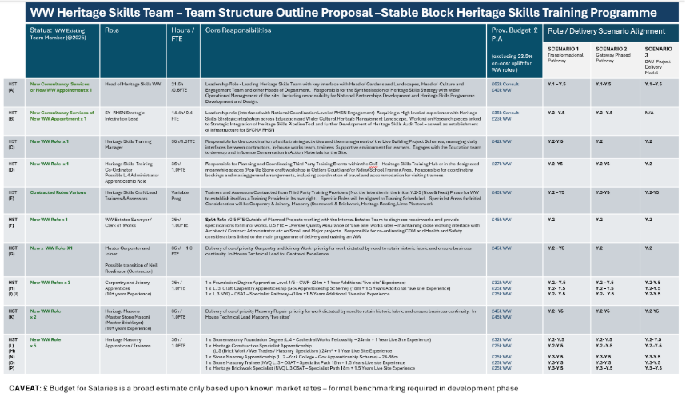
The majority of these roles illustrated in the table above have a clear focus on operational delivery and heritage skills training coordination at WW, complemented by more strategic roles (HAS & HSB) that will serve as critical enablers for the delivery of the ambition scale and across the region. Scaling impact from site-based activity to delivering a holistic and legacy premised accelerated model.
Factors Affecting Recommendations of Heritage Skills Craft Team Expansion
The Direct Craft Teams recommendations primarily span ‘Carpentry and Joinery’ and ‘Masonry (Brickwork and Stonemasonry) Specialisms’ to align with the largest volume of skilled work required in the context of WW – as identified through a High Level Initial Skills Audit Completed at the Site (See Report B – Section 5)
Pathways for trainees in the Direct Craft Team incorporate differential levels ranging from Level 4-3 qualification in the relevant trades/crafts. The training pathways for the in-house trainees are also varied (e.g. including Apprenticeship pathways and non apprenticeship vocational pathways) in order that the strengths, weaknesses and opportunities presented by each of the respective training pathways can be fully tested through the programme investment – and relevant lessons fed back through formal training feedback loops established through RHSN-SY’s. In turn these lessons would also feed into National Level Heritage Skills Networks that would provide a coordinated structure for inter-region and interorganisational knowledge sharing linked to the development of optimised future models for Heritage Skills Training UK wide.

Alignment of Phased Recruitment to the 3 Modelled Capital Investment Scenarios
The Outline Recruitment Plan incorporates columns that indicate the years when the roles are recommended to be mobilised to align with the programme of works within the Stable Block, linked to three capital investment scenarios across the Now, Next and Later timeframes.

4.3 An Overview of 3 Capital Investment Scenarios for the Programme
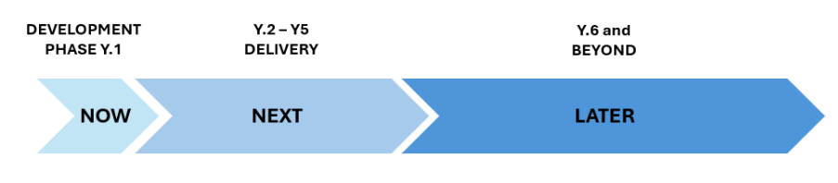
4.3.1 CAPITAL INVESTMENT SCENARIO 1: TRANSFORMATIONAL HIGH Investment £ - High Impact – Growth Trajectory
Y.1. Development Phase - both the Ostlers House and the Carriage House would be propped scaffolded and made wind and watertight, slowing the rate of rapid deterioration. Following advice from the architect, in this scenario the scaffolding would be purchased directly by WW and a programme of regular scaffold checks confirmed.
Y2-3. The total refurbishment of existing Stable Block Northern corner (external envelope and interior) to create a Heritage Skills Centre of Excellence for Carpentry and Joinery and the establishment of a Regional Hub for Heritage Skills Training (Incremental transition from meanwhile spaces).
Y.2. Live site active training work with Direct Craft Team would not start until Year 2. (The two live sites ‘ the Ostlers House and The Carriage House’ would be made wind and watertight and safe from collapse (through structural propping and introduction of a covered roof in Year 1). Collaborative Summer School Partnership linked to the construction of new gates in Mews Court (combined with Education Enrichment Strand).
Y.2. It is envisaged though that some masonry & roofing themed training could, however, take place in the context of the live sites, aligned to Category 5 ‘Career Progression and Training Development Training Programmes ‘– targeted to upskill existing construction professionals into Heritage Skills Specialisms. This might initially take advantage of using spaces within the Riding School (meanwhile HS use) for large scale structural models of roofing etc.
Y.3. to include refurbishment of a series of first floor rooms above the Training Hub to serve as office space and accommodation for trainers and a limited number of trainees (linked to plasterwork and internal fit out work – that could be completed in winter months (providing flex in programme) when external lime works are not possible.
Y.3 A Pop up Masonry and Wet Trades Yard would also be established within the context of Ostlers Court to serve as an external base for stone work – complementing provision of meanwhile use space within the temporary training area to be established.

4.2.2 CAPITAL INVESTMENT SCENARIO 2: GATEWAY PHASED: Medium Investment £ - Moderate Impact – Incremental Gain
Y.1 Development Phase - both Ostlers House and the Carriage House would be propped scaffolded and made wind and watertight, slowing the rate of rapid deterioration. Following advice from the architect, in this scenario the scaffolding would be purchased directly by WW and a programme of regular scaffold checks confirmed.
Y.2 The initial refurbishment of the existing northern corner Stable Block to create a Heritage Skills Centre of Excellence for Carpentry and Joinery Initially in Y2 (to be specified formally in the development phase). Collaborative Summer School Partnership linked to the construction of new gates in Mews Court (combined with Education Enrichment Strand)
Y.2 It is envisaged though that some Masonry & Roofing Themed Training could, however, take place in the context of the live sites (aligned to Category 5 ‘Career Progression and Training Development Training Programmes ‘– targeted to upskill existing construction professionals into Heritage Skills Specialisms. This might initially take advantage of using spaces within the Riding School (meanwhile HS use) for large scale structural models of roofing etc
Y.2 and Y4 – The Meanwhile Spaces within the Stable Block should be established as a temporary Training Hub.
Y.3 A Pop-up Masonry and Wet Trades Yard would also be established within the context of Ostlers Court to serve as an external base for stone work – complementing provision of meanwhile use space within the ‘temporary training area to be established
Y.4. The Regional Hub for Heritage Skills Training and First Floor Spaces would not, however, follow until Y.5

4.2.3 CAPITAL INVESTMENT SCENARIO 3: Sector BAU Limited Skills Investment beyond Capital Costs – Lower Impact – Lacks Scalability
Y.1 Development Phase - both the Ostlers House and the Carriage House would be propped scaffolded and made wind and watertight, slowing the rate of rapid deterioration.
Y.2 Commercial contracts would be let for the full conservation of the external envelope of both the Ostlers House and Carriage House in following a Development Phase to refine the Project brief in Y.1.
Heritage Skills Training Activities in the context of the live sites contracts would only be mobilised / governed by the inclusion of Heritage Skills Education and Training Clauses (requiring the integration of Training Hours into the Contracts) mirroring arrangements made in the context of earlier capital works delivery at the site. This may include provision for a Summer School but in the absence of establishing a Heritage Skills Centre – WW engagement with Heritage Skills via the project would be limited and would fail to position WW as a Beacon for Heritage Skills in the Region.
The table below frames the differential outcomes from an individual site level BAU Sector Skills engagement versus a project being connected in a RHSN coordinated level and regionally-nationally connected ‘accelerated’ model.
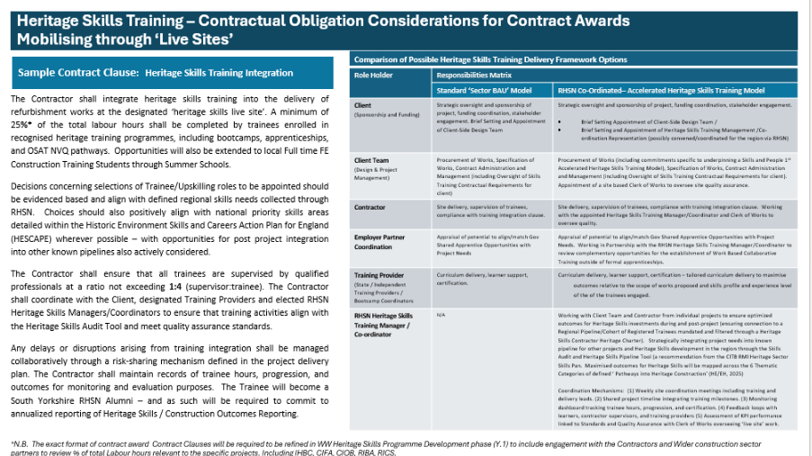
The design of SCENARIO 1 & 2 – have been influenced by a desire to sustain outcomes of the training (for both skills resilience and people) beyond the duration of the initial funding invested in its development and launch. Further details relating to the 3 Capital Investment Model Scenarios, including plans illustrating the areas and provisional costs will be presented in Section 5:
4.4 Statement of Priority Audiences
The development of priority audiences for WW heritage skills training has been summarised in report B and is added here as well for ease of access and visual links to training types.
Audience Segment PAIR 1 (yellow):
Focus 1. Those with Special Educational Needs and Disabilities (SEND/SEMH) Focus 2. Those Not in Education, Employment or Training (NEET)
A focus on SEND is present in the culture and education strategy and therefore alignment with the heritage skills offer is natural. A focus on NEET is aligning the offer with the gaps and economic impact providing a clear and fundable opportunity for the region, while allowing for links to SYMCA’s strategy and recruitment to link to skill gaps in the SY market for targeting socio-economic growth, a clear and fundable opportunity by bringing new opportunities for those not in employment or education.
Audience Segment PAIR 2 (green)
Focus 2. Those Enrolled on Formal Construction Education Programmes (FE Colleges Predominately 16-18y)
Focus 3: Those Already working in the construction Sector (Up-skillers, Retrain, Sustain the Sector).
Those enrolled on formal construction programmes provide an audience base with new skills in construction, applicable to heritage with further specialisms. Targeting younger audiences can support career pipelines and align with sector gaps presented earlier. The Focus group 3, suggest matching those with experienced heritage skills workforce aiming at retraining but also sharing expertise with younger trainees.
Audience Segment PAIR 3 (blue):
Focus 4: Volunteers with Heritage Organisations (including WW)
Focus 5: Homeowners DIY / Special Interest Hobbyists etc
This pair includes existing audiences in models adopted by WW but also expanding them to heritage owners seeking practical maintenance skills development or hobbyists which could support bigger audience for DIY and showcase day offers and link to actual needs for repairs across the region, increasing impact.
The pathways embody the commitment to both 'Advocacy for Gender Equality & Inclusion' and 'Contributing Actively to Local Economic Growth' which run through all PAIRED Focus Group Recommendations.
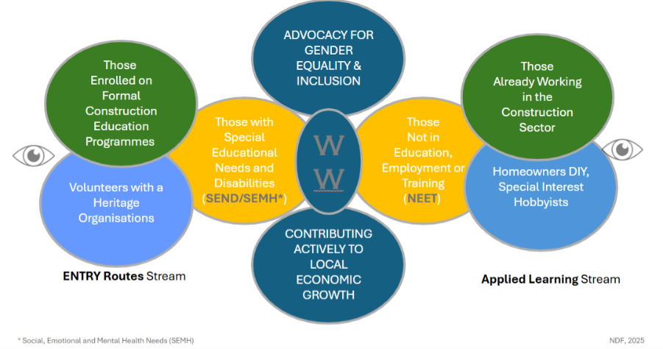
The 3 audience types (paired and colour coded and alignment with entry or applied learning streams at WW)
4.5 Recommendations for Core HS Training Design Components
Contributing to WW’s Holistic and Accelerated Heritage Skills Training Programme
STRAND 2 of WW’s Heritage Skills Programme centres on recommendations for a catalogue / range of Heritage Skills Training inititaives components to be delivered in the context of the ‘live skills’ sites and the Heritage Skills Training Hub. All of which can be divided into one of the 6 Thematic Areas for Engagement with heritage skills training defined in the recent joint publication between Historic England and English Heritage (discussed in Report B). These different thematic components to the WW HolisticTraining Offer have been designed to be tailored to priority audiences identified in South Yorkshire.
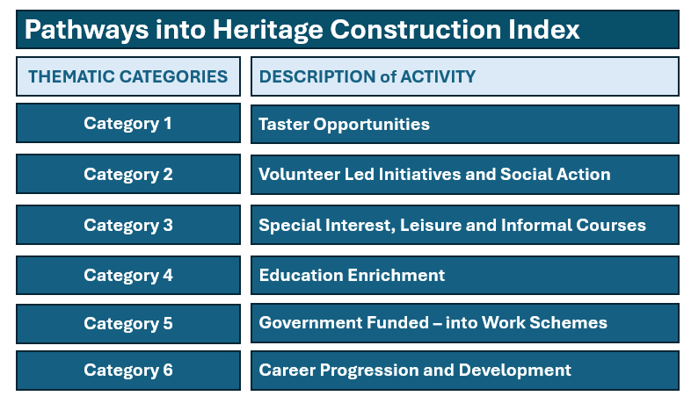
Recap of Now, Next and Later
Stage | Financial  Year | Year of  Programme | Total  No. of  Years | Phase | Level of Focus within Report
Now | FY26/27 | Y.1 | 1 Year | Development Phase | Detailed Focus  & Recommendations
Next | FY27/28 –  FY30-31 | Y.2, Y.3, Y.4, & Y5 | 4 Years | Delivery Years 1 - 4 | Headline  Recommendations
Later | FY31/32 –  2036/37 | Y6, Y7, Y8, Y9 & Y10 | 5 Years | Initial Project Closes – Work at Stable Block Complete (Initial Live Sites complete and CoE and Hub operational – Proposed Incremental Transition to BAU  Heritage Skills Activity at WW | Outline of Possible  Trajectory / Headline Recommendations

4.5.1 Category 1 - Taster Opportunities
Proposal 1A: CIA / Passive & Active: Link to Lifelong Learning – Inspiring Engagement with Learning and Training
Audience: General Visitors to WW – in Person Conservation in Action (CiA) Boards in the context of live projects and a commitment to develop augmented digital content specific to heritage skills. Creation of a dedicated heritage skills landing page on the WW website (summarising all engagement to date). Also a clear and fundable opportunity here to demonstrate the ambition and potential of WW to serve as a Regional Beacon for Heritage Skills and Heritage Construction particularly in South Yorkshire, perhaps through a dedicated RHSN page hosted on the WW Webpage.
Stage | Component | Potential  Partners | Funding  Opportunity? | Model  for Delivery | Duration | Provisional  £ (annual)
Now | 1A.CiA  boards/  materials Live  project  works | Digital skills team  /RSHN and general  education  programme alignment | * NHLF  Private  Philanthro py  Work  Wise /  Skills  Street  Outreach | In house delivery  and rresource  s | As an when engagemen t through  visits and  aligning  with  planned  projects | 10-40k for a  year or works visualisation and  production/staf f costs  included

Proposal 1B: Link to Engagement Enrichment / overlap with Skills Street Workstreams (that can also be classed as Educational Enrichment)
Skills Street engagement can provide a novel approach to experiential learning from young ages and support pathways to heritage careers selection later on, filling in a significant gap in structured early years education enrichment and youth engagement with the sector.
Skills Street – Yorkshire’s Immersive Careers Experience
Skills Street is a hands-on, immersive training and careers experience based at Gulliver’s Valley Theme Park in Rotherham. It is designed to inspire children, young people, and adults by simulating real-world work environments across multiple sectors—including construction, manufacturing, healthcare, and retail.
The initiative aims to:
- Bridge the gap between education and industry
- Provide experiential learning through interactive sector zones
- Support vocational pathways and aspiration raising
- Align with Gatsby benchmarks for meaningful careers education
Skills street programme in SY engages children and young people with a set of careers through simulations, interactive exhibitions and activities. Visiting schools can be hosted on site and capacity varies but promises large scale engagement with younger age groups and influencing career choices. Engagement in partnership with current construction zone company lead (Esh Construction group) would support a focus on mainstream and heritage career skills within the zone. As school curriculum has a great link to the activities in Skills streets, aspects of heritage schools training can be included in the activities where feasible to do so. The Skills Street Initiative is also closely linked to the WorkWise foundation in Sheffield6.
Audiences: Skills street brings children, young people, and adults closer to real careers through 15 interactive sector zones designed with employers and educators. It provides opportunity to include heritage skills in display for audiences ranging from early years to pre university level by combining curriculum learning with industry insight.
Sessions are including 45 minutes per area in the Skills street while capacity for school visits is large (300 students a day reported in opening). Costs for renting a Skills Street Space is estimated to be ca. £15k and this investment would support the a clear and fundable opportunity for heritage careers to be advocated more generally in the space together with actual specific skill’s tasters to be delivered there.
In designing the specific offer for Skills Street engagement linked to WW, the opportunity for integrating materials linked to careers linked to Conservation of Heritage and wider Heritage Crafts can also be reviewed in tandem with local SME’s experienced in delivering showcases in Heritage crafts and any having contracted works on WW site. This is particularly relevant as Skills Street already runs a stream on Creativity and Culture in collaboration with Rotherham Children’s Capital of Culture – exploring the roles in the creative and cultural sector. There may be benefits for a revolving programme with changing seasonal focus – influenced by heritage skills work being undertaken live on sites that could be visited by attendees as a next step on their learning and inspiration journey.
Engagement across phases and application for WW
From discussions with Head of Culture and Engagement at WW, it is deducted that the Skills Street opportunity could be particularly positive if timing for its installation and launch coincided with a phase when the Education Suite Capital Project reaches a delivery phase. In the course of works on site, such activities would need to transition from a WW delivered model of engagement on site to a predominately out-reach model for the duration of capital works. An alignment between Heritage Skills and wider cultural engagement at this time could therefore bring significant advantages to the management of the programming and outcomes for the visitors.
Funding
Stage | Component | Potential Partners | Funding Opportunity? | Model for Delivery | Duration | Provisional £ (annual)
Now | 1B. Skills Street | ESH Construction Group | Rotherham City Council (education/culture budget) | Partner delivery, | 3 times a year (school year times)week long | 40k
 |  | Other construction sector companies | Historic England (HE) Heritage school programme |  |  | 20k

Proposal 1C – Heritage Skills focussed Crafts Digital Trail Creation - centred on WW but embracing the wider built heritage of South Yorkshire / Yorkshire.
Actions: Develop a project-based activity to communicate links between crafts and place and share the using digital means (e.g. QR Codes next to features can begin to narrate the stories of craftspeople and their place in both the construction, maintenance and repair of heritage buildings). Trail to include challenge of identifying at least 5 different craftspeople across the site. This has a positive link to an emerging priority workstream of City and Guilds’ Heritage Skills Creative Coalition.
Funding: Review possible opportunities to fund this work through partnerships with other heritage organisations and grant giving bodies. This provides an ideal opportunity for funders like NLHF, where the content developed and created through the WW Digital Team engagement could contribute to a national resource.
Both this and Skills Street can be linked and engage with HE’s Schools Programme by Historic England, providing a prototype for merging school engagement with on-site communication by young creators.
Further opportunity to engage with YUF Heritage Project UK. Heritage Youth Partnership Online Hub | Youth United Foundation.
An objective that would allow for young people engaged with a range of Youth Uniformed Organisations to have structured pathways into engagement with WW – with a clear and fundable opportunity alignment with badges and awards linked to some of the formal programmes run by organisations like the Brownies, Scouts and Guides.
Povides a clear and fundable opportunity to integrate with the SYLVEP (linking to other Historic Houses in the region). Partnerships at WW could lead to grants made for a group of young people studying at a local college to attend heritage sites and capture content from live projects where heritage skills are deployed.
Phase | Component | Potential  Partners | Funding  Opportunity? | Model for  Delivery | Duration | Provisional  £(annual)
Later | 1C.  Heritage craft trail | YUF  Heritage Project UK | Grant Giving  bodies- (private and heritage funders like NHLF)  Link into City and Guilds’  Heritage Skills Creative Coalition – Possible sector joint funding bid | WW Digital Team engagement creating content in partnership with external organisation | Annual programme or 6 month long offers on monthly basis (link site with region) | 10-15k

Proposal 1D: Engagement with Careers Information Advice and Engagement (CIAG)
In the context of WW it is possible to provide direct learning experienced that would be relevant to a range of Specialist Heritage Skills Construction, Heritage Conservation and Heritage Stewardship Careers – as complements to WW’s existing provision linked to Digital and Horticultural Learning and Engagement Strands.
This business case recommends Wentworth Woodhouse proactively registers for engagement with the CITB Open Doors event – which is an annual event organised and delivered in partnership with Build UK Open Doors | Get Into Construction. A positive alignment of the WW Heritage Skills Team and Site Management Team’s enrolment and engagement with the CITB Stem Ambassadors and Speakers for Skills Programme should also be explored.
Activities under 4D also have the a clear and fundable opportunity to act as future engagement pathways from early engagement in the learning journey delivered in the context of Skills Street engagement. Heritage Network, Heritage Crafts and Queen Elizabeth Scholarship Trust (including their partnership with the National Saturday Club) are also all identified as a clear and fundable opportunity for foundational partners for WW’s strand of engagement specifically linked to schools. There are also positive links and alignment with Historic England’s Heritage Schools initiative and a clear and fundable opportunity through recommendations made in the CITB RMI Heritage Sector Skills Plan to align WW activity to help generate case studies linked to CITB’s Go Construct and Go Construct Careers. Additionally there are recommendations to link to the activities of Livery Companies and Construction Industry Training Groups like the National Stone Industry Training Group and Institute of Carpenters (IoC) who recently launched their WOOD/WORK new support programme specific to Woodwork that would have a strong link with the proposed WW Centre of Craft Excellence for Carpentry and Joinery.
WMFUK’s engagement with this specific pathway could provide a hugely positive and impactful way of grounding their engagement more widely throughout the UK, coordinated at a National Level through RHSN.
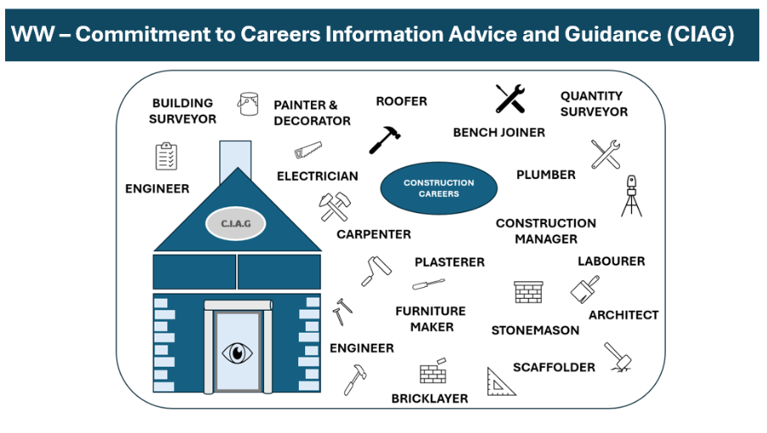
Figure **

Phase | Component | Potential  Partners | Funding  Opportunity? | Model for  Delivery | Duration | Provisional £ (annual)
Later | 1D.  Engagement with Careers Information Advice and Engagement (CIAG) | Build UK, CITB, IoC, NSITG, Heritage Network, Heritage Crafts, QUEST, CITB Go Construct, CITB Stem Ambassadors, Build UK, National Saturday Club | Grant Giving bodies- (private and heritage funders like NHLF)  Link into City and Guilds’ Heritage Skills Creative Coalition – Possible sector joint funding bid  Link to the Livery Company Skills Council and individual grant schemes of the Livery Companies WMFUK | WW Digital Team engagement creating content in partnership with external organisations  Careers Events (both hosted internally at WW and WW team coordinating attendance  at wider regional events – link to RHSN) | Commitment to 6 events a year with one major skills event a year hosted at WW | 25k

4.5.2 Category 2 - Volunteer-Led Initiatives and Social Action

Proposal 2A: Relevant to Next Phase (Y.2-5): Upskilling a Team of WW Heritage Skills Construction, Conservation and Maintenance Volunteers
This opportunity can relate to specific trades. Recruitment drives can be made alongside wider initial publicity for WW’s commitment to realising a Skills and People 1st Model for Heritage Skills (of benefit to South Yorks and the wider Yorkshire region) rendering WW a Regional Beacon for Heritage Skills Practice and national exemplar of strategic engagement with the agenda – phased over 10 years, to extend beyond the scope of a single project and evolve into a BAU approach.
This model would have resourcing Implications - there will need to be added resource / supervision within the Estates Management Team. (Maximum Capacity for Increased Numbers will need to be defined through further research and engagement in the development phase). It is likely that a growth target for volunteers (year on year) could be developed but it is likely appropriate for it to be phased and capped annually.
This can link into structured award of the NOCN Level 3 Award for Heritage Skills – with practical work focussed on the low risk / low complexity works linked to the conservation of the Bastion Wall.
To include a possible Affiliate Volunteer Programme with SPAB, NT, EH and CCT – who would be able to train in the context of WW sites. Such a shared Volunteer model review should be explored further at Development Phase following additional consultation work.
Wentworth Woodhouse has already recently launched a project with volunteers to restore some of the large sash windows in the stable block – working under the direct supervision of WW’s contracted Carpenter - that provides an early pilot that could be evaluated to ensure refinement of this concept in the future.
There is also a particular opportunity for volunteers to be upskilled in supporting some general maintenance inspections and basic level building condition surveys. Learnings from the work recently completed by Derbyshire Historic Building Trust – following their recent Heritage Lottery Award would be particularly valuable to be reviewed in the context of the development phase to define the exact future delivery models.
Next Phase Y.3 onwards
WW could extend their Volunteer upskilling scheme to wider volunteer communities engaged in the active care of South Yorkshire’s Built Heritage. Positive Collaboration opportunity with Heritage Network Members. Positive target sites for engagement would be those sites that have benefitted from funding via Lottery, HE, or AHF Grants specifically.

Now  Stage | Component | Potential  Partners | Funding  Opportunity? | Model for  Delivery | Duration | Provisional  £(annual)
Next  and  Later | 2A.  Volunteer  upskilling  scheme  (wide) | Heritage  Network  Members//  Affiliate  Volunteer  Programme with SPAB, NT and EH  NOCN  Level 3  Award for  Heritage  Skills | Lottery, HE, or AHF Grants  Livery  Companies  CITB RMI  Heritage  Sector Skills  Plan Proposal | Multi  partner  programme. in-house  practice | Deliver  annually at least  Biweekly  workshops for 4-  6months.  (Can be  shorter) | In-house 25k min to  (depends on scale/numbers of volunteers)-  Staff time for supervision  and set up  min.  5k

4.4.3 Category 3 - Special Interest, Leisure and Informal Courses
Proposal 3A: Short Term (1-2 Days) Short Courses for Home-Owners (Dual Non accredited/Accredited Pathways
(N.B: CPD equivalent version could be run for Professional Audiences – Surveyor, Estate Manager, Conservation Officer etc)
The owners of historic buildings have an important stewardship role in relation maintaining both the historic significance and fabric of the buildings in their care. With the cost of living increases seen over recent years, increasing numbers of owners are expressing interest in developing basic skills.
Partnership Opportunity: Caring for Historic Homes – Possible partnership ppportunity with Regional SPAB Group – with SPAB having a known national pedigree for such delivery. The scope of materials prevalent at WW also means that it provides a perfect location for learners to learn about a wide variety of skills. Also, a positive opportunity to collaborate with York CCC.
Financial Model: Key focus of these would be to provide a bespoke training offer in the area and ensure generation of funding to support capital / staffing costs linked to WW engagement with the wider HS Programme.
Challenges: Previous expressions of interest in running such introductory courses by SPAB would have resulted in a very minimal benefit to WW. Such an arrangement is unlikely to be financially viable unless offset from a core heritage skills enabling fund. Therefore a key development phase recommendation is to develop a business case for this specific element – others organisations run such training in an economically sustainable way (conduct review and appraisal of models such as West Dean , SPAB , Place Services Essex and TWYI – review a clear and fundable opportunity opportunities to partner with a training provider like TYWI) to allow for courses to have formal accreditation. DHBT has recently had a lottery bid to develop such an offer and it is recommended that they should be approached as a local partner to review options for collaborative working. USP here for WW : The scale of the large meanwhile space within the Riding School offers a clear and fundable opportunity to offer larger scale activities that other organisations – a clear and fundable opportunity linked to structural timber framing erection (which would have a positive link to WW’s carpentry and joinery focus and could align positively with works linked to the extensive roof repair projects required at both the Ostlers House and the Carriage House live projects.
Anticipated Impact: Positive early engagement – but would need to be tied to a programme of signposting for next stage engagement if desired.
Anticipated Challenges/tensions to be navigated designed out where possible: In reality these courses are likely to guarantee to achieve little if any material improvement in the site’s condition (with a novice level of experience) – training / upskilling of more advanced audiences would bring enhanced benefits.
CPD: Possibility to link with an Accredited CPD Training Provider
NOCN: Level 3 Award in the Repair and Maintenance of Pre-1919 Buildings – there is a a clear and fundable opportunity for attendees to include a stackable range of shorter courses to also work towards achieving an award of the NOCN Qualification.
Such courses have a a clear and fundable opportunity to link with both a ‘small scale live project’ engagement model and the ‘large scale capital project live sites’ initiatives that are proposed to be run in tandem at WW.
Content and curriculum developed for a series of modules targeted for home owners and special interest groups also has the a clear and fundable opportunity to act as a basis for the scope of a DWP sponsored SWAP initiative,
There is also a clear and fundable opportunity for such courses to link with offerings from colleges linked to Entry Level awareness building in relation to working in Heritage and Conservation – with a positive example of such training launched by the College of West Anglia in the East of England – entitled Introductory Programme in Built Heritage - Distance Learning.
Stage | Component | Potential  Partners | Funding  Opportunity? | Model for  Delivery | Duration | Provisional £(annual)
NOW (Riding School ) to Next  (Hub) | 3A.  Caring for and Maintaining Buildings of Pre 19 construction course | TWYI or Historic England CPD resources/SPAB/ York CCC | Attendee Personal Financial Commitment Possible Alignment with DWP SWAP type – government funded or college co funded as enrichment for full time students or evening course | Partner-led delivery expertise,accreditation partner , in-house practical | 1-2 days Deliver twice annually at least | Curriculum design 10- 15k  Set up in – house 10- 15k  (depends on machinery costs and H&S for hands-on

Proposal 3B: A longer duration evening / weekend course for Home -owners with a similar structure to 3A
More focussed on general maintenance skills for Buildings of Pre-1919 Construction - perhaps one evening a week or 10/12 weeks may also be possible and has a clear and fundable opportunity to lead to an award such as Entry Level 3 City & Guilds accreditation in trade skills
Curriculum Design: The design of the course would need to be worked on collaboratively and may well provide a springboard / delivery format that could subsequently be developed further for a Basic Heritage Skills Construction SWAP Course (targeted specifically at NEETS).
Stage | Component | Potential Partners | Funding  Opportunity? | Model for Delivery | Duration | Provisional £ (annual)
Next | 3B.Short Homeowners course | Historic England CPD resources/SPAB | Options should be reviewed for SYMCA AEB alignment. | Partner led delivery expertise or co funded | 10 weeks, 2-3 hours a week | Curriculum design 5- 10k Set up 5- 10k

Proposal 3C: WW as a Beacon for South Yorkshire’s Heritage Craft Community
This provides opportunity for WW to act as a beacon for the heritage crafts community in the region. It also aligns with the WW cultural strategy aims and partnerships development at WW.
Heritage skills are experiencing acute shortages—especially in traditional trades such as carpentry, plasterwork, stonemasonry—just as repair, retrofit, and public heritage projects are booming. A training programme focused on heritage craftsmanship, micro business support (tooling grants, mentoring, enterprise skills), and creative skills will help repopulate these dwindling trades, preserve built heritage, and foster cultural entrepreneurship. A starting approach to this, is suggested to start from inviting craftsmen for demonstrations on site allowing them to deliver their training activity workshops there. This can be partner-led and targeting youth (unemployed especially) but also heritage enthusiasts who may want to learn more as a free time activity.
It would strengthen the pipeline of local craftspeople, stabilise small workshops, and link them into the wider creative regional economy (design, making, set-building, museums) in SY. This approach is reinforced by Historic England skills-needs work, Heritage Crafts’ Red List evidence of endangered skills, and DCMS employment statistics showing creative industries’ scale and growth, while courses like the ones in West Dean College suggest that more certified learning pathways are possible in this category of offers.
A strategic Tri-Partite Approach of engagement with the cultural and craft sector
(A) Prioritise engagement with South Yorkshire craft businesses whose activity intersects with skills on the Heritage Crafts Red List,
(B) Align with business models of local creative / makerspace hubs that currently lease affordable studio/workshop space, and
(C) the common competitive business models these craft micro-businesses use

Hubs / makerspaces / studio providers in South Yorkshire (where craftspeople currently lease space)
In line with principle 1 (WW is not an island) there is a clear and fundable opportunity to partner with wider active creative hubs in the region. These are active local hubs where makers lease studios, hire workshop time, or access tools — natural partners for training, incubation and pop-up heritage craft activity:
Yorkshire Artspace (Sheffield) — major affordable studio network (160+ studios) with a long track record of supporting maker livelihoods and studio affordability. Good for longer-term artist-maker placements and peer networks. www.artspace.org.uk
ROAR Artspace / Rotherham — offers rentable studios and rehearsal/creative space; useful for Rotherham-based creative production and short courses. www.Rotherhamroar.com
Sheffield Hackspace / Access Space / The Makerspace (Sheffield) — community workshops and makerspaces offering themed craft nights, tool access (3D printers, sewing, basic fabrication) and guest workshops — ideal for introductory taster sessions and outreach. sheffieldhackspace.org.ukmusictuitionrotherham.co.ukThe Maker Space
Doncaster Hack and Makerspace / Art-Bomb studio connections — emerging maker community in Doncaster hosting events and developing dedicated workshop venues. doncasterhackspace.org.ukNeighbourly
Barnsley DMC / The Art House / WIPspace and BizSpace industrial/workshop leases — provide studio/offices and light-industrial units for makers who need larger workshop floorspace and access to short-term leases or business support. BizSpace in Rotherham and Barnsley DMC are pragmatic options for small craft businesses needing low-cost industrial units. barnsleydmc.co.ukartspace.org.ukBizSpace
Two approaches for delivery can be considered, mirroring models of funded skills bootcamps elsewhere:
Approach 1: the Leicester made model- combined bootcamp with skills development programme
Bootcamps in the style of Leicester made model https://leicestermade.co.uk/blog/free skills-bootcamp-in-garment-production-repair-techniques-ai-innovation/
Approach 2: Crafts Workshops & Creative Programming at Chatsworth
Chatsworth Estate’s creative offer spans workshops, local maker showcases, and a curated retail environment that highlight contemporary crafts in context:
Craft Workshops & Courses: Delivered in The Old Potting Shed and garden studio, these include:
Chatsworth Print Club—printmaking courses (monoprints, linocuts, collagraphs) for different experience levels. chatsworth.org
Seasonal craft workshops—e.g., paper-centrepiece making, needle-felting, linocut, paper wreaths, macramé, and other hands-on sessions.
Stage | Component | Potential Partners | Funding  Opportunity? | Model for Delivery | Duration | Provisional £(annual)
Next | 3C. WW as a Beacon for South Yorkshire’s Heritage Craft Community | Historic England CPD resources/SPAB Heritage Crafts Saturday Club QEST | Options should be reviewed for SYMCA AEB alignment.  Donor funded Grant Programme could be coordinated by WW  Livery Company Sponsorship | Partner led delivery expertise or cofunded | 10 weeks, 2-3 hours a week | Initial Curriculum design 10- 15k  Set up 5- 10k (p.a) + grant funding or direct funding for attendees – income generation

4.4.4 Category 4 - Education Enrichment
Proposal 4A Early Years : Skills Street Initiative linked with WW
The alignment of HS strategy with existing audiences and young families with children is important for capturing regional support and aligns with the focus on early years career information sharing for heritage futures. The development of a Skills Street offer focused on heritage skills is proposed to ensure CIAG is delivered off site even when the conditions or building work risks are high in site. Demonstration of skills can be arranged through construction group or contractor partnership and audience attraction a clear and fundable opportunity is outlined in report B on profiling of Skills Street. Discussion with Head of Culture at WW suggested as useful to have both a Heritage Building Skills and a Heritage Conservation / Operational Management Skills Area at Skills Street. The development of this is ideal to be possibly timed when the ‘Educational Suite’ is being developed on site to support singular launch and marketing of the initiative. Costs and partners for this are added in the table below.
Stage | Component Potential | Partners | Funding Opportunity ? | Model for Delivery | Duration | Provisional £(annual)
Next year | 4A. Early Construction private strategy, in school year  Skills street booking | (SY) ESH company  Local schools and Early years education partners,  CIAG Job centre Plus* | Alignment with cultural NHLF and relevant (locally based) funders | Delivered sessions off site | Specific Weeks across  - | 15- 20k for house design of online content, partner  Additional 5- 10k for  Management costs in long-term offer

Stage | Proposal | Potential  Partners | Funding  Opportunity ? | Model for Delivery | Duration | Provisional  £(annual)
Next and Later | 4B Full-time  Heritage construction course (college) | Technical Excellence Colleges /Local colleges in SY CITB approved / Rotherham - The Really Neet Project | CITB *Private funders HE grants or Education provision grants  (DFE/DWP intersection) | Paid experts to form curriculum / college partner to advertise and co host | Deliver annually, term time offer, or block teaching | *Depends on MOU with college and expected turnout for cohort (fee structure)
 |  | Entry Level 3 City and Awards accreditation in Trade Skills or a NOCN Level 3 Award in Understanding Repair and Maintenance | Recommended WMF UK  Alignment – linking to RHSN-SY and possible integration into wider National RHSNs through which the initiative can be scaled.

Proposal 4B: Ongoing Enrichment Programme
A complementary offer to a Full Time Construction Trade course run at local colleges / or links with Specialist Initiatives targeted at 14+ learners in Special Educational Settings.
Potential Partners: Potential Partnerships could be formed with Local Colleges (list of colleges and courses they currently run is provided below). Priority Regional Partner: Leeds College of Building would also be a positive target as it is the college that has been classified as one of the Government’s 10 x technical Excellence Colleges.
Priority Specialist Partner: Rotherham - The Really Neet Project Positive alignment opportunity – to allow for those engaged with this project / initiative – that supports learners through coordinating and supporting learners to overcome barriers due to travel etc. Home | Chameleon School of Construction (designed for learners 14-16 years old) and . Chameleon also runs CITB Assured Courses (CITB Approved Training Organization) and so exhibits a clear and fundable opportunity to engage those up-skillers already working in Construction.
Qualifications aligned: This could lead to either an Entry Level 3 City and Awards accreditation in Trade Skills or a NOCN Level 3 Award in Understanding Repair and Maintenance of Pre-1919 Buildings. NOCN Level 3 Award in Understanding Repair and Maintenance of Traditional pre-1919 Buildings - NOCN /
The live sites running at WW as part of the Heritage Skills Strategy also represent critical vehicles through with the current FE training courses in mainstream FT/ Apprenticeship Training Courses at regional FE colleges in trade occupations like Construction, Bricklaying, Roofing and Stonework (in the South Yorks Region) can be linked with practical work based upskilling opportunity in live Heritage Skills programmes at WW (Carriage House and Ostlers House). such engagement (supporting FE Heritage Skills Enrichment) aligns with a National Priority action identified within the Historic Environment Skills and Careers Action Plan for England (HESCAPE) 2024.
Partnership opportunities: In relation to a key development phase priority recommendation for a RHSN-SY, it is recommended that dedicated focus is given on working to establish FE Enrichment centred on WW’s live sites – there is a significant opportunity for the WW/SYMCA FE Engagement model to follow the blue-print of a model of FE engagement pioneered in East Anglia - through a Bury St Edmunds Town Trust Partnership with Industry and West Suffolk College. Such engagement would also align with one of the 5 strands of the National Thematic Defined Classifications for Strategic Engagement with Heritage Skills.
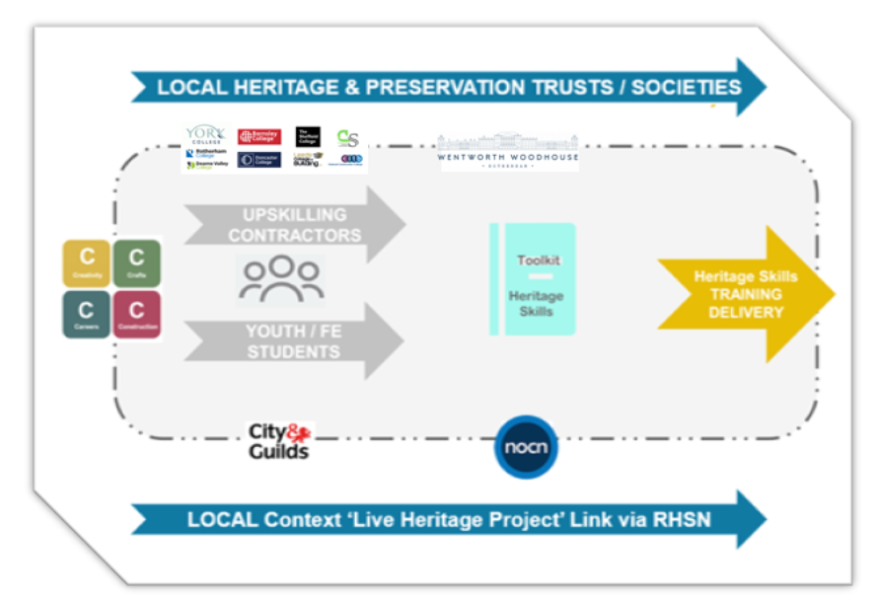
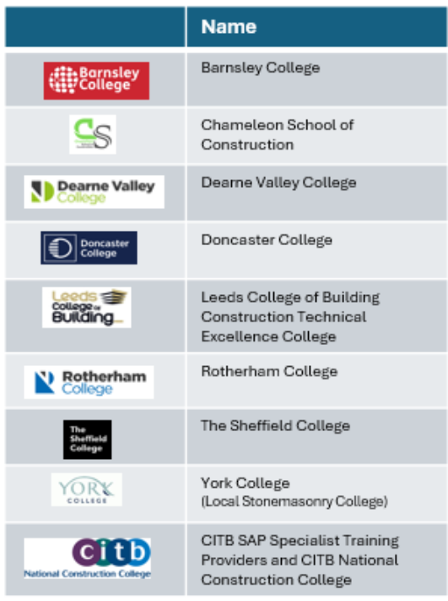

4.4.5 Category 5 - Government Funded Into-Work Schemes
Proposal 5A: APPRENTICESHIPS and TRAINEES
Strand 1 - Level 3 in-House Apprenticeship in Heritage Joinery (Paired with a Non-Apprenticeship Work Based Training Scheme Level 3 NSAC Pathway).
Stage | Component | Potential  Partners | Funding  Opportunity? | Model for  Delivery | Duration | Provisional  £(annual)
Now to next | 5A. Apprentices  5A Trainees | WW Core Delivery Strand 1 and / or Contractors employed to work on capital works ‘live sites’ at WW  Level 3 NSAC / OSAT Pathway (40 hours of attendance) | Apprenticeships Government funded SYMCA funding for Level 3 NVQ Quals in Heritage Skills NVQ OSAT  Routes Possibilities to weave in Shared Apprenticeship Models / Flexi Apprenticeship Models in the region should also be proactively reviewed.  Not eligible for Gov Education Funding – Instead pursue Philanthropic/ NLHF/HE/AHF/. SYMCA Partnerships Adult Education Devolved skills funding – review options for expansion to wider community partners/ contractors | In-House employed | 2-3 Years | Strand 1 Costs for in House Team. Provision would need to be considered for annual expansion of programme dependent upon review of success of evaluation phase.

Proposal 5B: Heritage Skills Summer School Enrichment Programme
For those studying Construction full time in Further Education Colleges - NVQ/TQ L2/3 T Levels. Also positive alignment with Block Release Construction Apprenticeships if Contractors see value in engagement. Indirect Gov Prog Apprenticeship Enrichment – a clear and fundable opportunity link with emerging CITB Work Experience Programme for FE Construction Students proposed within the CITB RMI Heritage Sector Skills Plan:
Early Phase (Development Y2 / Delivery Y1): This proposal can be classified as providing a bridge between taught programmes and practical work based experience. Comprising a series of Enrichment Placements for Level 2 Apprentices (to lead to Level 3 Award in Heritage Buildings) – Linked to the Enrichment Programme for a selected number of students on fulltime training courses (5 from each of the 4 local colleges)
Later Phase Y 3 Onwards: (WW Next Phase) Opportunities to design a Summer School Model ‘ providing ‘live site’ work based experience specific to those completing Higher Level Construction / Heritage Qualifications.
Including:
- L.5 Heritage Construction Specialist Apprenticeship: It is recognised that a Trainee Qualification at this level also has a clear and fundable opportunity to be embedded within the formal WW Site Management Team
- L6+Training of Architects, Surveyors, engineers and Estate Management - Degree Apprenticeships
Proposal 5C: Incorporating Sector -Based Work Academy Programme (SWAPs) into WW’s Strategic Heritage Skills Training Programme
SWAPS are government funded initiatives (sponsored by the Department for Work and Pensions) that are designed to help jobseekers (aged 18+) gain sector-specific skills and experience to improve their chances of employment. It is administered by Jobcentre Plus and typically lasts up to 6 weeks.
Significantly a clear and fundable opportunity has been identified to develop a Heritage Skills Focussed SWAP Programme for South Yorkshire through establishing a foundational RHSN-SY Collaborative
Skills Training Partnership between National Charity – Volunteer it Yourself and WW targeted specifically at 18-24 year old NEETs. Such a partnership would link WW’s future Capital Works Regeneration Programmes positively alongside harnessing VIY’s strong track record with the establishment of SWAPS and other entry level training programmes funded through a range of government funded initiatives such as UK Prosperity Fund etc.

Entry-level vocational accreditation (e.g. City & Guilds Level 1 )
Ideally WW would also work with VIY, HE and Heritage Crafts to develop an additional module for the City and Guilds Level 1 linked to working with Pre1919 building.
Mentorship from professional tradespeople.
Administering the programme would also require partnerships with some existing companies working in heritage skills construction in South Yorkshire with an interest in recruiting next generation talent – with the identification of consortia of such organisations being something aligned with RHSN formation. At least 1 live ‘ work based job’ opportunity in the region would be needed to catalyse each planned cohort of SWAP Trainees. Whilst it is considered that alignment of this requirement to contractual award of live capital development projects at WW would be ideal, it would not always be necessary for the appointment to be direct to a company employed at WW.
SWAP Components:
1. Pre-employment / pre-apprenticeship training – and awareness building - specifically tailored to construction/ heritage sector.
2. Work experience placement – hands-on experience with an employer / Heritage Skills Professional.
3. Guaranteed job interview – or support with the recruitment process. Whilst it is considered that alignment of this requirement to contractual award of live capital development projects at WW would be ideal, it would not always be necessary for the appointment to be direct to a company employed at WW.
4. Signposted Progression: Many move on to further training, apprenticeships, or employment.
Funding Pathway: SWAPs are fully funded by the government (DWP), and participants remain on benefits during the programme. Employers incur no direct costs, and travel/childcare support is available. [gov.uk]. VIY has a positive reputation for engaging with DWP’s and Local Authorities on the coordination of SWAPs and similarly styled initiatives funded through previous UK Prosperity Fund investments and so early collaborative engagement with these organisations would be recommended as a priority.

SWAP Qualification Pathway Alignment
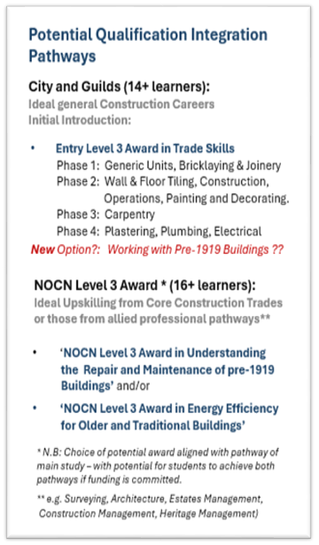
It would be recommended for individuals completing a SWAP Programme focussed on Heritage Skills to achieve an Entry Level Qualification in Heritage Skills – potentially incorporating one of those listed below, depending upon the pathway of ‘live site’ engagement integrated into the delivery model. Discussions are currently live between members of the London RHSN, HESF, HE, City and Guilds and other partners to review the a clear and fundable opportunity scope for C&G to credential a bespoke Working with Pre 1919 Buildings Module into their Entry Level 3 Award in Trade Skills

Stage | Component | Potential  Partners | Funding  Opportunity? | Model for  Delivery | Duration | Provisional  £ (annual)
Now to next | 5C.SWAP Programme | Heritage skills professionals and craftsmen/ employed contractors Linked to RHSN-SY  Collaborative Skills Training Partnership Potentially Delivered with VIY, HE, SYMCA as lead partners | DWP funding SYMCA / Government Skills Training Investment Cultural Heritage Funding initiatives similar to the now retired UK Prosperity Fund / HE Capacity Building Grants | Entry-level vocational accreditation +SWAP support  Large spaces available in meanwhile use – Riding School at WW - later stages to be delivered in the context of live sites and the HS Hub | 6 weeks summer | Target £50k

Proposal 5D: Bootcamp Development and Delivery at Wentworth Woodhouse
This business case recommends Wentworth Woodhouse (WW) explore the development of a Heritage Skills Bootcamp in South Yorkshire, designed to introduce core skills in the maintenance, repair, and conservation of pre-1919 heritage buildings. This initiative aligns with government "into work" schemes and presents a strategic opportunity to embed rolling Government funded bootcamp programmes within WW’s broader Heritage Skills Programme. Whilst bootcamps are often associated with entry-level training, this model is strategically designed to support both entry and progression, helping to build a pipeline of skilled heritage workers across South Yorkshire and beyond.
Targeted at New Entrants:
Targeting NEETs (Not in Education, Employment or Training) and individuals aged 19+ who may not have prior experience in heritage or construction.
Providing foundational training in heritage building repair, maintenance, and retrofit.
Upskilling workers in Mainstream Construction
Aimed at those already working in construction but at a more generalised – less specialist skill level.
Offering progression routes into Heritage Skills Specific Level 2/3 apprenticeships, NVQ OSAT award pathways, enabling them to start a journey towards becoming qualified heritage specialists.
The overall aim of the Bootcamp will be to provide an introduction to the specialist traditional skills central to building conservation and the repair, maintenance and retrofit of pre-1919 buildings.
To be viable, the bootcamp must address defined regional skills gaps and be validated by South Yorkshire Mayoral Combined Authority (SYMCA) and local Employer Representative Boards (ERBs). There is therefore a link between establishing the Bootcamp and launching a regional pilot of the RHSN Heritage Skills Audit Tool that will deliver measurable outcomes for robust local data in relation to skills needs that can be matched to emerging pipelines for works delivery in the context of buildings of Pre1919 Construction.
Participants must be aged 19 or over and do not need prior experience in heritage skills.
Recommended Focus and Structure
- Scope: A broad introduction to heritage skills, including sustainability and retrofit modules aligned with South Yorkshire’s green skills agenda.
- Curriculum: Co-designed with ERBs and heritage contractors, aligned with CITB guidance and LSIP/SYMCA Skills priorities.
- Delivery: 6–12 week programme combining live site experience at WW with practical and theoretical training at WW’s Heritage Skills Centre and regional colleges.
- Accreditation: City & Guilds Level 2 or NVQ-aligned modules, with progression routes into employment, apprenticeships, or NVQ OSAT pathways.

Strategic Partners
Wentworth Woodhouse: Live site and training hub
Regional Colleges: Barnsley College, DN Colleges Group, RNN Group, Sheffield College, and a clear and fundable opportunityly Leeds College (CTEC)
Independent Specialist Heritage Skills Training Providers Training Providers: • SYMCA: Strategic alignment and funding
ERBs: Curriculum development and employer engagement (master craftspeople) • RHSN: Coordination across heritage stakeholders

Funding and Impact
Funding will be sought through SYMCA’s Skills Bootcamp procurement, with additional support a clear and fundable opportunityly from the National Lottery Heritage Fund, SIMCA, or philanthropic partners. Over the next five years, the bootcamp aims to:
• Engage underrepresented learners
• Deliver social value through heritage site regeneration
• Create a scalable model for replication across other heritage sites and regions
Future iterations may specialise in trades such as stonemasonry, roofing, lime mortar repair, brickwork, and plastering, depending on the availability of suitable live sites.
Further Detail is provided in an Appendix)
Stage | Component | Potential  Partners | Funding  Opportunity? | Model for Delivery | Duration | Provisional £ (annual)
Next | 5D. NEET and Construction Sector  Worker Upskilling Programme (Higher level practical skills specific to heritage buildings NVQ3+) | SY Training Provider Partners / Employer Representative Boards/ SYMCA | DWP funding | Entry level Or Upskilling | 6-12  weeks | 25k contribution to capital works to develop pilot - Gov Scheme / DWP funding per attendee would cover other costs

4.4.6 Category 6 - Career Progression and Development
Proposal 6A: WW Heritage Skills Assessor Training Initiative
Wentworth Woodhouse is positioned to lead a strategic initiative aimed at addressing the critical shortage of accredited heritage skills assessors across South Yorkshire, Yorkshire, and the wider North. This initiative responds directly to findings from the CITB Sector Skills Needs Analysis and the CITB RMI Heritage Sector Skills Plan, which identified that only 14 qualified assessors currently operate nationally, with most concentrated in masonry and none based in Yorkshire.
The proposed Heritage Skills Assessor Training Initiative will leverage Wentworth Woodhouse’s live capital works and collaborative training partnerships to create a sustainable pipeline of assessors. By embedding assessor development into real project delivery and coordinating with NSAC and CITB, the initiative will facilitate the recruitment, mentorship, and qualification of new assessors across multiple heritage trades including roofing, plastering, and wood occupations.
Key actions include launching an Assessor Accelerator Programme, promoting NSAC and CITB pathways for assessor qualifications (such as CAVA and TAQA), identifying and mentoring experienced tradespeople, and developing a regional CPD hub for assessors. The initiative also seeks to align funding streams to support assessor training and deployment, with a clear and fundable opportunity sources including CITB’s Innovation Fund, sector skills plan aligned proposals, livery company sponsorship, and philanthropic donations.
Through this leadership role, Wentworth Woodhouse will model a place-based approach to heritage skills development, helping to resolve a national bottleneck in accreditation and ensuring the long-term sustainability of traditional crafts and training ecosystems.

Proposal 6B: Facilitating Hands on Heritage Skills Upskilling Opportunities for those already working in Construction
Primary Initial Focus on Supporting South Yorkshire SME Tradespeople with skills development specific to Heritage Skills - Heritage Wood Occupations. This initial programme could then scale over the 5 year period to include specific Engagement with Stonework and Plasterwork Skills Development. Generalised advocacy for wider Crafts will also be provided (a clear and fundable opportunity to provide and develop a generalised introduction to Heritage Skills, Heritage Maintenance and Building Pathology) course for all contractors.
Partnership Opportunities to be Reviewed: CITB ATO’s have the a clear and fundable opportunity to also partner with WW on the delivery of Short Duration Training Standards18 Potential to collaborative with the TYWI centre in Wales who previously delivered training coordinated through the HOF Building Skills Programme on the development of a training programme is also recommended. Where CITB short duration courses specific to Woodworking occupations have been identified.
In the context of this specialist work-stream WW will also innovatively pioneer an engagement path that is specific to supporting those working in the sector that have SEND / Neurodiversity
There is a clear and fundable opportunity to develop a Skills Training Partnership with SYMCA / LSIP LSIF- specific to adult education linked to Heritage Skills, or Heritage Skills linked to NEETS will also be signposted as a KEY recommendation.
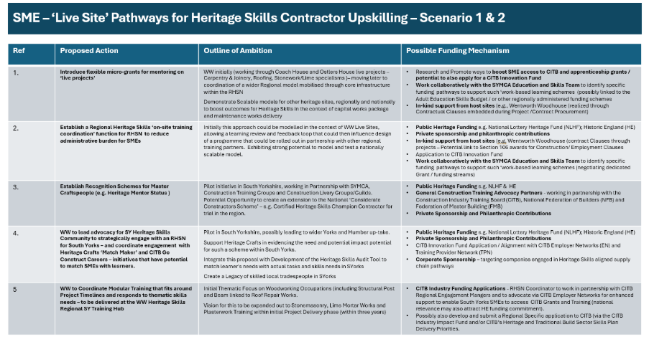
Proposal 6C: CITB Short Course Delivery and Development Specific to Heritage Skills.
Specifically in 2024 a specialist CITB Short Course was developed concerning Conservation Philosophy and Law– designed for site-based contractors working in heritage buildings. Whilst the standard has now been approved it has not yet been offered for deliver by a CITB Accredited Training Organisation (ATO). Potentially delivering this course in the context of a heritage site, like WW, would make for a powerful and inspiring course location– where learners could walk around a complex site learning first hand from practical examples about constraints etc – as opposed to merely been presented such concepts through case studies. Running a course like this would also transition WW from providing training only in the context of Projects ‘live hands-on training’ to include a training reach to capture wider awareness building with those that already have core construction skills.
Across the wider sector - there is also an ambition to build a requirement for all people working on WW projects to complete this short course in the future – linked to an active procurement requirement and this approach would also be recommended more broadly as an output from the emerging SY-RHSN partners. Indeed, the Restoration and Renewal team are considering integrating the course into all their practical works delivery procurements. The course, therefore, has huge a clear and fundable opportunity to increase sector awareness and advocacy for heritage – providing a bridge to the world of heritage to those working in mainstream construction trades (like plastering, brickwork, roofing, carpentry and joinery, metal roofing etc )– All of whom would have a significant reserve of tacit skills and experience that could be transferred to the benefit of heritage properties.
Through active engagement with the RHSN – Local Procurement Practice of foundation RHSN Heritage Skills Anchor Partners could write in the requirement for such training into procurement leading to a significant amount of upskilling. WW would provide a perfect location for the training to be delivered, and it could be CITB funded for CITB levy registered companies, ensuring a very flexible entry pathway that is accessible.
The CITB website provides positive links to the National Occupational Standards (NOS) for wood working occupations and outlines available Short Courses linked to Heritage Skills Training Woodworking Modules. These are copied below.
Through this research several existing Training Providers for Heritage Skills Specialisms have been identified (Figure below) with whom it is recommended that WW partner on initial phases of delivery. From Y.3 onwards it recommended that WW commission further research to review the viability of establishing as an independent training organisation.
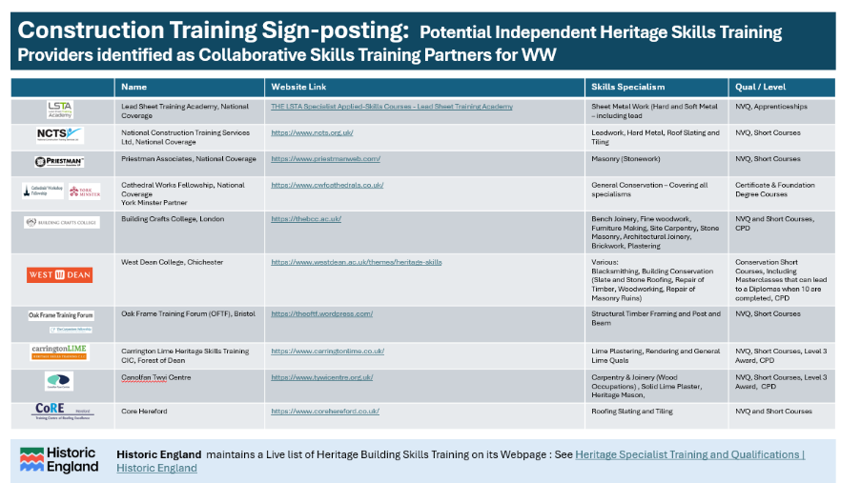
The variety of a clear and fundable opportunity engagement pathways outlined above are proposed to be reviewed by the WW internal team, key identified stakeholders and funders to review the optimal blend of activities aligned to resources. Crucially it will be required for WW to avoid tokenistic training and instead pace a high-quality delivery programme to ensure that the outlined programmes are delivered to a high standard that maximises opportunities and benefits linked to financial sustainability, community engagement and wider social impact. Ultimately it is intended that the offer would be flexed to align with changes in regional need but may also align into some core annual deliverable programmes.
The financial projections and the overarching business model will also need to be developed during the Heritage Skills Training Programmes Development Phase, forming a critical component of the planning process aligned to tailoring development of funding bids that are judged to constitute the optimal range and blend of initiatives. This work is also essential to determine the most optimised blended approach for funding and delivery across the range of activities and proposals outlined here in Section 4. By modelling different scenarios and testing assumptions with identified a clear and fundable opportunity partners and funders, the financial framework will ensure that resources are allocated efficiently and that the programme is both sustainable and scalable.
The ambition will also need to be centred on offering a provision that is holistically framed and integrates alignment between priority audiences identified through Report B and C. Ensuring that the initiatives have the a clear and fundable opportunity to maximise social benefit to the local community.

Stage | Component | Potential  Partners | Funding  Opportunity? | Model for  Delivery | Duration | Provisional £(annual)
Next | 6A. Assessor training  Target 10 Assessors trained per year blended across trade specialisms.  Initial Priorities Carpentry and Joinery, Stonework, Brickwork and Plasterwork (Heritage Trade Specialisms) | CITB  NSAC, HE, Livery Council  Members, Trade Federation  Local Contractors | CITB, Livery  Council, SYMCA Adult Education Budget | Block training or night school  Training blended between WW and FE College Training Centres.  Training in the context of Live Sites and overseeing WW  Directly employed Trainees Completing NVQ Pathways | 6 months to a 1 year | 50k

Next  Y2/3 | 6B / Non CITB Contractor Upskilling  Target 24 Trainees per year (4 cohorts of 6) | SY Training Providers / identified Specialist Training Providers Link with Local Chambers of Commerce Contractors signed up to EY-RHSN Heritage Skills Charter | SYMCA  Philanthropic Funders –  NLHF  Privately funded | Online Intro - with on site practicals tied to WW ‘Live Sites’ and other simulated synoptic training at the WW Centre of Excellence / WW Regional Heritage Skills Hub | 18 months 4 weeks block FT (or more weeks PT evening) and then NVQ Portfolio completion)  Evening or block sessions daytime  Timescales with vary depending on chosen syllabus / curriculum content to be covered. | Target  8000k per  student
Next  Y2/3 | 6C CITB  Contractor Upskilling Target 24 Trainees per year (4 cohorts of 6)  (6B & 6C trainees to be blended into 4 x cohorts of 12) |  | CITB Grants (Short Courses  CITB Registered employer candidates) CITB SAP |  |  | Target Dependent on CITB Courses selected and funding available.

5.0 Feasibility Study – Outline Heritage Skills Training Delivery Model / Options Appraisal Recommendations

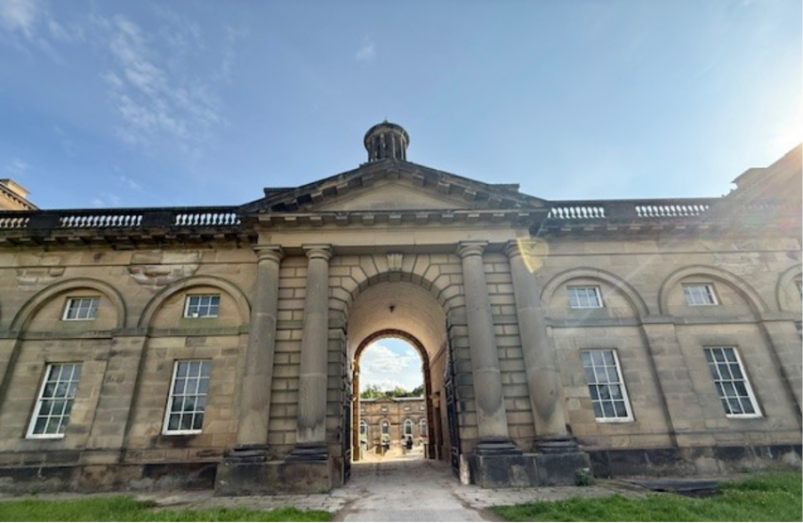
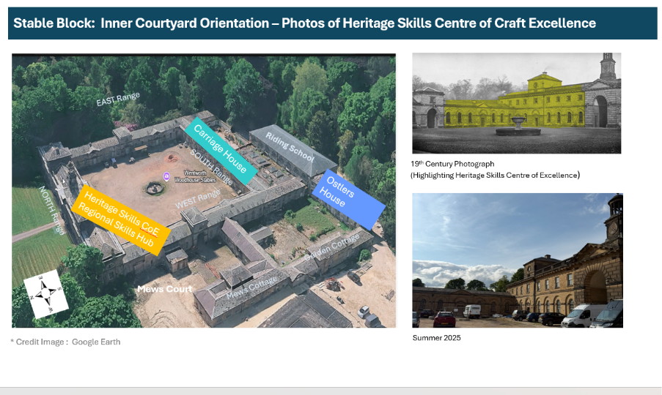
5.1 Vision for the Centre of Excellence in Carpentry and Joinery (Wood Occupations) at Wentworth Woodhouse

This business case recommends Wentworth Woodhouse should establish a Centre of Excellence for Carpentry and Joinery within its historic Stable Block, transforming an underutilised workshop into a dynamic hub for heritage craft skills. This centre will serve as a regional and national beacon, addressing the critical skills gap in traditional carpentry and joinery required to sustain the historic built environment – confirmed through the Sector Skills Needs Analysis.
Over the next 30 years, it is estimated that WW will require £100 million of conservation work, including the restoration of thousands of original windows and the future refurbishment of significant areas of vacant and underutilised space, including the wider Stable block and Bedlam Wing, alongside wider small projects and general maintenance work. These projects demand high-quality bench joinery and site carpentry, delivered by skilled craftspeople who understand historic fabric and conservation principles.
The Establishment of a Centre of Craft Excellence (CoCE) will be central to ensuring Crucially, to ensure the long-term sustainability and enduring impact of WWPT’s regeneration programme investments for future generations, it will also be essential for each phase of regeneration to be accompanied by a parallel, well-resourced programme of long-term cyclical maintenance (also supported by the CoCE), firmly grounded in the principles of Sustainable Conservation (English Heritage, 2023).
Indeed, it is only through the integration of both regeneration and ongoing maintenance can a truly holistic and intergenerationally responsible approach to asset management be achieved at WW - shifting from a reactive model of upkeep to a proactive, planned, and sustaining approach that protects and enhances the estate’s heritage value incrementally over time.
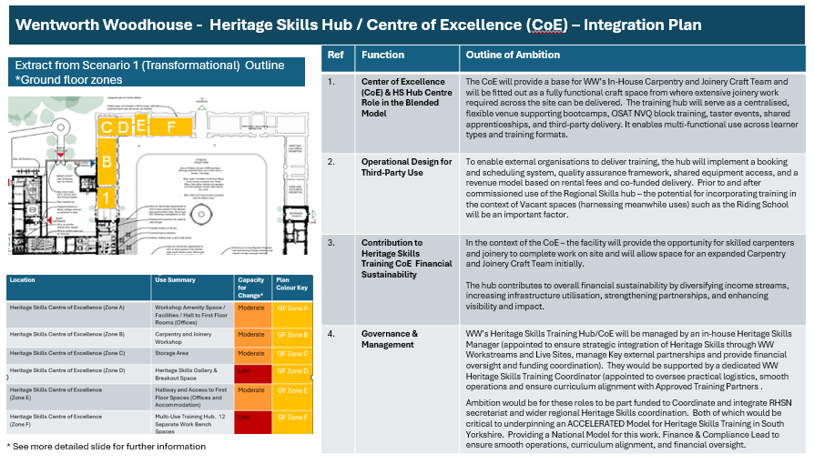
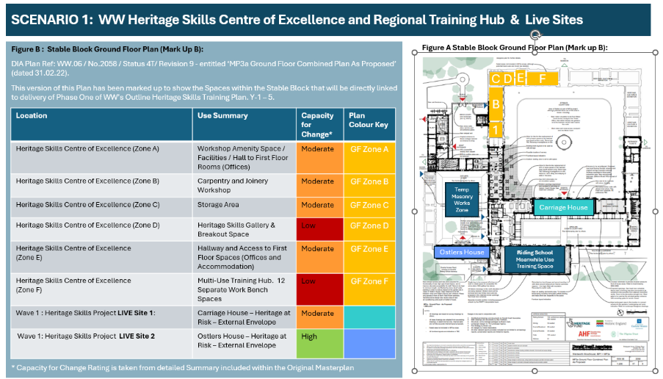
The Centre of Excellence (1,B & C Figure *) will:
- Modernise and revitalise the existing joinery workshop (dating from an earlier commercial use on the site), equipping it with state-of-the-art tools, securing high standards of staff welfare (Extraction) while preserving its heritage character.
- Provide opportunities for advanced training and apprenticeships (within the in-house craft team), using live projects across the estate as immersive learning platforms.
- Provide opportunities for advancing training and upskilling courses for wider audiences when linked with the proposed Heritage Skills Regional Training Hub.
- Foster collaborative partnerships with Regional Heritage Skills Networks, local craft teams, and community organisations to create inclusive pathways into heritage careers.
- Champion sustainability and craft integrity, ensuring that every intervention respects the authenticity of Wentworth Woodhouse’s historic fabric.
- Act as a catalyst for regional economic and social impact, inspiring future generations and embedding heritage skills within community wealth-building strategies.
Through this vision, Wentworth Woodhouse will not only safeguard its own future but will lead the way in shaping a resilient, skilled workforce for the heritage sector nationwide.
5.2 Vision for the Hub when linked to a Centre of Craft Excellence
The vision for the Heritage Skills Training Centre Hub is to create a flexible and dynamic space that forms an integral part of Strand 1 and Strand 2 of the wider skills training programme (relevant to both Scenario 1 and Scenario 2. This hub will act as a central point for advancing heritage craft skills in all their forms, across the three subdomains we have identified: heritage crafts and trades, heritage conservation skills, and heritage manufacture.
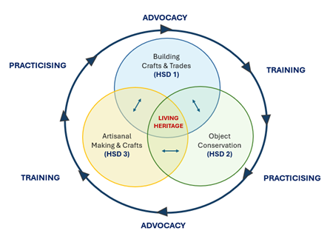
Figure *
The concept behind the hub is to provide a space that can adapt to multiple uses, enabling active learning through initiatives such as bootcamps and skills workshops, while also supporting extended learning through night school classes and continuing professional development. Beyond structured training, the hub will also accommodate more informal and creative engagement, complementing Wentworth Woodhouse’s existing cultural outreach programme and ambitions to extend this in the future. For example, it could host artists in residence and partner with other creative hubs offering opportunities that might for example include, pottery, drawing, and other art forms and craft manufacture thereby enriching the educational offering already established within the main house.
This centre will not only serve as a enabler for regional skills accelerator but also has a clear and fundable opportunity to serve as a celebratory space for the generational pedigree of the national livery companies. It will deliver measurable outcomes for a home outside London where craft excellence can be recognised, sustained, and showcased. By inviting external expertise and fostering collaboration, the hub will strengthen South Yorkshire’s heritage skills base and create a platform for innovation, knowledge exchange, and cultural enrichment. Through targeting these works specifically to the identified audiences it will possible to maximise social impact and economic growth opportunities in the processes.
Beyond the practical Trade Crafts works/ training elements (HSD1) recommendations in the interests of ensuring a HOLISTIC offering it will also be recommended that other strands of learning be introduced (enabling a strong Academic and Practical Training interface)
incrementally. Such training could include links to Estate Management of Heritage Assets (Maintenance, Surveying etc - targeting at Architects, Engineers and Estates Manager) . Potentially Complemented by a programme of training aligned to Object Conservation Specialists (HSD2) or Artisanal Manufacturing Crafts (HSD3).
The a clear and fundable opportunity for WW to be framed as a Key Site for Specialist Professional (level 4-7) training linked to the development of optimised Sustainable Conservation and Maintenance Management Models (spanning Building Conservation, Mechanical and Electrical Engineering) Specialisms) and retrofit should also be considered and would have strong a clear and fundable opportunity to Built Environment Courses being taught in local universities to WW such as Sheffield and York, as well as other pioneering Universities with a strong interest in Sustainable Conservation – such as University College London (UCL) and the University of the Built Environment amongst others. Such alignment would in essence allow students to develop proficiency through active engagement with site surveys, project design and specification, through to delivery. The relevance of the site for serving as a national beacon for such advocacy is also strengthened through WW's credentials as Green Apple Award winners.
Ultimately, the Heritage Skills Training Centre Hub will be a place where tradition meets innovation—a space that nurtures talent, celebrates craft heritage, and connects communities through learning and creativity. In summary it is wholly aligned with WW’s Core Values outlined below in Figure *.
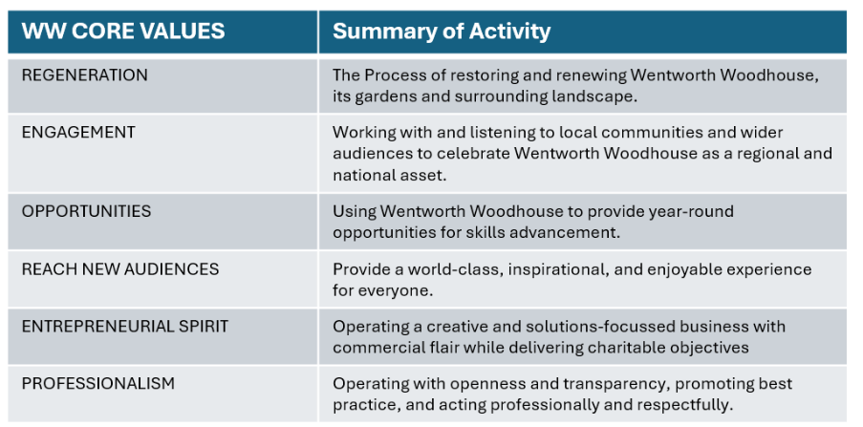
Figure *
All of which sit at the heart of their future commitment to skills excellence, inclusive engagement and a belief in the ability of WW to inspire meaningful change around Heritage across a Local, National, Regional and International geography.

5.3 An example Syllabus for the Centre of Excellence Training Pilot linked to Heritage Carpentry Joinery
Having considered currently available courses in Carpentry and Joinery and, the slides below present an illustration of a course structure that could be used specifically for upskilling experienced carpenters in relation to Heritage Skills Specialisms. The syllabus is based upon alignment of currently endorsed CITB Short Courses that could be delivered and attract funding directly for those registered as working at CITB Levy Registered Employers. Whilst the Course design can be linked to Heritage Skills Funding, it would also be viable to a clear and fundable opportunityly link the funding and pathway to the context of Bootcamps specific to Heritage Skills or other ‘Live Site’ training programmes that could be linked to Level 3 NVQ in Heritage Skills (Construction) Joinery Pathway with OSAT Pathways.
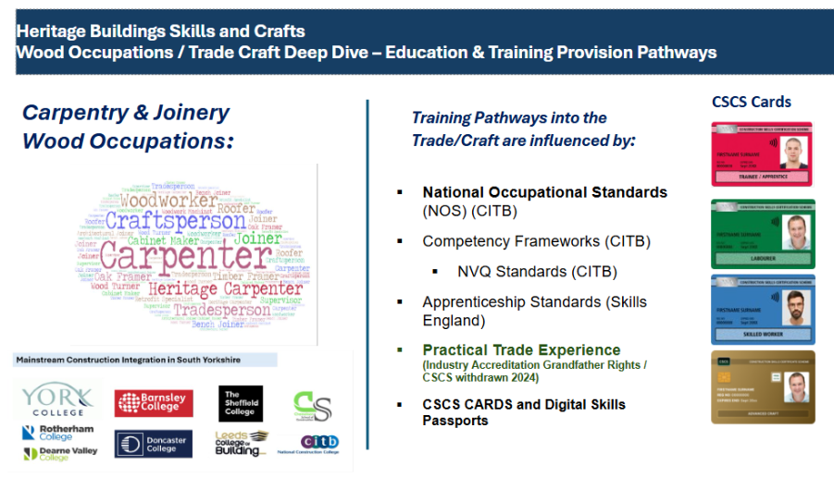
Figure * Heritage building skills and crafts and occupations
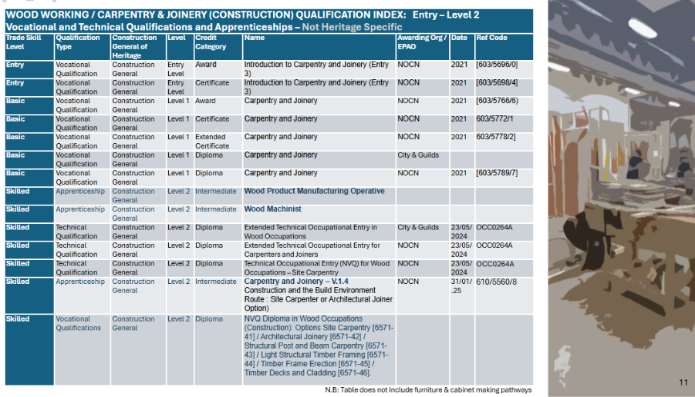
Figure * Wood working Qualification index (level 2)
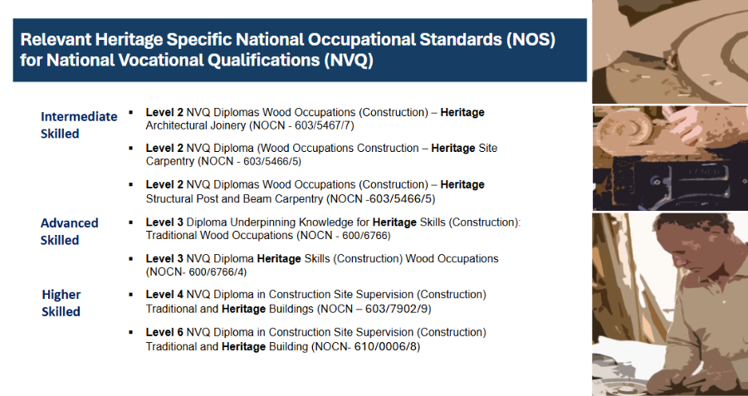
Figure * Apprenticeships standards: Levels 2 to 5
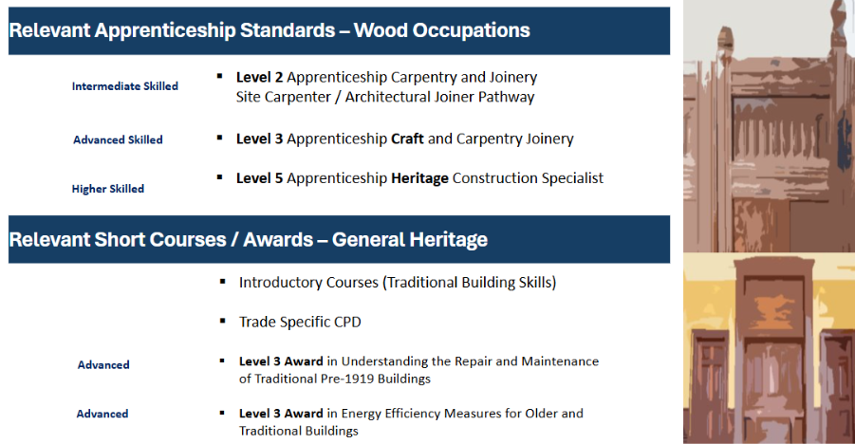
Figure * Relevant apprenticeship Standards
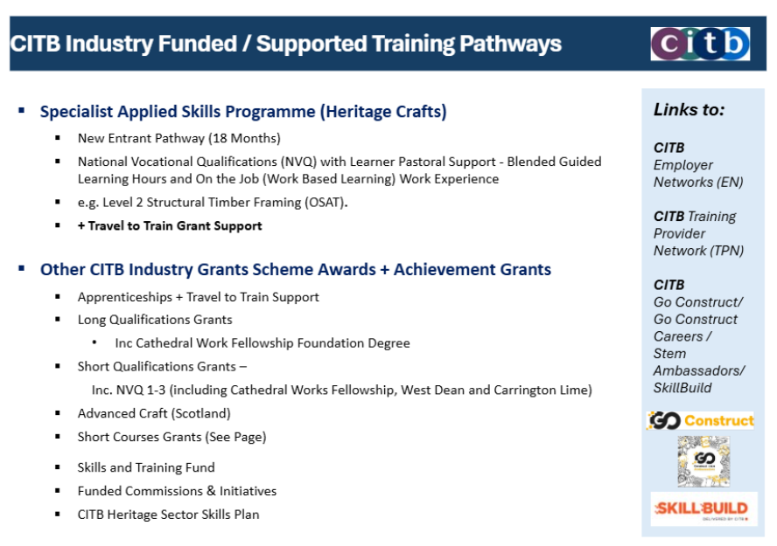
Figure * CITB Industry funded/Supported training pathways (CITB Short Courses) that could be delivered in Partnership with an Accredited Training Provider
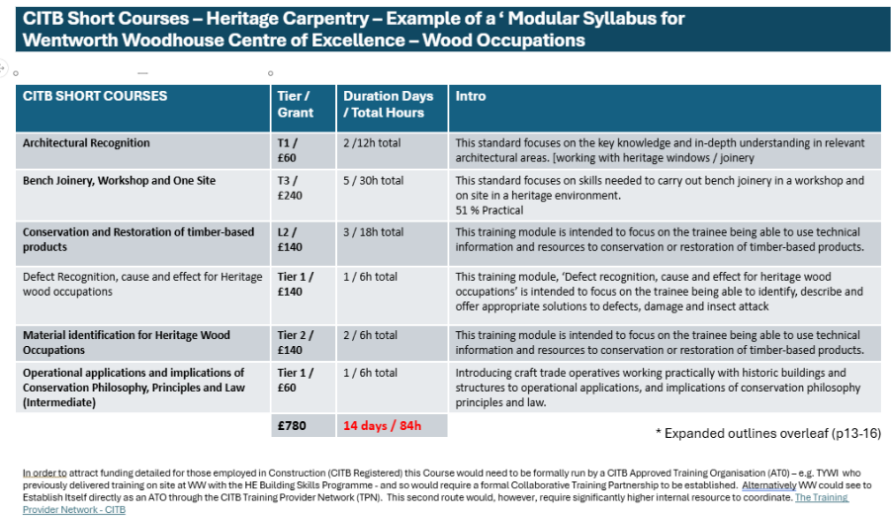
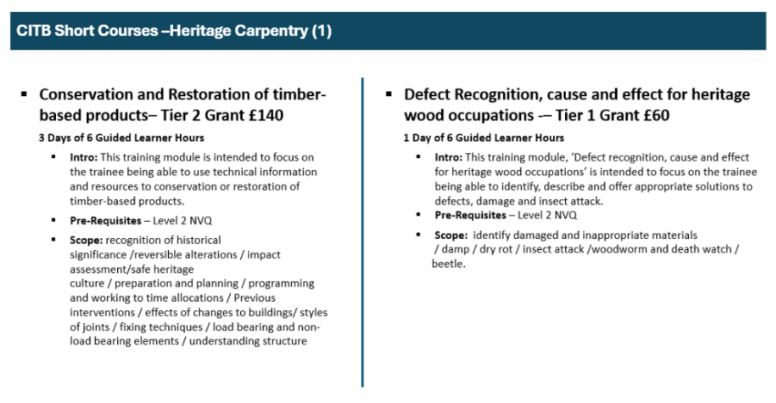
CITB-Short courses in Heritage carpentry.
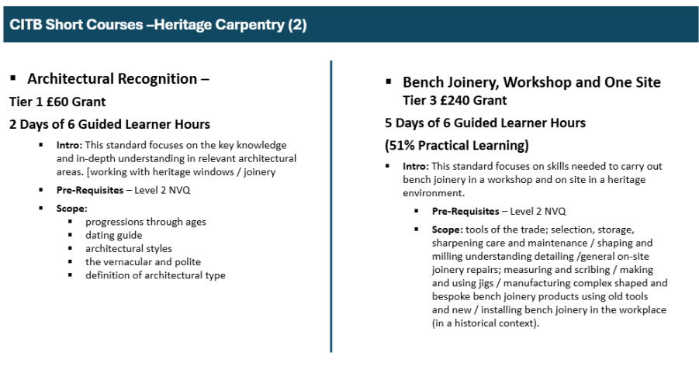
Figure * CITB Short courses
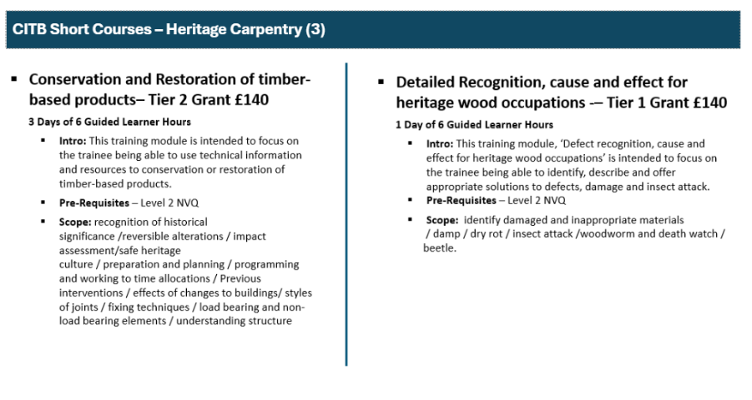
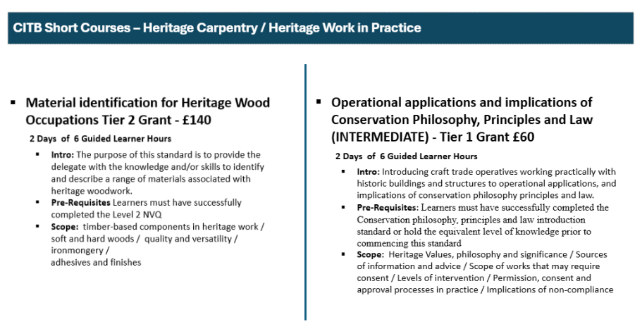
These slides have been included as an example of an early pilot initiative that could be developed – during the WW Heritage Skills Development phase it is recommended that similar syllabus are developed for stone and plasterwork.

5.4 Outline of the Operational Role of the Hub
The transformation of the Stable Block at Wentworth Woodhouse will not only create a Centre of Excellence for Carpentry and Joinery but also establish a Regional Heritage Skills Training Hub—a flexible, inclusive space designed to accelerate skills development across multiple heritage crafts.
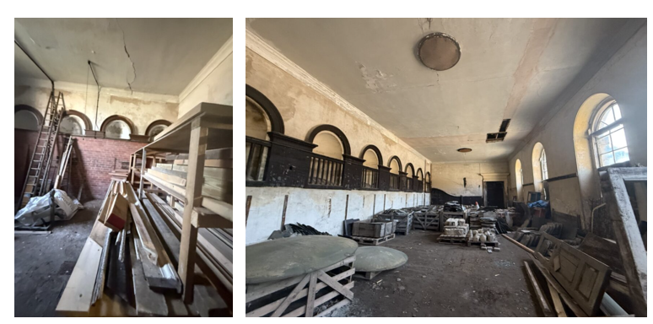
Figure **. Existing Photos of Ground Floor Heritage Skills Hub and Storage area

Key Features of the Training Hub
- 12–15 dedicated bench spaces for trainees, enabling structured learning and hands-on practice.
- Adaptable layout that supports a wide range of heritage craft disciplines beyond carpentry and joinery.
- Open-access model for external trainers, fostering collaboration with colleges, independent craftspeople, and industry partners.
- Integration with the Centre of Craft Excellence workshop, where heavy machinery and advanced joinery work will take place, ensuring a seamless link between theory and practice.
Strategic Impact
Scalable partnerships: The hub will not be limited by space or equipment constraints, allowing Wentworth Woodhouse to host diverse training programmes and attract national heritage skills initiatives.
Community engagement: By creating an accessible training environment, the hub will open pathways for local learners, schools, and underrepresented groups to enter heritage careers.
Regional leadership: This hub will anchor the Regional Heritage Skills Network, positioning Wentworth Woodhouse as a central node in a collaborative ecosystem of heritage training providers.
Together, the Centre of Excellence and the Training Hub will unlock the full a clear and fundable opportunity of Wentworth Woodhouse as a beacon for heritage skills, combining deep craft expertise with inclusive, future-focused training infrastructure.

5.5 Why Carpentry and Joinery are the Optimal Focus for the Centre of Craft Excellence (CoCE)
In considering options for Craft Specialisms for Wentworth Woodhouse’s Centre of Excellence, development of a Centre of Excellence for Stone working for SE Yorks was initially explored. However, stone masonry facilities require large spaces and extensive extraction systems to manage dust and silica hazards – as can be seen in the photographs below of Historic Environment Scotland’s Purpose-Built Stone Training Centre. A focus on stone alone would have significantly restricted the internal space available for training and collaboration and would have necessitated a scale of machine installation and extraction at odds with WW’s strong commitment to safeguarding the significance of the Grade I listed Stable Block.
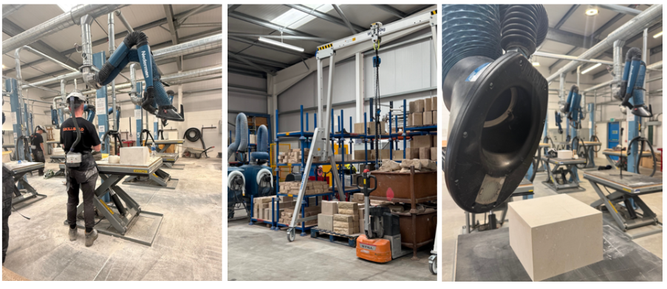
Sterling Skills Training Centre – Stonemasonry Focus – High Tech H&S Provision
It is also important to recognise that an inspiring Centre of Excellence for Heritage Craft Skills and Estate Management, with a predominant focus on stonemasonry, has already recently been established nearby at York Minster (1.2h from the site). The York Minster Facility is then further enriched through the Stonemasonry Training school embedded within York College. The existence of this regional provision for stone training, combined with the infrastructure challenges of stone yards, informed the recommendation to prioritise carpentry and joinery at Wentworth with the Centre of Excellence. It is, however, noted that there is an excellent opportunity for WW to partner with York Minster on commissioning the heavy stonework (machine shop work) that may be needed to supply WW’s future regeneration works.
Above the proposed Heritage Skills Hub on the first floor, there is a significant area of vacant space in reasonable condition that offers exciting opportunities for adaptive reuse. This space could accommodate offices and workshops for the existing estates team, creating a centralised base for operational management and craft advocacy within the Stable Block.
An indicative plan for the scope of accommodation that could be achieved at first floor was prepared by Donald Insall Associates and is illustrated below.
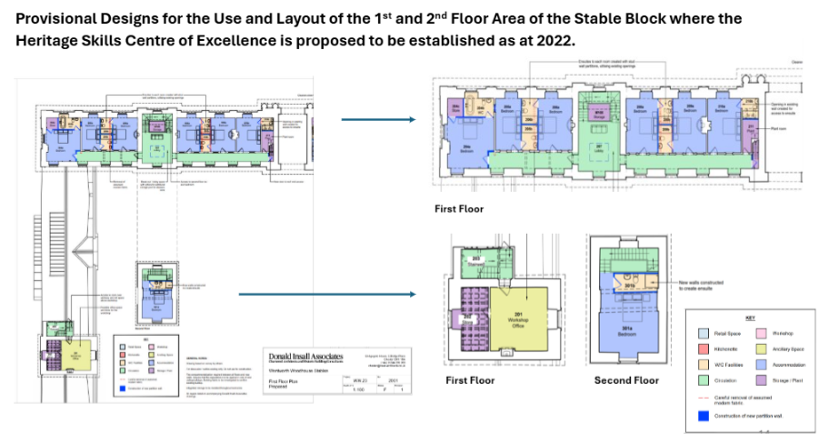
Figure *
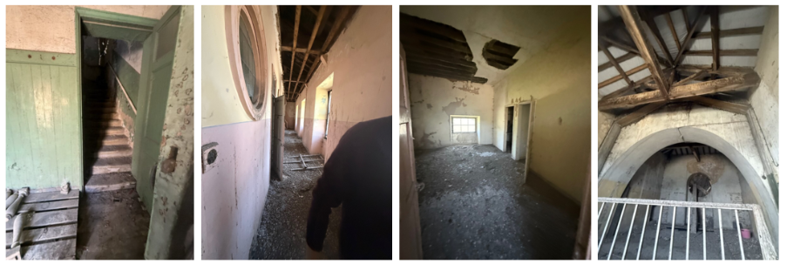
Figure. * Existing Photos of First Floor Rooms above Heritage Skills Hub
In addition, there is a clear and fundable opportunity to introduce some limited short-stay residential Accommodation for visiting trainers and specialists, supporting the delivery of high quality training programmes. While the site cannot provide full cohort accommodation, this is not a critical barrier; local hotels offer competitively priced rooms (circa £40 per night), and partnerships could be developed to secure preferential rates for trainees and trainers.
The first-floor space also provides flexibility for future mixed-use development, including administrative functions, ensuring that the Stable Block becomes a fully integrated hub for heritage skills, estate management, and collaborative working.
Whilst the creation of some first-floor accommodation for trainees and assessors linked to the Heritage Skills Programme would be desirable a clear and fundable opportunity has also been identified for trainee accommodation to be achieved through formation of a partnership with a local hotel – such as the Travel-Lodge in Rotherham, where rooms can be booked for as little as £42 per night. Housing students overnight in Rotherham would also positively support secondary spend revenue generation within the local community.
It is also important to note that, as the wider masterplan regeneration of the WW Stable block progresses – additional residential units will be created. It has however, been noted that the commercial leasing of such properties is only viable or attractive at the point that a critical mass of units / rooms viable as a commercial letting enterprise.

5.6 Complementary Provision for Training Spaces for Stonework and Wet Trades within the Stable Block
While the primary Craft focus for the Centre of Excellence Workshop will be Carpentry and Joinery, research and stakeholder discussions confirm a clear need for stonework and associated wet trades (such as pointing and brickwork) to be embedded within a holistic Strategy for Heritage Skills at Wentworth Woodhouse. Additionally, it is also recognised that the creation of a space dedicated to training in Lime Plasterwork (which is also a priority craft skill identified through HESCAPE) would also be desirable and could be an activity delivered in the context of localised conversion ‘live internal works’ in the future within the context of the Carriage House, Ostlers House, Bedlam Wing and the wider Stable block.
To negate the challenges presented by the existing spaces within the Stable Block is, that will preclude permanent wet trades spaces, it is proposed that some pop-up training facilities specific for stone and external wet trades could be created.
Proposed Solution
Phase 1 – Pop-Up External Facility
- The Ostler’s Court courtyard offers an ideal location for a temporary, external stone-working / wet trades area. This space would:
- Support live site training linked to projects such as the Coach House and Ostler’s House.
- Enable stone cutting, pointing, and brickwork tuition in a controlled outdoor environment.
- Use face-mounted masks and portable extraction systems designed for site work, avoiding costly retrofits.
Phase 2 – Permanent Covered Yard
In later stages, it is recommended to establish a dedicated external yard for stone and wet trades, inspired by the model at Dumfries House (King’s Foundation). This would provide:
- A weather-protected environment for advanced stonework.
- Capacity for larger-scale training and specialist courses.
Embracing Meanwhile Uses for Provision of Internal (weather protected) Training Facilities
Wentworth Woodhouse also has the flexible opportunity to utilise meanwhile spaces within the Stable Block before permanent uses are established. This approach would allow for a steady and incremental pace of delivery and investment whilst maximise training impact during early phases of capital investment.
Riding School (500-person event venue – 50-person training venue): This large space, which will remain vacant for a considerable time before its long-term conversion to an events venue, offers an ideal environment for major internal training programmes.
Focus areas could include brickwork, stonework, and wet trades, delivered with minimal alterations to the existing structure.
The scale of the space would also be ideally suited to construction of mock-ups for structural roofing systems, including traditional post and-beam construction, which cannot be accommodated within the joinery workshop – with a clear and fundable opportunity for a significant link to the Live sites of Ostler’s House and Carriage House that will both require extensive works
Through embracing a clear and fundable opportunity meanwhile uses in the context of the ‘Riding School’ initially and a clear and fundable opportunityly other areas across the site, it will be possible to increase the ROI of investments already made in the Regeneration of the Site, while working towards securing a longer-term funding model for Heritage Skills engagement at WW – with delivery programme adapted in pace to align with the pace and scale of development and fundraising ambitions.
In conclusion, to ensure the Heritage Skills Programme at Wentworth Woodhouse is holistic, resilient, and responsive to real sector needs, it is critical to incorporate multiple strands and themes of engagement. This approach will embed flexibility and sustainability into the fabric of Wentworth Woodhouse while delivering meaningful skills development.
Key Strands of Delivery
Centre of Craft Excellence (CoCE)
Focus on exemplary joinery and fine woodworking, providing advanced craft training and upskilling opportunities for existing contractors. This strand represents the highest level of precision and technical excellence, positioning Wentworth as a beacon for heritage carpentry and joinery.

Live Sites
Utilise restoration projects across the estate to create immersive experiences that engage communities, support career changers, and inspire homeowners. These should include both large-scale, multi-million-pound refurbishments (e.g., Ostler’s House, Carriage House) and smaller, isolated projects such as individual rooms or craft-specific interventions. This flexibility ensures incremental progress in site restoration while creating accessible entry points for learners.

Specialist Craft Modules and Partnerships
Collaborate with organisations such as SPAB to deliver targeted training in areas including:
- Planned joinery repairs
- Plasterwork conservation
- Fit-out and joinery installation
By combining room-by-room restoration projects, meanwhile spaces, and external pop-up facilities, the programme will deliver measurable outcomes for a dynamic and scalable model for heritage skills training. This ensures Wentworth Woodhouse’s approach is not only ambitious but also agile—capable of responding to different scales, crafts, and community needs while contributing significantly to the regeneration of the estate.

6.0 Consolidated Recommendations Wentworth Woodhouse Heritage Skills Programme Y.1-5.
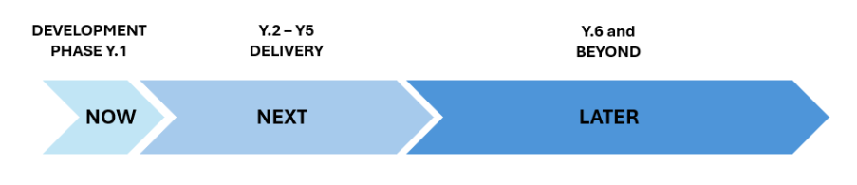
Overarching Recommendations
At the Client’s request a separate spreadsheet has been developed to summarise the various recommendations made throughout Report B and C and provide a Pathway for the imminent recommended Development Phase.

Recommendations within the Spreadsheet are presented as both Higher Level Strategic Action Aligned Recommendations alongside more Operationally Focussed / Training Delivery Focussed Recommendations. This spreadsheet is intended to allow the reader to visually map both Capital Works and Skills Training Delivery Programme Priorities at WW.
, the recommendations made have been shaped to align with the ambitions of WW – communicated through their Draft 5 Years Strategy – received in October 2025. It is noted that there may be some discrepancies between the emerging Draft that was used and integrated and the final release of the 5 Year Plan at WW.
These recommendations have also been influenced by meetings held with Key identified 3rd Party Stakeholders engaged with Heritage Skills advocacy and Cultural Heritage Stewardship in the sector that have included:
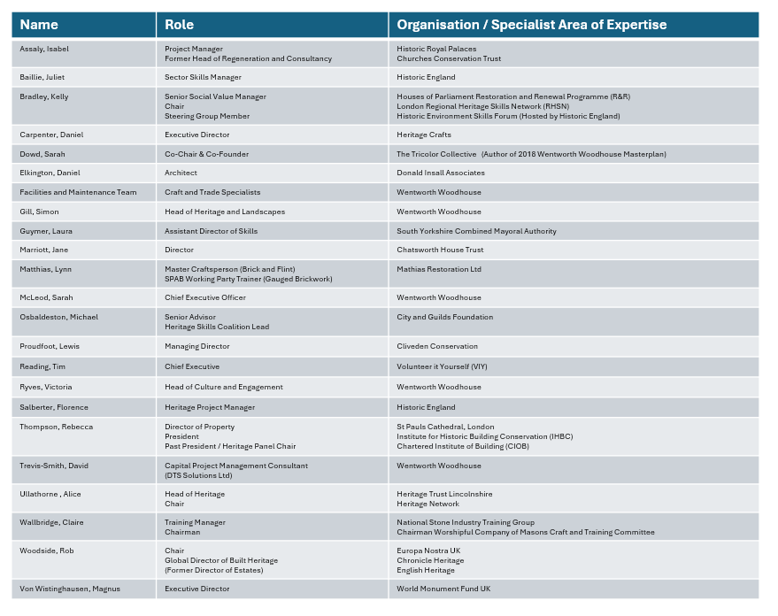
The content has also been significantly shaped through active engagement of the authors with the Historic Environment Skills Forum, The City and Guilds C, The CITB Repair and Maintenance Sector (RMI) Heritage Skills Sector Skills Plan and London Regional Heritage Skills Network coordinated by the Palace of Westminster

The overarching recommendation is for WW to consciously move away from the BAU delivery model (Scenario 3) that has prevailed in the sector in favour of adopting a more holistic and long-term accelerated approach to put People and Skills 1st .
The primary recommendation and the optimal delivery pathway is for WW to follow Scenario 1 Transformational Pathway. This will, however, attract a higher initial investment cost than Scenario 2 (Gateway Phased Model) that has been designed to achieve the same level of transformational impact, connected through a commitment for WW to become a Regional Beacon for HS excellence over a longer lead in period – through which the capital works could be incrementally funded.
N.B: As requested by the client, the Breakdown for imminent Y.1 (NOW/NEXT) development phase and early stage / wave 1 roll out will be the most detailed element to support programming for the development phase work. With general direction but less detail provided for years 2 -3. General Ambition will be presented for the years beyond up to Y.5.
Please refer to the Spreadsheet Recommendations
N.B: The Spreadsheet also provides some recommendations in relation to a clear and fundable opportunity funding pathways that could be explored to support delivery of some areas of work. It is also understood that Development / Fundraising applications are currently being prepared by WW to support the next stage (formal Development Phase of the Heritage Skills Programme / Initiative at WW) – at the same time as the preparation of this report. To date it is known that the SWIRE Trust and AHF and HE have been approached, although it is not confirmed which Grant Streams have been applied for from the respective Grant Bodies. Wider Grants are being sought from funders such as the Clore Duffield to advance more cross-strand Curriculum aligned education provision and offer at WW. Attempts will be made to identify and High priority Funders / Possible funding alignments with Heritage Skills interest and/or active engagement with skills in the context of the spreadsheet that accompanies this section.

This report has been produced with the support of our partner The World Monuments Fund.

