DOCUMENT B: THE LOCAL NUCLEUS FOR A NEW NATIONAL & INTERNATIONAL FRAMEWORK
The Wentworth Woodhouse Outline Heritage Skills Training Programme

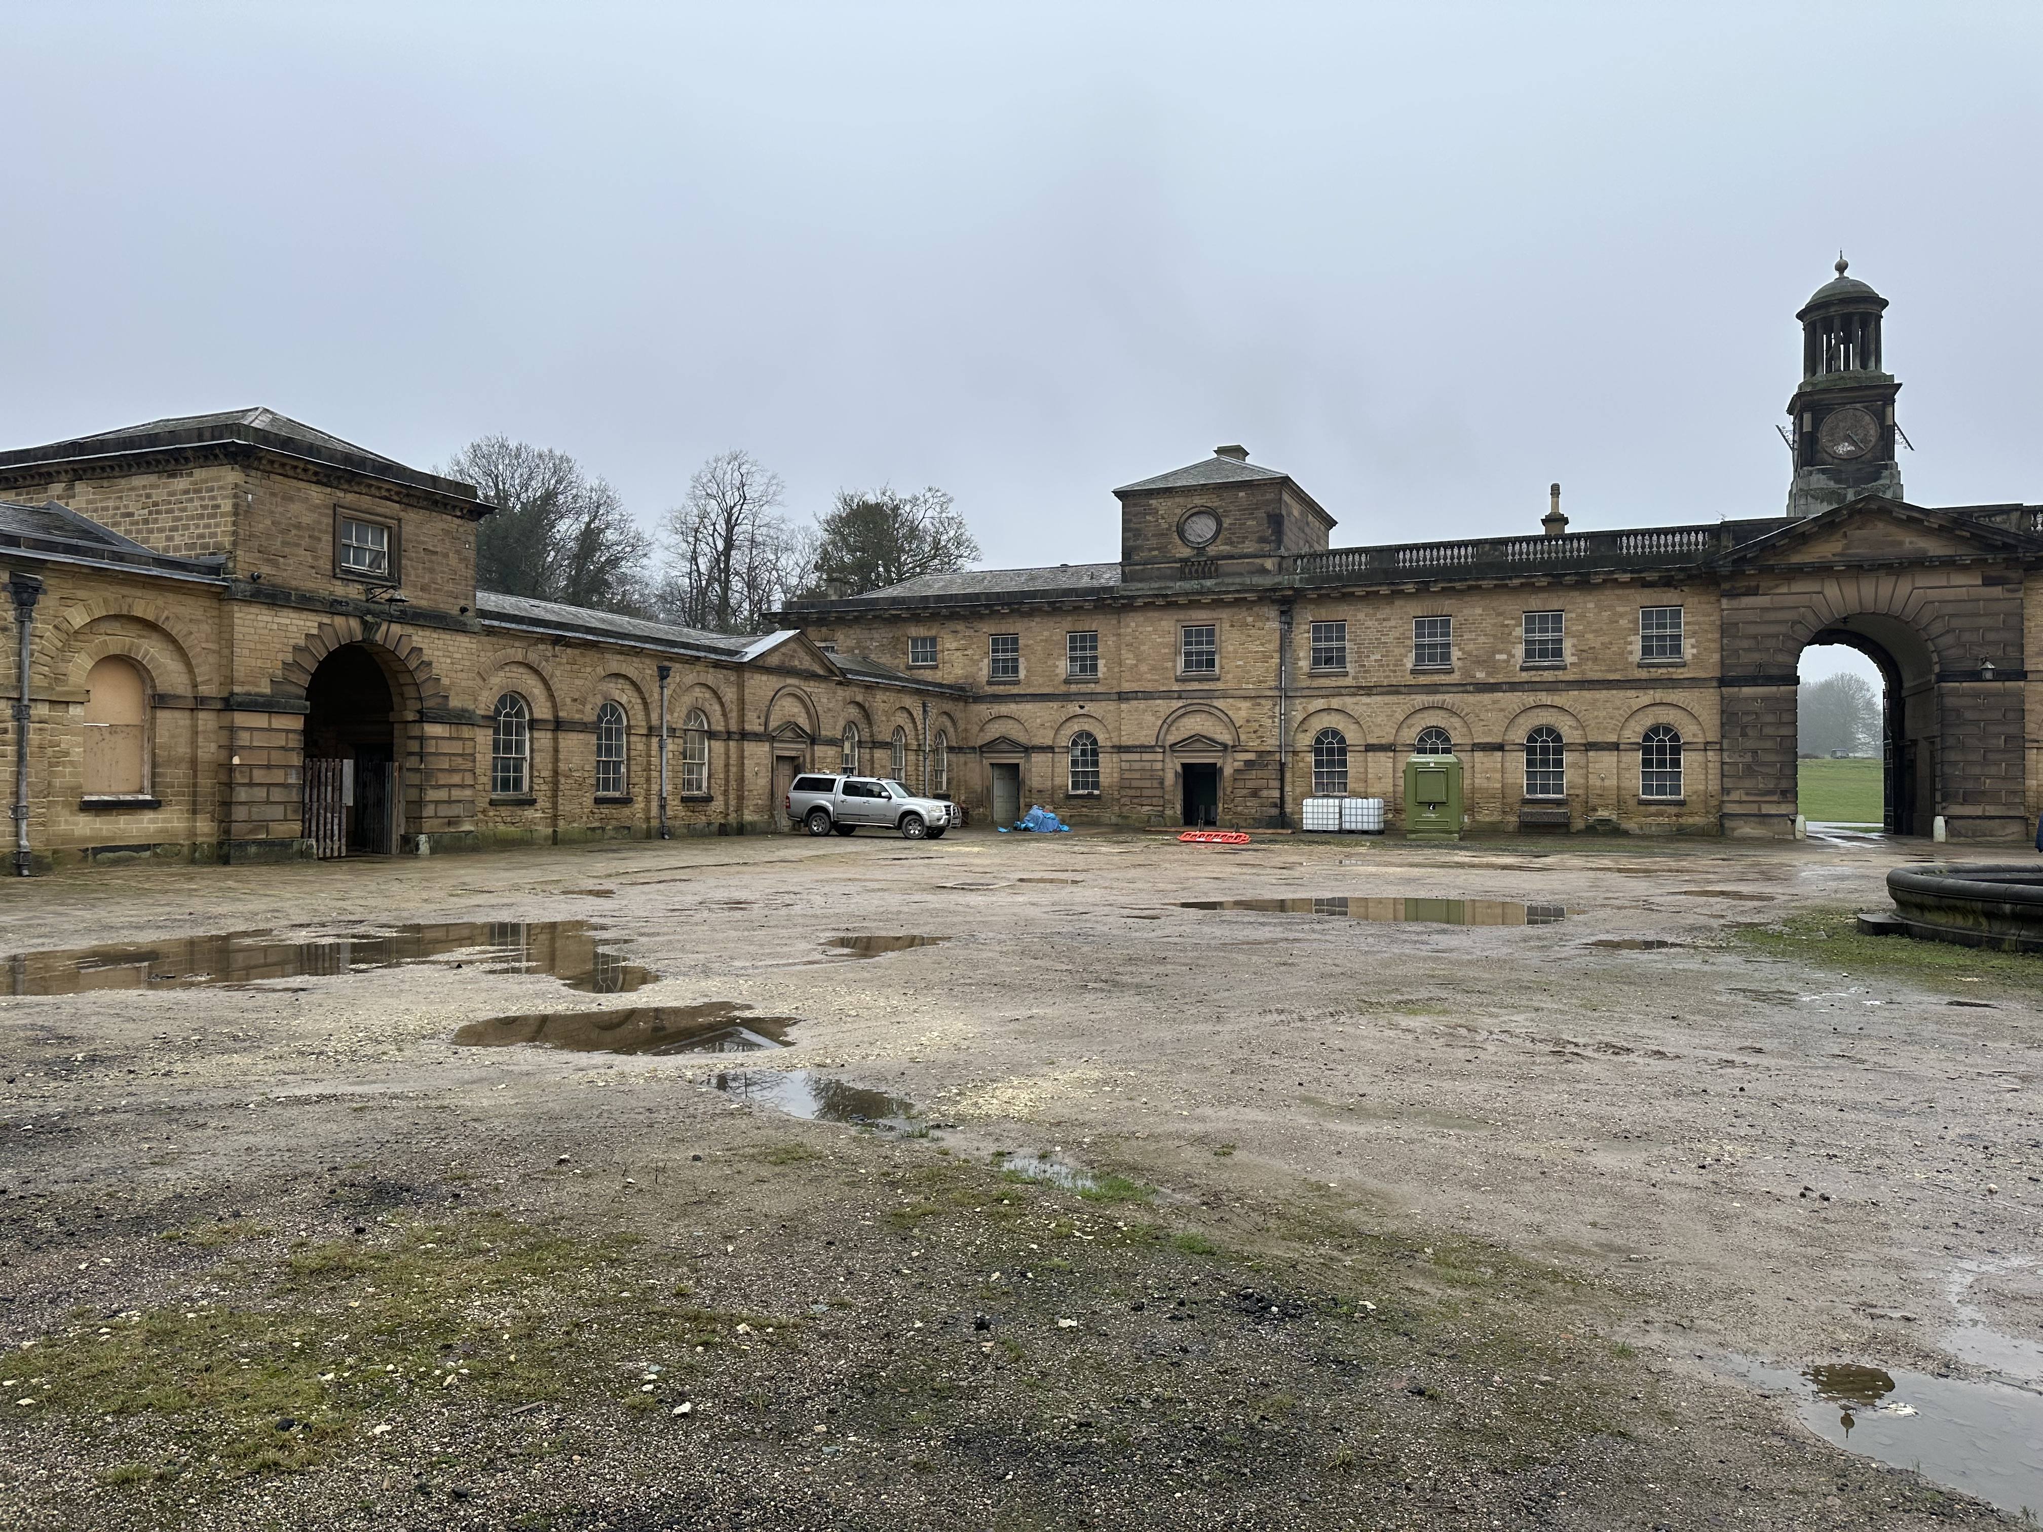


This report has been produced with the support of our partner The World Monuments Fund.
This document outlines why this is the Outline Heritage Skills Training Programme for the Wentworth Woodhouse Preservation Trust. It includes all the work which led to the development of Document C and Document 4: Appendices in Moderate Detail.
It covers the Vision & Strategy specifically relating to the WWPT site and includes information not relevant or appropriate for a wider global audience.
This document is the evidence base - the need, the opportunity, and the foundation for recommendations made in Document C Outline Heritage Skills Training Programme. It is the evidenced narrative upon which our recommendations have been made to Wentworth Woodhouse for their Future Engagement with Heritage Skills - and proposed role as a Regional and National Beacon for Heritage Skills.
How Document B Strengthens the Investment Case

1. Establishes the Scale and Urgency of the Skills Crisis
Provides national and regional labour market evidence (Historic England, CITB, HESCAPE) demonstrating ageing workforce, skills shortages, and limited training provision.

2. Demonstrates Structural Market Failure
Explains fragmentation between construction, heritage and education funding systems, justifying need for an integrated intervention model.

3. Aligns with National Policy Priorities
Links heritage skills to housing delivery, retrofit, Net Zero, and workforce reform agendas, strengthening relevance to public funders.

4. Tests the Market Through Case Study Appraisal
Evaluates existing heritage skills programmes, identifying sustainability gaps and lessons that inform the Wentworth Woodhouse model.

5. Positions Wentworth Woodhouse as a Regional Anchor
Demonstrates site-specific readiness, restoration pipeline, partnerships and regional labour market relevance.

6. Introduces a Scalable System Innovation (Heritage Skills Audit Tool)
Sets out a practical mechanism for aligning conservation pipelines with workforce planning, enhancing credibility and long-term impact.

7. Provides a Clear Logic Chain to Document C
Ensures that recommendations in the Outline Training Programme are evidence-led and grounded in sector intelligence.

Contents

1.0 Evidence Summary for Funders

2.0 Purpose of this Document

3.0 Strategic Alignment with National and Regional Skills Priorities

3.1 Definition of heritage skills, skills gaps, skills shortages
3.2 UK-wide momentum & strategic focus on skills
3.3 Framing Specialist Heritage Skills as a Crucial Missing Piece of the National Construction Skills Jigsaw
3.4 Contextualising relevance of mainstream Construction and Government Targets
3.5 The English Heritage Skills Landscape: A Sector-wide Picture
3.6 Factors influencing the fractured heritage skills landscape are multifaceted
4.0 Appraisal of Sector Skills Interventions – Strategic Implications for Wentworth Woodhouse

4.1 Case study 1 - Historic England heritage skills programme

4.2. Case study 2 - York Minster Centre of Excellence for Heritage Craft Skills and Estates Management

4.3 Case study 3 - Lincoln Heritage Skills Centre

4.4 Case study 4 - Weald and Downlands Museum (West Dean College)

4.5 Case study 5 - Sussex Heritage Trust (SHT)

4.6 Case study 6 - Bury St Edmonds Town Trust (BTT): West Suffolk College Training Partnership

4.7 Case study 7 - Landmark Trust – Sector-based Work Academy Programme (SWAP)

4.8 Case study 8 - Petroc College Heritage Bootcamp

4. 9 Case study 9 - CITB National Construction College (NCC), a comparator from mainstream construction

4.10 Case study assessment conclusion

5.0 Heritage Skills Audit Concept – Strategic Development Opportunity

5.1 Rationale for the Function of the Heritage Skills Audit Concept

5.2 Linking WW Heritage Programme to Regional Skills Needs

5.3 Skills Audit Specific to Wentworth Woodhouse

5.3.1 Skills and Materials Fabric profiles across works in Stables area

5.3.2 Indicative alignment between works, skills and occupational categories engagement: Riding School and events breakout spaces

6.0 Heritage Skills Need & Training Opportunity: The Wentworth Woodhouse Context and Profile of Skills Need

6.1 Summary of Skills Training Categories at WW
6.2 Widening Access to Skills Through Education Partnerships (Category 3+ Education Enrichment)
6.3 WW opening up to community knowledge: Boosting Careers Information Advice and Guidance (CIAG) Events and Conservation guided tours (Thematic Category 2)
6.4 WW Summer school (Historic England programme) - building further on success (Category 4/5)
6.5 Digital Heritage Skills Training & University Partnerships
6.6 Informal partnerships for volunteering and social action - hosting SPAB Summer working party activities

7.0 Defining a targeted future audience for Heritage Skills Training at WW and Wider South Yorkshire

7.1 Audiences for heritage in SY and lessons for WW
7.2 Local skills dashboard insights (LSIP & SYMCA wide skills and employment data)
7.2.1 Further evidence on diversifying audiences for skills training (across SY)
7. 3 Introducing “Audience-targeted skills training” Recommendations for WW
7.4 Formal Educational Engagement Programmes at WW: The Four Principal Strands of Education and Skills Engagement outside the Under-16 Curriculum Alignment
8.0 Vision and Theory of Change
8.1 National vs International Change
8.2 Regional and Local THEORY OF CHANGE

9.0 Core Delivery Principles
10. 0 Funding Leverage Points
11.0 Future State: Possible Blended/Integrated funding stream components of an ACCELERATED Heritage Skills Programme Model
12.0 Risks and Dependencies and Mitigations of an Integrated and Blended (Multi-Component) Approach
12.1 Phased Development Model for Heritage Skills Delivery
12.2 Transitional R&D Phase – Building Mitigation against Identified
12.3 Background
12.4 Proposal: Development of a Blended Funding Framework
12.4.1 Key Components
12.4.2 Governance and Administration
12.4.5 Financial Resilience Mechanisms
12.4.6 Strategic Alignment
12.4.7 Benefits
12.4.8 Next Steps
12.5 Alignment with Further Education Colleges and Training Providers
12.6 New Funding landscape & opportunities for WW
12.6.1 Adult Skills Fund: What is ASF funding?
12.6.2 Community Wealth Building -What is Community Wealth Building?
12.7 Monitoring, Evaluation and Learning
12.7.1 Monitoring & Evaluation (M&E) Framework for the Wentworth Woodhouse Heritage Training Skills Centre
12.7.2 Objectives of M&E
12.7.3 Metrics for Evaluation
12.7.4 Reporting and Review: approaches to adopt
12.7.5 Recommendations for Legacy Impact Prediction & Social Value Capture
12.7.6 Metrics & Indicators to consider
12.8 Risks Dependencies and Mitigations
Annex – Summary of Key Recommendations (Report B)

1.0 Evidence Summary for Funders

This document provides the strategic and evidential foundation for investment in the Wentworth Woodhouse Heritage Skills Training Programme. It demonstrates that heritage construction skills in England face structural decline, with an ageing workforce, limited entry pathways, fragmented funding, and weak alignment between capital projects and training delivery.
National evidence from Historic England, HESCAPE, CITB and related sector bodies confirms significant shortages in traditional building trades, limited specialist training provision, and poor visibility of heritage career pathways. These pressures are intensified by housing delivery targets, retrofit ambitions and Net Zero commitments, all of which rely on skills relevant to pre-1919 buildings.
Existing interventions have demonstrated impact but are frequently time-limited and insufficiently integrated into long-term workforce planning. There remains no coherent regional infrastructure capable of aligning live conservation pipelines with structured training pathways at scale.
Wentworth Woodhouse is well positioned to address this gap. As a nationally significant heritage estate with a long-term restoration programme and regional partnerships, it can act as a convening regional anchor and test-bed for an integrated skills delivery model.
This evidence base establishes the case for investment in a coordinated, place-based Heritage Skills Training Programme that aligns site-specific demand, regional workforce need and national policy priorities. It underpins the recommendations in Document C and demonstrates why timely funding intervention is necessary and credible.
This document provides the key evidence base and synthesizes contextual information around heritage skills, gaps and opportunities at the national, regional and local level, while providing key research evidence for the recommendations for WW in this report. The challenges with the current Heritage skills system are well documented in national reports: there is an observed sector-wide recognition of the risks of loss of skills and associated heritage Assets at Risk, aligned with Scottish and Irish national strategic focus on heritage skills as well combined with the recognition of a ‘lost opportunity’ in delivering heritage’s role for social impact at regional level as well. The existing models of integrating skills next to projects have been majorly focused on piloting small scale training for apprentices or skilled workers without committing to resourcing career-level opportunities or site-targeted opportunities for longer term integration of skills in programming.
This report illustrates what has not been working well, to be able to propose an alternative, integrated model tackling the key aspects of: funding, delivery approaches and sustainability as critical success factors. The significant volume of published reports and developed new skills-focused schemes from heritage funding bodies during the last 5 years, suggest that there is significant momentum, combined with real experience from pilot models of heritage skills training (and lessons learnt). These provide a more solid foundation for upscaling existing solutions and developing space for innovation in integrated skills training within the heritage restoration and conservation master planning and delivery processes.
Wentworth Woodhouse’s significant regional, national and international profile and experience, together with the depth and diversity of heritage skills training possible on site, positions the Trust to take a prominent and leading role in regional level coordination of a novel model for integrated skills delivery, and the development of a Training Skills Hub with unique character. This could not only serve the needs of WW but also the wider region, and align with national priorities for skills gaps, attracting partnerships and collaborators across the country. The document presents the resources and outcomes of the new role for WW within this landscape and context using tools like TOC models to illustrate the key preconditions of success and expected outcomes.
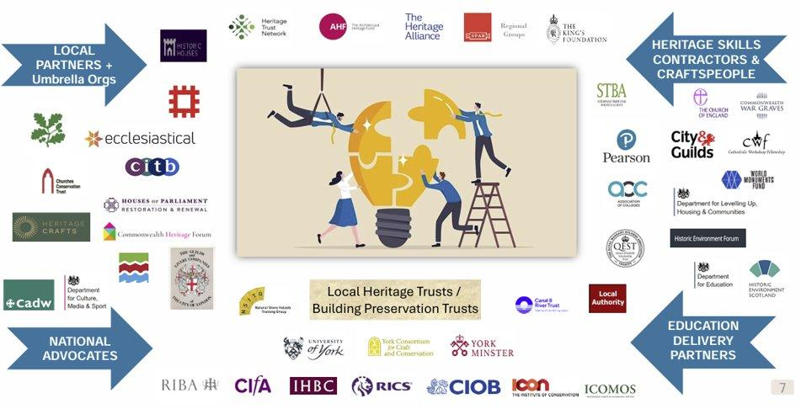
Figure 1: A new Era of Sector Collaboration and Shared Ambition linked to Heritage Skills

2.0 Purpose of this Document
This document sets out the national, regional and local evidence informing the proposed Heritage Skills Training Programme at Wentworth Woodhouse. It clarifies structural weaknesses within the current skills system and explains why an integrated delivery model is required.
The document positions Wentworth Woodhouse within the wider heritage skills landscape, linking site-specific opportunity to regional labour market demand and national workforce policy. It provides the evidential narrative underpinning the strategic recommendations in Document C.
This document provides the key evidence base and synthesizes contextual information around heritage skills, gaps and opportunities at the national, regional and local level, while providing key research evidence for the recommendations for WW in this report. It is setting the scene by outlining and contextualising the challenges with the Current Skills System and Training Delivery models that have resulted in the ongoing National Skills challenges, prevailing for decades and now reaching a critical point (SSNA HE 2024). The section will profile and summarise the current Heritage Skills landscape across England and with regional repercussions for WW. It will incorporate ways of working, core issues and challenges to skills gaps and ways of delivering training. The document offers the evidence base to understand and define the need for a new Integrated Skills Training Model and the opportunity WW might bring by taking a leading role in this context.
It therefore stands as an overarching context and reference point underpinning the recommendations made in Document C Outline Heritage Skills Training Programme & Plan, which includes the proposed programme and strategic recommendations for WW.
Through the discourse of this section, outlined impacts and opportunities are linked to the existing ‘Heritage Skills National Landscape’ and then reviewed against the potential at five relative geographic levels: Site (or WW specific); Local; Regional; National; and International. Within that context, the proposal for an innovative INTEGRATED Heritage Skills Model, tailored to serve multiple points across the Intergenerational Arch of Heritage Skills and key identified audiences, is positioned. The document outlines expected impacts at levels from the micro (site level) to the macro-levels of a National and International Heritage Skills Ecosystem, ranging from a proposed strategic and leadership role for WW to shaping of an ecosystem of actors delivering innovation and social impact locally, and a model which can be upscaled nationally and globally. The expected outcomes and impact at those levels are linked to input and resources required and depicted through a higher level Theory of Change (TOC).
The document will also provide crucial content to help the reader understand how the sector functions at present, and will identify the limitations of the current system, and the need for changes in how skills are integrated in funding and conservation projects. The existing readiness of the WW Operating Model to integrate a strategic focus on heritage skills training will also be profiled, starting with the Estate’s current experience in delivering skills training programmes, and progressing to opportunities and resources required to expand and sustain this across time. The alignment with the existing Education and Culture strategy at WW is also integrated here to ensure feasibility and synergies in terms of resources and use of spaces across the Estate, while taking into account phased changes in use and condition assessment (eg. Heritage significance, and options for different uses post restoration works).
Finally, the document will set the scene for the Theory of Change (ToC) model presented, which has in turn informed Document C and the final recommendations for an Integrated Delivery Model for Heritage Skills and pathways to the future. The document is also supported by a bibliography (provided in the Appendix), with relevant Links to key documents and published reports at both national and regional levels.

3.0 Strategic Alignment with National and Regional Skills Priorities
The proposed programme aligns directly with national construction workforce priorities, heritage sector strategies and regional economic development objectives.
3.1 Definition of heritage skills, skills gaps, skills shortages
To date, a sector lack of definition has been observed to complicate strategic engagement and discourse focussed on the development of strategic responses. To help shape these and concentrate attention, it is proposed that Heritage Skills will be framed and narrated in this document under three key Heritage Skills Subdomains, linked to a stacked model of education and skills at Wentworth Woodhouse.
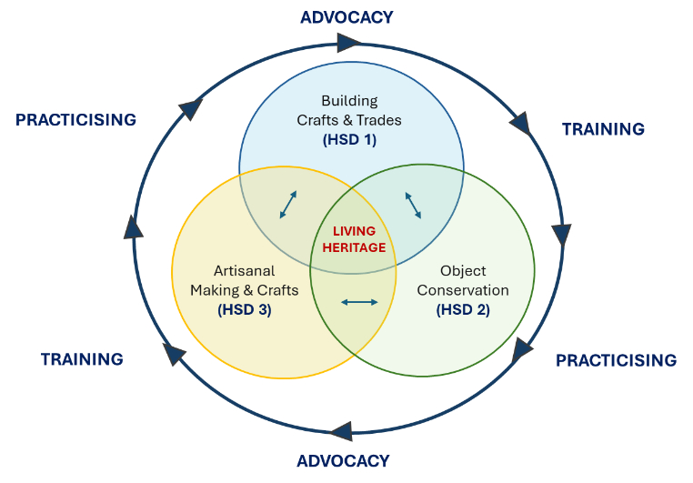
Figure 2: Skills domain with core relevance to heritage skills training at WW. (Horticultural and historic landscaping can also be considered as a 4th pillar. Source: Authors, NDF)
The three core Heritage Skills Sub Domains (HSD) have been developed following stakeholder engagement with key stakeholders including Historic England, Historic Environment Skills Forum, Heritage Crafts and members of emerging Regional Heritage Skills Networks (RHSNs) across the UK
This section describe the wider alignment between WW activities and its contribution to heritage skills training with the broader international scene, but also its alignment with regional needs and opportunities for skills training and development programmes.
3.2 UK-wide momentum & strategic focus on skills
WMF Summary
A UK-wide movement to protect heritage skills and crafts whilst responding to sectoral skills gaps and linking those to local economies has been evident for almost 10 years. This section profiles some of the latest investments in heritage skills across the UK, and serves as an introduction for the more detailed HESCAPE section. This summarises England’s main national effort to respond strategically to the need for space for the development and nurturing of heritage skills through structured programmes. This section emphasises that this is a critical time for WW, which offers a unique but almost certainly time-limited opportunity to take advantage of the present momentum for change and assume a leadership role.
In England the National Trust was awarded £6.2m to open an apprenticeship scheme in partnership with the Vinehill Trust (2021-25), which focussed on training 30 Apprentices over seven Years in Level 2 Stonemasonry and Levels 2/3 Carpentry and Joinery skills. In 2024 Historic England (HE) published the first report detailing sector-wide labour requirements for heritage skills in a decade. The emergence of the Heritage Skills forum and the development of a set of summer schools offering nationwide block learning programme offers at sites including Wentworth Woodhouse, Hopwood Hall, Manchester Church of St John the Evangelist, and Lancaster Haigh Hall, Wigan formed part of the Heritage Skills programme supported by Historic England (see section 3.4 for analysis of those), complementing the wider picture and the increased interest in supporting Heritage Skills at a national level. The recent commitment by the Hamish Ogsten Foundation to providing support for a national programme of heritage building skills is also part of this wider picture.
English Heritage also recently published its Sustainable Heritage Conservation Principles (2023), identifying the need to link sustaining properties and sites with the nurturing of the necessary skills and practices. The Heritage Crafts Association (Heritage Crafts) was established in 2009 and launched at the V&A Museum as a Membership Charity in 2010. Heritage Crafts is supported by the Kings Foundation to deliver its own programme for heritage skills training.

Two programmes from Ireland and Scotland are also presented here to showcase the momentum for change:
Ireland: The All-Ireland Heritage Skills Programme supports those working in the construction sector in both Northern Ireland and the Republic of Ireland to push their skills to the next level and continue on their journey to becoming the next generation of master craftspeople. The All-Ireland Heritage Skills Programme partners believe that it is crucial to preserve the wisdom and knowledge that embody many of the traditional building skills which have shaped Ireland’s historical built environment. As many workers in the sector now reach retirement age it is vital that these skills are passed on to the next generation of master craftspeople, ensuring the continued restoration and conservation of history, but importantly demonstrating the significant role that traditional craft skills can play in creating new spaces and places.
Scotland: Traditional skills are a prime example of Intangible Cultural Heritage, aspects of heritage that cannot be seen but that are passed down through generations, such as recipes, songs and crafts. The re-thatching of The Old Thatch, a property on the Isle of Tiree, saw Intangible Cultural Heritage in action. This project was awarded funding to provide urgent repairs to a property on the most westerly of the Inner Hebrides islands, employing the skills of a traditional thatcher who used locally sourced and sustainably harvested materials including local marram grass.
Historic Environment Scotland (HES) has committed to work with the Institute for Conservation (Icon) and other partners through the heritage sector’s Skills Investment Plan to identify the skills most at risk. This follows in the footsteps of the UK-wide initiative to identify and track endangered skills through the Heritage Crafts Red List, and will look to quantify the practitioners working in Scotland responsible for the built environment. Of the 49 key traditional building skills defined by HES, only 6% have formal training provision in place, 50% have no informal training provision in place and the initial suggestion is that 49% are at high risk of loss and 41% at risk. Examples referenced by HES include the absence of any Modern Apprenticeship in roof slating and tiling provision north of Arbroath, any architectural blacksmith training at all in Scotland, and absence of the knowledge and skills required to properly repair and maintain existing traditional buildings from available training courses. HES has two skills training centres in Elgin and Stirling, and also helps people learn on-the-job while earning a wage by offering Apprenticeships, Traineeships, and Craft Fellowships.

3.3 Framing Specialist Heritage Skills as a Crucial Missing Piece of the National Construction Skills Jigsaw
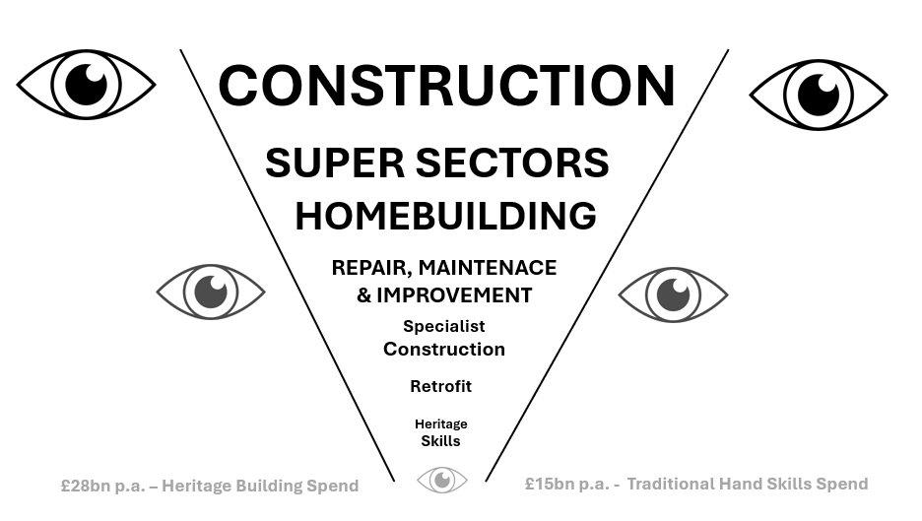
Figure 3: Developing opportunities around the relative INVISIBILITY of Specialist Heritage Construction Skills in the National Skills and Training Narrative
A National Moment of Focus on Construction Skills
Skills shortages and gaps in the construction sector - a longstanding national workforce issue that led to the establishment of the Construction Industry Training Board (CITB) in 1964 - have once again become a hot national topic, capturing widespread public and political attention. This section begins by outlining the mainstream national position on general construction and retrofit skills shortages, followed by a high-level summary of current government initiatives and responses to these challenges.
Repositioning Heritage Skills Within the National Skills Agenda
This section reframes Heritage Skills as a critical and under-recognised component of the construction sector. Officially classified within national workforce reports as a sub-element of the Repair, Maintenance and Improvement (RMI) subsector, heritage skills are essential to the sustainable repair, maintenance, and retrofit of the UK’s historic built environment.
Despite this, pre-1919 buildings, which make up around 20% of the UK’s building stock and often hold cultural and historical significance, have been largely overlooked in national construction skills strategies. The CITB, while responsible for workforce development across the sector, has historically underrepresented heritage skills in its strategic planning. Instead, advocacy for this area has largely fallen to the Department for Culture, Media and Sport (DCMS), whose broader remit includes cultural and heritage policy.
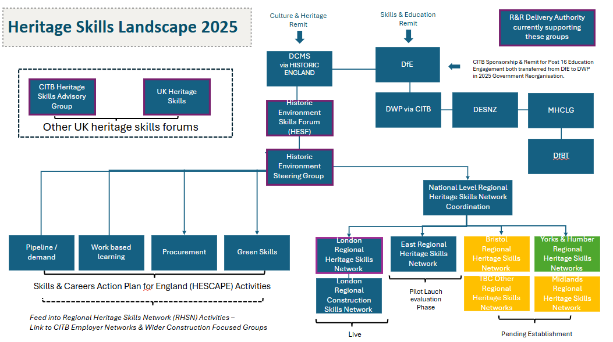
Figure 4: Heritage Skills Landscape as in 2025, with illustrated divided remits between culture and heritage sector and Skills and Education sectors shaping the picture on responsibilities. (Source: NDF)
Towards a Future-Ready Skills System
We argue for a future skills system that reflects the full breadth and depth of the UK’s construction ecosystem. This means not only building high-quality, low-carbon new homes, but also unlocking the potential of our existing building stock, particularly the pre-1919 heritage buildings that define so much of our national character of place and the familiar and cherished local scene.
By embedding heritage skills into national workforce planning, we can power up our capacity to deliver sustainable retrofit, support economic growth, and meet Net Zero targets, whilst preserving the cultural fabric of our communities.
This section outlines the mainstream construction and retrofit landscape and clarifies the underrepresentation of heritage skills.
3.4 Contextualising relevance of mainstream Construction and Government Targets
Since the Labour government took office in 2024, its manifesto pledge to “Get Britain Building” with a target of delivering 1.5 million new homes over its term (equating to 300,000 annually) has been widely echoed across national media.
The Government's Warm homes plan which provides £13.2bn in investment for the retrofit of five million homes, provides a new opportunity for embracing the critical role of heritage skills for achieving technically competent delivery of heritage properties. This ambition has reignited public debate around the persistent challenges facing the construction workforce, particularly the low enrolment and achievement rates in Construction Trade Apprenticeships and Technical and Vocational Education and Training (TVET) programmes. A new body has been specifically created to deliver the Government's needs and ambitions. The Construction Mission Board is intended to coordinate efforts by providing strategic oversight, policy compliance, coordination across departments and arms-length bodies, and skills and workforce development, including links to occupational pathways offered by Skills England.
Responsibility for national education and training provision, including construction-related programmes, was formally transferred from the Institute for Apprenticeships and Technical Education (IfATE) to Skills England, an executive agency of the Department for Education, on 2nd June 2025, and then subsequently transferred to the Department of Work and Pensions on 16th September 2025, following restructuring in government departments, including CITB sponsorship. Despite increased media attention over the past two years, government targets for housebuilding, retrofit, and construction training have remained largely unchanged from those set by the previous administration.
The targets set by the current administration have been informed by longitudinal labour market intelligence from organisations such as:
Construction Industry Training Board (CITB)
Construction Leadership Council (CLC)
Office for National Statistics (ONS)
And other sector-specific bodies
Collectively, these sources point to a longstanding mismatch between workforce availability and labour demand, a trend that continues to be reflected in the CITB’s 2025–2030 Construction Workforce Outlook.
3.5 The English Heritage Skills Landscape: A Sector-wide Picture
In 2024 Historic England (HE) published the first detailed report for labour requirements for heritage skills in a decade. This helped the organisation to understand the fractured nature of the landscape and enabled it to draw links with the Government’s national mainstream construction plan.
The Historic England report, ‘Skills Needs Analysis for the Repair, Maintenance and Retrofit of Traditional (pre-1919) Buildings in England’ (2024) provides key data for the skills landscape in England:
Ageing Workforce is a fact in specialist heritage construction. 50% of the specialised heritage construction workforce are aged 55 or over and most will have retired by 2030, compared to just 25% of mainstream construction workforce figures in the group aged 45-59. (Skills England, Sector Skills Needs Assessments, 2025)
There are multiple skills gaps and skills shortages in traditional skills and trades, including those supporting Retrofit, Net Zero and Green Skills
There is a lack of new people entering the sector
There is poor visibility of traditional construction career pathways
There is limited national training provision and uptake specific to Heritage Skills (including apprenticeships)
There is limited if any traditional heritage skills specific content in core vocational construction training, and a ‘postcode lottery’
There is no visibility of heritage work, conservation or retrofit pipelines regionally and nationally
There is a fragmented Funding Position
Key facts on specialised heritage workforce demographics -age and gender challenges
AGE: Over 50% of the workforce is aged 50+; 18% of workers are under the age of 35 . The largest single group is 55-64 (which comprises 30% of the workforce); Fewer than 5% of workers were aged under 25. | IMPACT: Indicating a significant ageing demographic, challenges highlighted in attracting young entrants to heritage construction roles.
GENDER: Only 2% of the workforce in traditional building repair and maintenance roles are women*. | IMPACT: A persistent gender imbalance in heritage construction, particularly in the skilled trades (such as carpentry, stonemasonry and roofing)

Table 1: Key facts on specialised heritage workforce demographics. Source: Skills Needs Analysis for the Repair, Maintenance and Retrofit of Traditional (pre-1919) Buildings in England, Historic England. (2024)
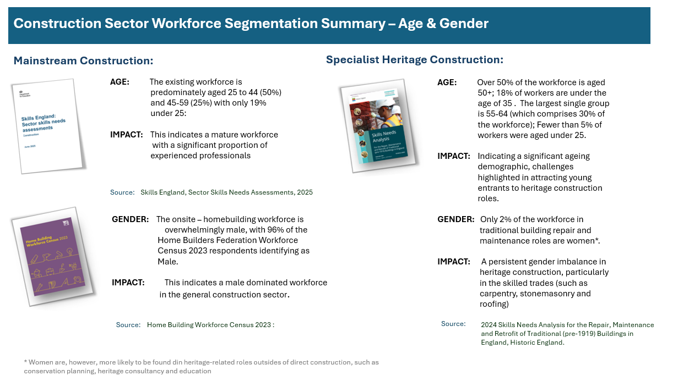
HESCAPE & Strategic national priorities for heritage skills
For over 10 years there have been increasing concerns from those working in the sector about both evidenced and perceived skills gaps and shortages, and how this poses a threat to the continued management, protection and conservation of the historic environment.
The Historic Environment Skills Forum Steering Group has prepared a document on behalf of the wider Forum membership which includes an action plan for Heritage Skills in England called the Historic Environment Skills and Careers Action Plan for England (HESCAPE, v1 September 2024). The document includes considerations beyond building construction, but the focus of this report covers the aspects related to built construction and conservation specifically. It acknowledges the Skills Investment Plan for Scotland’s Historic Environment as a direct source of inspiration and approach. Outlined key gaps in the sector include:
A quarter of heritage construction firms are experiencing skills shortages. 15% have had to turn down work on pre-1919 buildings due to lack of available knowledge and skills
Around a third of conservation organisations have reported challenges with recruitment, citing low overall numbers of applicants and low numbers meeting the requirements of jobs advertised
Technical skills are often not explicitly described in job descriptions and adverts, with employers relying on academic or professional qualifications as proxies
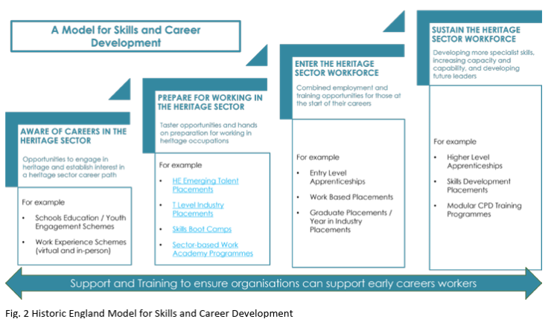
Figure 5: Historic England Model for Skills and Career Development. Source: HESCAPE report, HE.
HE has developed a tiered model for work-based learning for the sector. The model can be applied to various parts of the sector, from building skills to archaeology, architecture and historic environment advice. The broad model is designed to be adaptable, which means it can respond to emerging policy areas, new skills needs, or regional training requirements, ensuring local skills provision meets local needs. It focuses on segmented entry points, which could be defined by age or experience, that interconnect with the working journey in the heritage sector. This highlights the need to work across the sector to create new opportunities for entry. Its tiered approach is easily aligned to the range of initiatives developed through government skills policies and can be used to promote effective use of these in historic environment occupations.

The design of the model focuses specifically on work-based training (informed by research by the Centre for Economics and Business Research which noted this approach would best alleviate sector skills gaps).

The report includes 5 strategic objectives that identify key pathways to future strategic Heritage Skills Training initiatives. Not all of these align with the needs of skills for construction and conservation but they all provide interconnections to Heritage Skills.

SO1 | Develop and enable a broader range of pathways into historic environment roles.
SO2 | Reduce the barriers to cohesive career progression that currently exist for historic environment roles.
SO3 | Improve the perception of and recognition of historic environment roles; including addressing issues such as limited levels of qualification and accreditation in some areas, and perceptions of elitism in others.
SO4 | Invest in building the capacity and capability of sector employer organisations to deliver work-based training.
SO5 | Support the development of capacity and capability building initiatives for formal training providers to enable them to better deliver the knowledge and skills employers need from their current and future workforce.

Table 2: Strategic Objectives in HECAPE identifying pathways to skills training initiatives.
HESCAPE SKILLS AREAS SUMMARY
Skills Area 1: Skills for Retrofit (Climate Change Adaptation). With 20% of residential homes being historic ones, retrofit aligns with national agendas like the Warm Homes strategy. It has been estimated that an additional 86,500 workers will be needed each year up until 2050 to retrofit England’s traditionally constructed buildings, in order to meet UK net zero targets.
Skills Area 2: Traditional Skills in Plastering and Carpentry/Joinery. The 2024 Skills Needs Analysis indicates organisations are experiencing the largest national skills shortages in carpentry, joinery and plastering. Just under a third of organisations report skills gaps in carpentry and joinery and around a third of organisations have not been able to find appropriate skills training in plastering. One fifth of organisations have had to turn down plastering and carpentry/joinery work due to lack of available skills.
Skills Area 3: Post-excavation Specialist Skills (Archaeology) - not specific to construction skills
Skills Area 4: Industrial Heritage Conservation Skills. Skills that relate to the conservation of metals, engineering and mechanical objects are in particular demand in this area, and are specific to a sub-set of works on built heritage sites.
Skills Area 5: Skills to Manage Change to the Historic Environment. Conservation Professionals, including Conservation Officers and Heritage Managers, are listed on the UK Skills Worker Visa list of eligible occupations, demonstrating a demand for such roles that is not being easily met by the existing labour market. Other areas, such as those identified through the Heritage Crafts Red List of Endangered Crafts (e.g. Vernacular and local traditions like flint and brick working), are not listed in HESCAPE.
Strategic areas 1,2 and 5 align stronger with the initial phases of engagement and skill types at WW as we will also explain later.
The report highlights the following nationwide priority actions;
Priority Actions 1: Develop the evidence base: Focus on regional skills needs
Priority Action 2: Upskill the UK retrofit workforce to work appropriately with historic buildings. Clarify the interrelationship between retrofit and core traditional building skills.
Priority Action 3: Identify and obtain resources to provide opportunities for career-entry training roles (inc. career changers)
Priority Action 4: (Shared Apprenticeships) will also contribute to this Action, but apprenticeships development should not be the single activity undertaken [This should incorporate vocational training beyond apprenticeships to reach the targets due to limited number of apprenticeships standards]
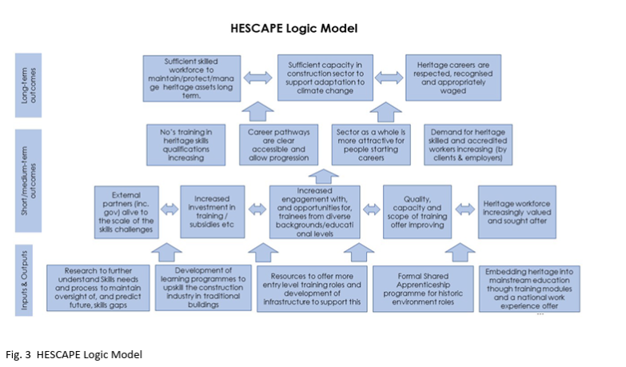
Figure 6: HESCAPE logic model, Source: HESCAPE report, HE.
One of the key recommendations of the HESCAPE was the development of Regional Heritage Skills Networks (RHSN) to support the delivery of the skills training and ensure relevance to the regional needs.
In relation to Strategic Priority Area 1 (green and retrofit skills), we recognise the national significance of the area but also its integrated nature with wider traditional building construction, maintenance and management skills. For this reason, an additional outline is provided for this area summarising key reports on Green skills development for the sector.

Retrofit Considerations in Mainstream Construction
As national awareness of the importance of retrofitting the built environment has grown, so too has recognition of the specialist skills required to deliver it effectively. Retrofit is now widely acknowledged as a key component of the Repair, Maintenance, and Improvement (RMI) segment of the construction industry - a segment that also encompasses the specialist heritage skills needed to care for and adapt the UK’s vast stock of pre-1919 buildings.
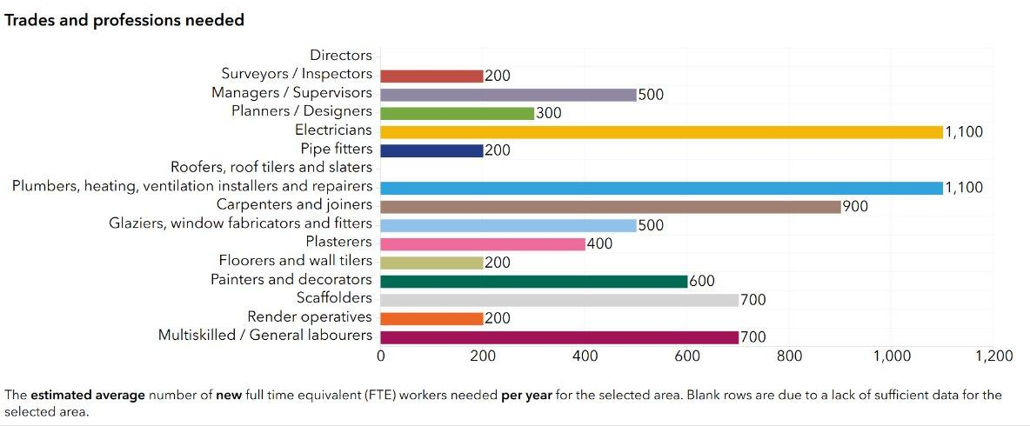
Graph 1: Historic England’s Carbon Dashboard Skills Need Demand Summary for Yorkshire region. While retrofit is only a section of the overall workforce required, the graph shows the significant demand in numbers, with Electricians, Plumbers and Joiners forming the highest demand categories. South Yorkshire Estimated Workers Needed account for 22.7% of total needed in Yorks & Humber. (Source: Historic England’s Carbon Dashboard Skills Need Demand Dashboard)
Defined as “improvement work on an existing building to improve its energy performance and reduce carbon emissions,” retrofit can range from upgrading building fabric and fitting insulation to installing renewable energy systems. Yet, the successful delivery of retrofit, particularly in traditionally constructed buildings, depends on a nuanced understanding of materials, methods, and building physics that is often absent from mainstream construction training.
Despite its growing relevance, retrofit remains a specialist area within construction, with relevance to fabric upgrades, solid wall, roof, and floor insulation. Policy efforts have yet to deliver the scale of activity needed to meet climate goals, and retrofit training is not yet embedded within mainstream apprenticeships or National Technical Vocational Educational Training (TVET) provision. This is in contrast to core trades such as bricklaying, roofing, plumbing, and electrics.
Further context for the complex interrelationship between heritage skills and retrofit, and estimated skills shortages, see the graph above and relevant sections of the Appendices..
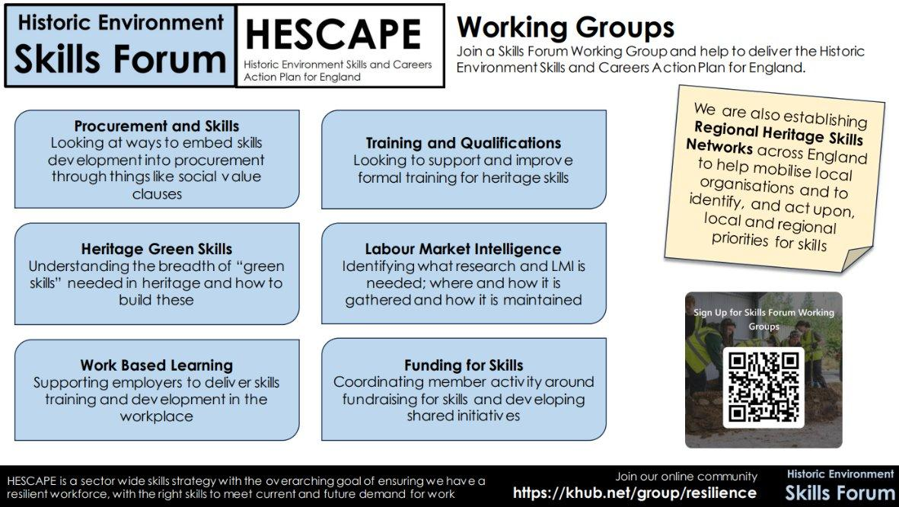
Figure 7: Historic environment Skills forum and HESCAPE working groups with commitment to RHSNs development. Source: HESF
3.6 Factors influencing the fractured heritage skills landscape are multifaceted
The context here provides an understanding of the key challenges limiting the impact of current engagement with heritage skills:
1- Training Provision Limitations
Formal education training providers and independent/alternative training providers both have important roles to play in developing a more diverse and holistic skills landscape. At present, engagement with seasoned specialists across many core trades, nationwide, has confirmed a general acknowledgement that the quality of offers varies, with considerable misalignment of qualifications and standards with the practical skills needed by craftspeople to deliver on the ground. This has also been repeatedly flagged in National Heritage Skills roundtables held over the last few years, including those linked to the HE SSNA, CITB Sector Skills Plan, RHSN, HESF Working Groups and other groups.
It is also acknowledged that large numbers of those completing full time vocational training courses in trades (at Level 1 and 2), including Bricklaying, Roofing, Carpentry etc, fail to secure roles in industry once they have completed their training. This points to significant misalignment between the pool of potential future workers, and recruitment and retention in early career roles. These findings apply to both full time college training programmes and apprenticeships.
2- A Fractured Funding model
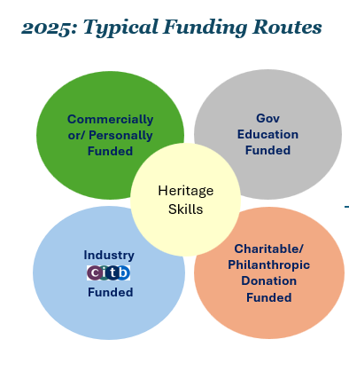
The infographic below shows that funding for Heritage Skills training has commonly straddled four potential funding pathways.

Figure 8: Typical funding routes for heritage skills training, including commercial and industry funding as well as philanthropy and government routes open to skills training. Source (NDF)
Summary: Four Core Thematic Funding Routes for Heritage Skills Training
Heritage skills training has historically been supported through funding mechanisms which can be grouped into four thematic categories:
A. Commercial or Personal Funding Pathways
Commercial Projects: Training is embedded as part of a social value commitment or skills development requirement within a larger construction or conservation contract, including Section 106 Planning Commitments which require the developer to mitigate the impact of a development through financial contributions or other obligations.
Personal Investment: Individuals self-fund their participation in heritage skills courses, often driven by casual interest or personal career development.
B. Government Education Funded Education Pathways
Delivered through formal Government education pathways, including:
Secondary Education, Further Education
Adult and lifelong learning
Skills and training budgets
Such funding may come from central or devolved government education departments, often aligned with broader workforce development or cultural education goals.
C. Industry Levy Funding (CITB)
Funded via the Construction Industry Training Board (CITB) levy, which collects contributions from CITB registered construction employers to support the sector in developing the skills needed for the future. CITB Scope Order Charities are presently excluded from being registered with CITB, as eligible contractors are required to have over 50% of their employees’ total time spent on construction work.
CITB Heritage Skills Specific Training Pathways are currently very limited and represent a very small segment of CITB investment in Heritage Skills.
Specific funded courses are, however, available via:
CITB’s Specialist Applied Skills Programme (SAP), which is a supported pathway towards NVQ qualifications in Level 3 Heritage Craft Trades, including Level 3 validated through On-Site Assessment and Training (OSAT), which is currently funded up to 2027. Live Training Pathways include Level 3:
Heritage Metal Roofing/Lead
Heritage Roof Slating & Tiling
Heritage Solid Plastering
Heritage Mason/Stone Masonry
Heritage Wood Occupations
N.B: Heritage Brickwork was formerly taught under SAPS pre 2022.
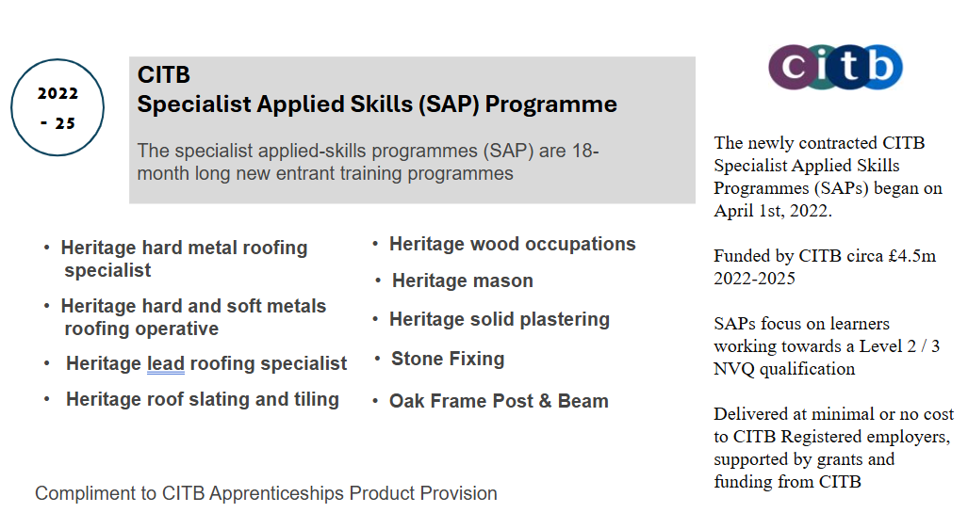
Figure 9: CITB specialist applied skills (SAP) programme explained. Source of information: https://myportal.citb.co.uk/
CITB Approved Qualifications, which can be one year or longer and attract grant funding.
These include HNCs, HNDs, Degrees and Post-graduate certifications. delivered by CITB Approved Training Organisations (ATOs) or Training Provider Network (TPN) members. Courses are listed on the CITB Construction Training Directory: https://myportal.citb.co.uk/ and the long period qualifications eligible for a grant - CITB. This includes funding provision for a range of courses, including the Cathedral Works Fellowship Foundation Degree in Heritage Skills
Previously the CITB collaborated more meaningfully with bodies like Historic England, Cadw, and Historic Environment Scotland, and funded an organisation known as the National Heritage Training Group (NHTG), which was founded in 2003 but subsequently de-funded in 2013. A Heritage Skills Strategic Partnership Agreement was signed in 2017, to run up to 2019 (Historic England, 2017). Since then, there have been few direct, collaboratively funded initiatives to support heritage skills. The current CITB Heritage and Traditional Building Sector Skills Plan, which forms part of the wider Skills Plan for Repair Maintenance and Improvement, however, shows significant potential and includes dedicated grant funding to support more collaborative working.
D. Charitable and Philanthropic Funding
Includes support from:
Charitable Trusts e.g. National Lottery Heritage Fund (NLHF), Architectural Heritage Fund (AHF), Swire Charitable Trust
Foundations e.g. The King’s Foundation,The Hamish Ogston Foundation (2019-2023), the Vinehill Trust (who actively support innovative programmes delivered in Scotland by Historic Environment Scotland), and the Commonwealth Heritage Forum.
Individual Donors: often used to fund bespoke programmes, community engagement, or pilot initiatives where other funding is unavailable or insufficient.
3- Aligning skills and employment
The skills funding model differs from the employment model, leading to a construction sector employment mode which is not fit for purpose. Crucially, it does not meet the needs of Small and Medium Sized Enterprises (SMEs), which constitute the majority (99%) of construction sector private companies and which will have a critical role to play in developing national skills resilience. A shift to integrate the needs and capabilities of smaller contractors and craftsmen could support skills training at a larger scale. However, the ability to deliver such change will depend significantly on raising national awareness of the needs of SME training providers, particularly in relation to the requirements that should be reflected in procurement exercises, from schemes involving Tier 1 large-scale contractors through to those covering the full range of heritage skills contractors.
4- Differential government accountabilities over many years
The funding landscape for heritage skills training has long been shaped by structural divisions between government departments, resulting in a fragmented and siloed approach to support and delivery. This disjointedness has had lasting implications for how heritage craft skills are recognised, funded, and sustained across the UK.
In 1964, the Construction Industry Training Board (CITB) was established to address skills shortages in the UK Construction industry in response to the Industrial Training Act. Since then, the organisation has mainly been sponsored by the Department for Education, with a remit to support skills development across the construction sector. At the time the CITB was first established, heritage skills were still actively practised and organically passed via generations of craftspeople within government-sponsored bodies such as English Heritage, Historic Royal Palaces, and others, many of which maintained their own in-house craft teams. These teams operated across a network of over 400 sites in public stewardship, forming part of the National Heritage Collection. This created a natural, cyclical flow of heritage skills at local and regional levels and ensured that skills transfer was centrally supported.
Accordingly, when the CITB was formed, it introduced a regulatory framework known as the Scope Order, which defined the boundaries of its funding and operational remit. Crucially, many heritage organisations and institutions were explicitly excluded from this scope, including charities and cathedrals. More specifically a range of specialist heritage craft skills, such as thatching and fibrous plasterwork, were not recognised within the mainstream construction training framework at all and continue to sit outside CITB criteria.
As a result, heritage craft skills have historically sat outside the core funding mechanisms of the construction industry, despite being integral to its broader ecosystem. This has created a persistent dichotomy: while heritage construction contributes an estimated £15 billion annually to the UK economy, the specialist skills that underpin this sector do not benefit from a dedicated funding stream within the CITB.
This misalignment between departmental responsibilities, particularly between the Department for Education (now transferred to Department for Work and Pensions) and the Department for Culture, Media and Sport (DCMS), has led to a situation where heritage skills are clearly within the cultural remit, yet lack the structural support afforded to mainstream construction skills. The result is a systemic underinvestment in heritage-specific training, despite its economic significance and cultural value.
DCMS‘s focus lies in sector-specific support for culture, heritage, museums, libraries and the creative industries, delivered mostly as grants, capital funding, sector programmes and targeted skills initiatives run through arms-length bodies like Historic England, The National Lottery Heritage Fund, or Arts Council England.
The integration of skills within capital projects suggests that DCMS funding for heritage sector programmes and targeted grants would allow a percentage for this, but this is not always made clear in initial budget setting, affecting wider skills training at scale.
It is also relevant to note that the DfE has held a broad remit over the national skills architecture for decades, including responsibility for formal state education, adult skills funding (ESFA / Adult Skills Fund), the apprenticeships system (funding rules, levy, non-levy procurement and standards), as well as the funding rates and allocations provided to colleges and training providers.
Specific to Heritage Construction Skills
As part of a government re-organisation in 2025, DfE transferred the entire skills remit for over-16s to the Department for Work and Pensions. This included transferring the recently created Skills England. It is also proposed to significantly devolve adult education skills funding allocations through both the existing Strategic Mayoral Authorities and the establishment of more in waves over the next few years.
Charities/Trusts (including organisations like Heritage Crafts, QEST, etc.) also provide bursaries and fellowships to support craft training and placements. Whilst some funding for such initiatives flows DCMS or NLHF, a high percentage of such engagement nationally over recent years has been funded through charity investments or through grants made to charities by Trusts and independent Philanthropists.
Combined and blended funding would provide for the cover of training costs, for example via DfE funds for delivery of accredited learning or apprenticeship frameworks.

Regional differences in skills and gaps
Accepting that practices differ between regions also makes the development and employment of networks critical. The GVA data, for example, supports that the economic potential of heritage conservation differs between regions
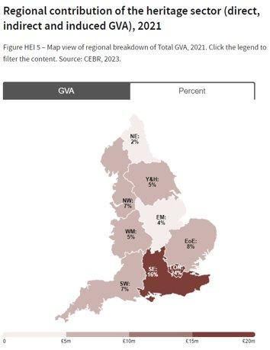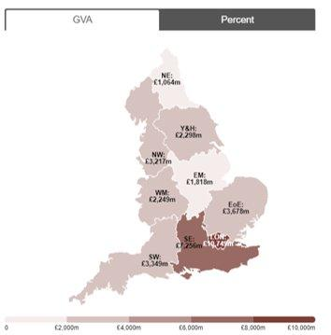
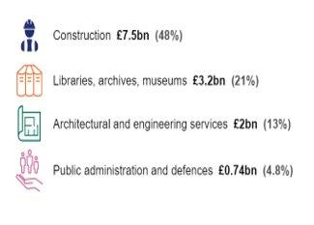
Figure 10: G.V.A – Nuanced £ breakdowns per region (Source of graphs: Historic England/The Case for RHSN Grass Roots Engagement)
There are regional characteristics that affect regional skills economies. For example, Flint working is only relevant in the east of England but represents a significant percentage of local Heritage Skills in need, according to the CITB’s construction workforce outlook for England.
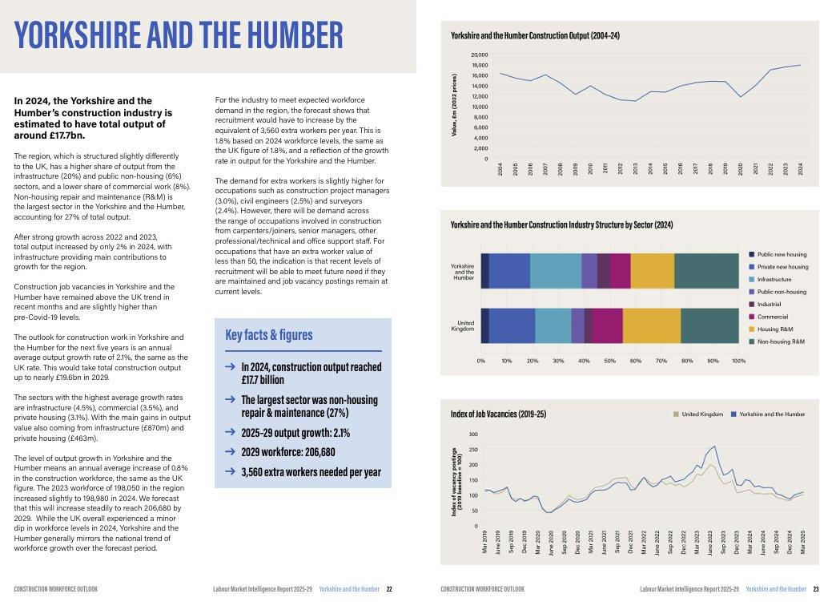
Figure 11.CITB’s CWO for England - Graphs for Yorkshire and Humber showing how construction output for the region has been on a growth curve since 2013 onwards and makes a significant contribution to non-housing as well as repair and maintenance across the region. (Source CITB, CWO for England)
5- No centralised and longitudinal infrastructure for advocacy
The fractured landscape described above, shaped by the complexities of skills funding, the links between skills, training and employment, and the regional specificities of the skill types in focus, highlights the need for strong advocacy for skills and for a bespoke infrastructure to support them. Such an infrastructure can drive change within the sector, facilitate learning, and promote the sharing of knowledge among regional actors who are innovating in different ways. Most importantly, it can strengthen networking between heritage, craft, SMEs and construction-sector stakeholders, enabling the development of new large-scale models for skills training.
Throughout 2025, the APPG for Craft and its members have expanded their advocacy efforts relating specifically to Heritage Skills. In parallel, the national charity Heritage Crafts is taking on an ambassadorial role, working collaboratively with the Historic Environment Skills Forum, as well as with key actors such as the City & Guilds Foundation, SPAB and others. This was confirmed through roundtable workshop discussions held in Norfolk and through the resulting (unpublished) report produced by HE and EH, in which the main author participated.
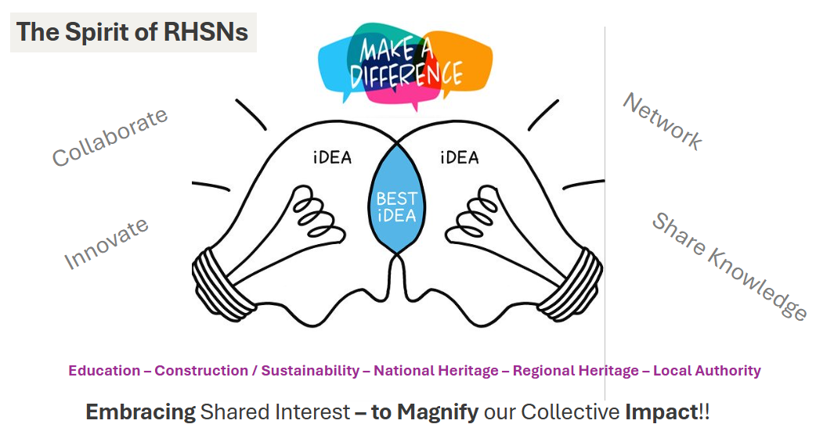
Figure 12: The spirit of RHSNs: collaboration, innovation, networking and knowledge sharing as main functions of the networks, linking ideas to actors (Source, Author NDF)

4.0 Appraisal of Sector Skills Interventions – Strategic Implications for Wentworth Woodhouse
This section assesses recent heritage skills training initiatives to identify structural strengths, delivery risks and lessons relevant to the proposed Wentworth Woodhouse model.
This section outlines current sector-wide heritage skills training responses and provides an assessment of their limitations, drawing on a range of initiatives and project models relevant to the development of heritage skills training at Wentworth Woodhouse.

4.1 Case study 1 - Historic England Heritage Skills Programme

The Heritage Building Skills Programme is a major five-year in-work training and apprenticeships programme in the North of England, running from 2021 to 2026. It aims to:
Reduce shortages in heritage craft skills
Improve the condition of Heritage at Risk (HAR) sites
Create viable career opportunities for people from diverse backgrounds
It was designed to provide:
A three-tiered training scheme for craftspeople to gain direct experience at critical points in their careers
On-site training with expert teams at some of the country’s most valuable historic buildings and places, identified by Historic England as ‘at risk’ and in need of rescue.
Impact and scale
The Heritage Building Skills Programme has created 44 opportunities for apprentices and trainees, hosted by heritage construction firms, in trades including plastering, bricklaying, roofing, carpentry, stained glass, and stonemasonry. While the programme will not be completed until 2026, 33 apprentices and trainees have graduated as of February 2025.
Strategic implication
The programme has been comprehensively evaluated, although this has not been published). Key learning from this model include:
Intensive to manage and coordinate if not managed by apprenticeship or training agency
Legacy for what happens next for trainees is not clear, despite an outcome-focused approach.
Links to complex projects were harder to coordinate (e.g. managing side effects on capital project delivery.) Smaller, discrete projects were more manageable and better connected to contractors.
Qualification pathways chosen for training (e.g. apprenticeships) were not ideal to the development of needed skills, as there were mismatches with the actual skills required.

4.2. Case study 2 - York Minster Centre of Excellence for Heritage Craft Skills and Estates Management

The remarkable, £9m investment in the development of a Centre of Excellence at York Minster (which was also a member of the Cathedral Works Fellowship Programme) offers significant learning for the shaping of a heritage skills hub and the network of actors around it.
Impact and scale
Many cathedrals across the country have established their own Works Departments, housing a range of craftspeople carrying out essential conservation and repair work. Since 2006, the Cathedrals’ Works Fellowship (CWF) has brought fourteen Anglican cathedrals together, including Westminster Abbey, Canterbury, St Paul’s, and York Minster, as members of the fellowship. All share a commitment to preserving traditional craftsmanship and developing the skills necessary to maintain the national treasures under their care.
Developing new skills hub
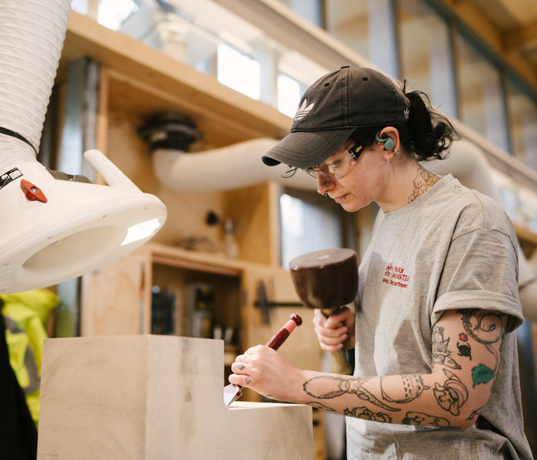
The New Heritage Quad at York Minster has received national and international acclaim for its commitment to Heritage Skills. Facilities are provided for scaffolders and gardeners but the site also offers dedicated residential accommodation (six bedrooms around a shared kitchen and lounge) for the Minster’s first and second-year apprentices, as well as international exchange visitors and trainees. The Commonwealth Heritage Forum has recently announced an exchange programme with York Minster. The Works and Technology hub, which boasts cutting edge technology, has now been completed at Deansgate and has significant free capacity to support wider commercial stonework across Yorkshire and the wider country.

Innovation & skills recognition.
In response to the missing skills in the sector, the Cathedrals’ Workshop Fellowship has developed a Foundation Certificate (FCert) in Stonemasonry, validated by the University of Gloucestershire and available to their cathedral members. This certificate will allow stonemasons to attain a qualification equivalent to an A-Level in Stonemasonry, advancing their skills and experience while allowing them to continue their employment. York Minster also maintains strong partnerships with other leading international cathedrals, including Washington, Cologne, Milan, Pisa and Trondheim, and intends to initiate valuable reciprocal visits and training placements across the organisations, to promote global knowledge sharing of the work centred at York Minster. York College, one of only four national colleges that still run Stonemasonry Courses, also plays an important role in the educational training pathways of York Minster’s masons.
Strategic implications
This model is functioning well, mainly thanks to the beacon leadership role of York, and but is designed to be sector specific and tackle the funding models and specific skills needs of Cathedrals, thus has limited replicability. However, the lessons learned about the impact of creating a national beacon for specific types of skills is important. Most funding for the York Centre for Excellence initiative was awarded directly from the York Minster Fund, which has been raising vital funds for the conservation of the Minster since 1967.

4.3 Case study 3 - Lincoln Heritage Skills Centre

The National Lottery Heritage Fund awarded over £12 million to Lincoln Castle for the "Lincoln Castle Revealed" project supported by the European Regional Development Fund, Lincolnshire County Council, and the East Midlands Development Agency.
Impact and scale
The project included a major restoration and the creation of a new Heritage Skills Centre. It helped provide training in traditional crafts (joinery, stonemasonry) and served as a sustainable architectural showcase. The project was the first living example of modern timber construction, including the use of offsite prefabrication, and also one of the first new buildings within the castle grounds in over a century. The Centre currently offers a Conservation in Action programme for panels of Victorian stained glass. Found on site during the Lincoln Castle Revealed project, the panels have been carefully cleaned using conservation ‘dry’ methods.
Strategic implications
The major challenge for the initiative has been that although it continued as a local authority run centre for heritage skills activity in Lincolnshire for some time, there is little evidence of any links to local businesses and the construction sector which might suggest that its impact on the heritage skills of the local workforce has been sustained.

4.4 Case study 4 - Weald and Downlands Museum (West Dean College)

Weald and Downlands Museum at West Dean College in Sussex is a site with 50 relocated historic houses covering a 40 acre site. The museum enables links with rural history and the College offers accredited courses at diverse levels, including extensive programmes of day-schools and longer courses in Historic Building Conservation and Traditional Rural Trades and Crafts, along with a series of evening talks on a range of lively topics. The Museum offers two Master’s Degree programmes in Building Conservation and Timber Building Conservation endorsed by the University of York (see below SHT linked into this partnership).
To support Skills Training Excellence within its internal craft team and to allow for training in craft excellence to be nationally disseminated, English Heritage formerly operated a Heritage Skills Training Centre from Fort Brockhurst (Fort B), a historic Palmerston fort in Gosport, Hampshire. The scheme was nationally and internationally acclaimed for the quality of its training, in both the technical knowledge and practical skills needed to maintain heritage (pre-1919) buildings. The training centre also incorporated a ‘ruinette’ where trainees could practice skills linked to the conservation of complex heritage masonry structures. It was from Fort B that a series of English Heritage Masterclasses in Building Conservation were first established, spanning specialisms that included Stone and Slate Roofing, Tile Roofing, Stone Masonry, Brick and Flint Masonry, Plasters and Renders and Metalwork. The Closure of the Fort B National Training Centre coincided with the dissolution of English Heritage’s direct craft team in the late 1990s under the leadership of Sir Jocelyn Stevens. This decision is now understood to have had far reaching consequences, notably the stalling of the inter-generational transmission of skills that the EH training model had enabled since the 1940s. Fortunately West Dean College acquired the ruinette and other teaching materials and continues to offer Historic England-accredited masterclass programmes offering specialist construction training with a local and limited national reach.
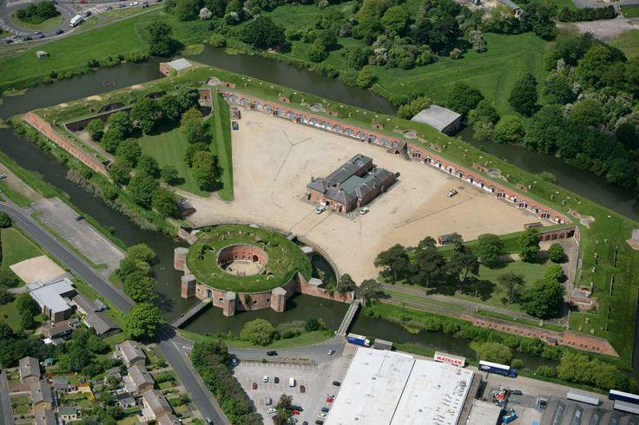
English Heritage former Craft Training Centre at Fort Brockhurst)
Lessons learned: The existence of a National Centre of Excellence for Traditional Skills at Fort B provided a national backbone to heritage-specific skills training in England, similar to the training supported in Scotland by Historic Environment Scotland, where intergenerational and cross governmental commitments to craft advocacy have been consistently sustained.
In England, CITB’s National Construction College at Bircham Newton,which was established to provide skills training in construction specialisms that face market failure in training provision (though not currently focused on heritage skills), offers another example of the importance of having a national centre with residential accommodation to support large-scale training.
EH’s decision to close the Direct Craft teams at Fort B in the 1990s has undoubtedly stalled the inter-generational transmission of skills that the EH training model had enabled since the 1940s. 30 years on, this short-sighted change has resulted in the deteriorating condition of EH monuments, a desperate need for expert skills once more, and proposals for the reinstatement of a craft team supported by a £11.2m grant from the Hamish Ogston Foundation. This scheme, however, failed to progress after the EH board handed back the grant, dissolved the programme, and made associated staff roles redundant, citing an irreconcilable issue with the funder.

4.5 Case study 5 - Sussex Heritage Trust (SHT)

Supported by an NLHF grant of over £207,000, SHT began with a pilot in 2024. The initiative introduces students from across Sussex to heritage skills through immersive Taster Days at the Weald & Downland Living Museum, followed by short-course bursaries in crafts such as timber repair, lime plastering, brickmaking, and thatching in collaboration with partners like the Chichester College group.
Wider bursaries focus on Building Conservation techniques, supported by West Dean College or South Coast Roof Training. SHT also has a long-established partnership with the University of York’s Department of Archaeology to offer two world-class MSc programmes in Building Conservation and Timber Building Conservation.
Additional work with endangered heritage crafts led to the Sussex Endangered Crafts Fund which is ringfenced for projects in Sussex, so applicants will only be competing for funds with projects in the counties of East and West Sussex and Brighton and Hove, not with projects elsewhere in the UK. There will be a maximum of £2,000 available for each project and the Heritage Crafts Association will work with applicants to develop and support their work.
Impact
Thanks to this new funding, the pilot project is expanding its reach to hundreds more students, offering practical skills training, bursaries, and direct pathways to work experience with employers. The development and support by a regional network of partners in education and construction, and outreach to identify local community youth needs, has led to significant impacts.
Strategic implication
The programme harnesses the experience of years of work by the SHT to link a significant number of regional and local partners, whilst seeking financial support through national programmes.
Offers relevant educational opportunities in the conservation building and construction industry for young people based in Sussex
Focuses on those seeking to retrain, people under 25 and those in financial hardship
Synergies with local needs by highlighting, surveying and reporting on Buildings at Risk
Read more:
https://sussexheritagetrust.org.uk/bursary-scheme
https://sussexheritagetrust.org.uk/endangered-crafts-fund
https://southcoastrooftraining.co.uk/ (foundation and NVQ level 2 training)
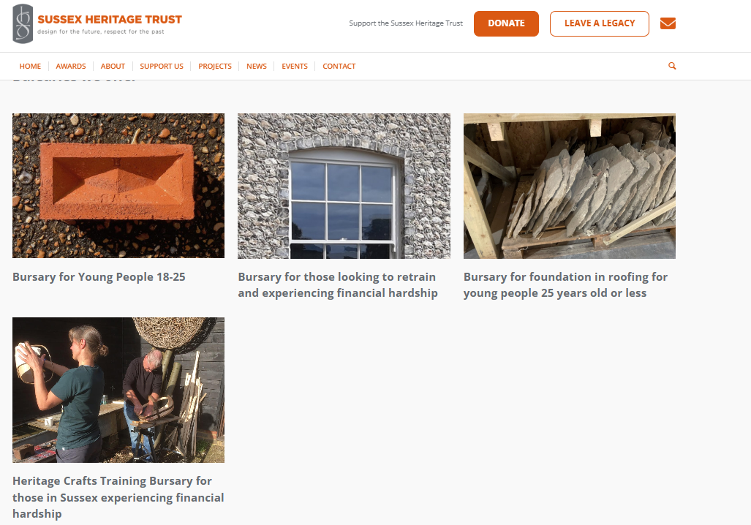

4.6 Case study 6 - Bury St Edmonds Town Trust (BTT): West Suffolk College Training Partnership

The first allied craft skill course of its kind in the country to be integrated formally into accredited training pathways through an MOU, focused on Construction and Conservation in the Built Environment Course, since 2012 it has offered training on historic building conservation for construction students at the West Suffolk College. The College runs an annual free Building Conservation Training Course, which includes practical construction elements. It was funded through community sponsorship, and integrates with existing BTT Conservation Projects and works to Bury St Edmunds Abbey, working in partnership with English Heritage. For some years the Trust provided a free lecture course covering the main historic building trades for selected students at BTEC 2 & 3 levels. In 2018, it decided to change from lectures to practical training for construction students as this was found to be of more use and interest to them. The Trust arranges and part-sponsors each year‘s programme. In 2024-25, for the first time, the course comprised two elements: Practical Trade Training and the Construction of a Prototype of Design (PoD), a complete miniature neo-medieval timber framed structure.
Audience: The course is being taken by Levels 1 & 2 Brickwork, Carpentry & Joinery, Painting & Decorating, Construction Crafts Year 1 students, and T Level Construction Design & Planning at the College. Selected trade groups of students will attend Tours of Bury St Edmunds and Lavenham, and the Holkham visit. The remaining training days will be allocated to students for whom the trade training directly relates, e.g. bricklayers to bricklaying.
Impact
This offer integrates conservation and traditional skills training advocacy and practical activities into core FE construction education provision. It was supported by partnerships, including with both West Suffolk and Bury St Edmunds Town Councils and other organisations such as the Bury St Edmunds Society.
No other similar level course provides mandatory conservation training as part of its standard trade teaching – normally students must opt for the specialisation. In Bury St Edmunds, for example there are more than 6,000 pre-1919 historic buildings and the programme provides an excellent opportunity for employment in the sector at the start of people’s careers. https://burystedmundstowntrust.org.uk/education/

Innovation and lessons learnt
Blended funding is possible, in this case the programme was funded through community sponsorship and supported by EH and WSC English Heritage Skills Training Partnership. Sponsorship from lime plastering and materials companies and the Lund Trust also supported the programme.
Tackling both education enrichment and construction skills development: This was administered as an annual programme, under the ‘enrichment’ stream for Construction and T-Level students a WSC.
OPPORTUNITY TO ENGAGE with CTEC for LEVEL 3 awards
On 12th Aug 2025 West Suffolk College was named as one of the ten Construction Technical Excellence Colleges (CTEC) in England that would benefit from a £100m additional Government investment to support the construction sector to train 40,000 additional construction workers needed to deliver the Government commitment to build 1.5m homes through its Plan for Change.
In the context of CTEC, vast potential therefore exists for WSC to model the benefits of their BCTC Mainstream Construction Enrichment Programme Model (delivered successfully for the last 11 years) to a national audience in a structured way that could contribute strategically to accelerated upscaling of the programme. Initially this would take place through an envisioned roll-out to the nine other CTEC colleges, with the potential to roll it out nationally in the longer term as a specialist module for state and independent mainstream construction training providers, which would significantly boost career opportunities for students to engage in specialist work and retrofit work of pre-1919 building stock.
Aligned to this – opportunities are being explored for those that complete the additional BCTC Modules to gain additional accredited academic credits through award of the ‘NOCN Level 3 Award in Understanding the Repair and Maintenance of pre-1919 Buildings’ and/or the ‘NOCN Level 3 Award in Energy Efficiency for Older and Traditional Buildings’, depending on the path of their core studies.

4.7 Case study 7 - Landmark Trust – Sector-based Work Academy Programme (SWAP)

A SWAP was integrated into a National Lottery Heritage Fund supported restoration of Calverley Old Hall by the Landmark Trust, where training and engagement activities formed a key element and aimed to diversify audiences. Taster days in May 2022 to recruit for the SWAP engaged speakers and tutors representing stone masonry, joinery, lime plastering, lime slaking and blacksmithing and including hands-on activities where possible.
Partnerships were key. Leeds College held apprenticeship places for candidates, with Dobson Construction offering apprenticeships as part of a contractual agreement within the wider works at Calverley Old Hall. Recruitment support for the SWAP and taster days was provided by a range of partners, including the DWP, Migration Yorkshire, the Refugee Council, and Canopy Housing.
Impact and scale
SWAP - 6 weeks summer programme, with 14 participants of which 11 were full-time.
- Six tutors each deliver mini courses, including off-site visits.
- Two apprenticeships offered with a SWAP partner, covering joinery, and brickwork/stonework, with two in reserve for apprenticeship positions
- Further career advice and training, jobs and apprenticeship opportunities were shared, and referrals made to other local companies.
- Programme enrichment partners included Bradford Museums & Galleries, Rushbond PLC, Yorkshire Water, Leeds City Council, North Yorkshire Youth.
Strategic implications
- Duration: six weeks is too long - three or four would be better
- There should be clearer communication with tutors around expectations and audience’s prior knowledge
- There is interest!
- There needs to be long-term evaluation and proper support for participants after the programme is otherwise finished
- Partnerships provided recruitment and training for people from broad backgrounds, ages and abilities.

4.8 Case study 8 - Petroc College Heritage Bootcamp

With funding from Devon County Council, Petroc (a higher and further education college) developed and delivered two heritage skills bootcamps from 2024 to 2025 in partnership with North Devon Council. The County Council is doing significant work with the UK Shared Prosperity Fund and the bootcamp was integrated in their portfolio of activities within that strand of funding.
Skills Bootcamps are *free, flexible courses of up to 12 weeks (usually one day a week), which give people the opportunity to build up sector-specific skills and fast-track to an interview with an employer. These courses are fully funded and are free for learners, subject to eligibility. They are part of the Government’s Lifetime Skills Guarantee.
Petroc are experienced with the bootcamp model for other sectors and used this to deliver heritage construction skills. The course was led by a local stone mason who had knowledge of drystone walling and lime. They were supported by a joinery course leader from Petroc who had expertise in traditional building skills.
Audience: Eligibility for the funded bootcamps was very broad to all adults within Devon, Plymouth, Torbay or Cornwall, employed or unemployed, or an adult returning to work after a break.
Partnerships: National Trust Arlington Court provided a venue for training and hosted open days and taster sessions for the course.

Strategic implication
- The programme was one of the few funded by the Government, as it aligned with levelling up funding pledges for place prosperity
- The biggest difficulty faced by the team was providing the required interview for further training or employment at the end of the bootcamp, as it was difficult to engage with possible employers.
- Audience: The audiences who engaged with the course were mainly local property owners rather than career starters, although architects looking to expand their knowledge of heritage building skills did take part.
- Duration: Feedback from the local construction sector suggested that the commitment of 1-day/week over 10-12 weeks was not feasible alongside regular work on site.
It is, however, notable that the Petroc Model does not specifically include a module contextualising the relevance of specific specialist approaches to the repair and maintenance of Buildings of Pre-1919 traditional construction. Such an addition to this course would have ensured a more holistic curriculum.
See more: https://www.petroc.ac.uk/courses/detail/construction-multiskills-skills-bootcamp-2/

4. 9 Case study 9 - CITB National Construction College (NCC), a comparator from mainstream construction

CITB-led in Bircham Newton Norfolk, the college was established to respond to market failure for courses in the construction sector. However, CITB has yet to engage with heritage skills. It offers a model for addressing the lack of skills in the construction sector, which could be expanded to the wider heritage skills landscape, and would be well placed to provide a NATIONAL centre linked to Regional Centres coordinated through regional level activity.

Impact and scale
With over 11,000 learners trained last year, covering courses from one-day health and safety training to three-year apprenticeships, the programme is one of the largest in the country. It offers over 100 open courses for the construction industry at all levels from apprentice to director.
This presents a significant opportunity for Wentworth Woodhouse to engage by linking programmes such as the CITB SAP Programme (currently run separately from the CITB National Construction College) to the needs of heritage skills training. Doing so would align established funding and pipeline structures with strong connections to construction-sector actors.
NCC benefits from a large-scale training infrastructure, with residential on-site facilities, gym, and workshop spaces as well as teaching rooms. The potential for the NCC to partner on delivery of Heritage Skills specific training courses is considered significant. Logically, the current CITB SAP Pathway (mentioned earlier) provides a pathway that could be upscaled in the context of the NCC, by working in partnership with a series of specialist trainers that are qualified nationally and who currently deliver independent training on Heritage Skills.
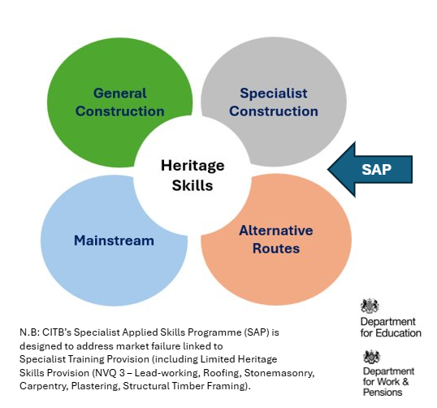
Figure 13: SAP integration in heritage skills landscape linking specialist construction with mainstream models & relevance for WW skills strategy.
Strategic implications
Wider benefits include its long term/permanent mainstream construction skills which influences a wider market segment.

4.10 Case study assessment conclusion

Factors reported as commonly inhibiting the success and sustainability of those initiatives and models:
- Project based (time-limited) funding
- Short-term planning and financial resources devoted to single-funded projects
- Failure to integrate within industry in the region and form an effective bridge between specialist heritage skills and mainstream constructure
- Failure to align with existing education pathways (Eg FE, HE)
- Limited contribution to increase local/regional infrastructure (e.g. Legacy and convening, galvanizing action locally)
Community-embeddedness (e.g. civic trusts, societies driving local input and sustained impact and integration in regions across the medium to long term). For any of those models, some commonly observable factors can be listed as contributing to the success of the models
- Connection to portfolio of sites, for duration of programme and beyond
- Network: the national to regional connection is significant for sustaining ever -changing needs and funding opportunities.
- Additional levers of change and success would include the presence of Regional Beacons: those would attach and link into National Technical Excellence Colleges (NTECs) founded as part of house building national mission e.g. Leeds College of Building and West Suffolk College, Bury St Edmunds.
- A Partnership model: Connecting with local heritage skills organisations, networks and professionals can be helpful to develop partnerships and share valuable lessons relevant to heritage skills training provision in the area.
Some examples of realising this include networks that span one-interest area of stakeholders, expanding to:
- Regional Heritage Skills Networks
- Construction Industry Training Board regional networks
- Local Skills Improvement Plans stakeholders
- Education providers
- Building preservation trusts
- Established traditional building skills training providers.

5.0 Heritage Skills Audit Concept – Strategic Development Opportunity
The Heritage Skills Audit concept provides a structured mechanism to align live conservation pipelines with workforce planning and targeted training provision.
Refinement of the Skills Audit Tool for WW and a wider national launch is a key recommendation for the WW Development Phase and would be supported by links made through a Regional Heritage Skills Network for South Yorkshire (RHSN-SY) and an emerging National Heritage Skills Network (NHSN).
The scope and aim of developing and mobilising a National Heritage Skills Audit Tool in partnership with other key stakeholders in the section is described broadly here. The Audit tool has the potential to describe spatial requirements for skills and resources and link them to plans for work, aligning with RIBA, RICS and CIOB requirements and procedural guides/stages.
As part of the WW Heritage Skills Programme, it is a key recommendation for WW to formalize a potential partnership to contribute to piloting the work as part of a national development stage for the Heritage Skills Audit Tool. This is linked closely to a national piece of work linked to the development of a Heritage Projects Pipeline tool for the sector, which is a formal recommendation within the emerging CITB Heritage Sector Skills Plan and is also referenced within HESCAPE.
Specifically, Nicola Duncan-Finn (co-author of this report) has led the development of the concept of the Audit over several years and has identified considerable potential and interest from Historic England (HESF), Restoration and Renewal, ICON, Heritage Crafts, Historic Environment Scotland, Cadw, WMF AHF, and CITB to progress this research and development phase further. WW and other grant funded restorations of Heritage at Risk, could provide a perfect case study through which the application of the Tool is refined and delivered. It is also considered that the development of the tool is something that would be of considerable interest to philanthropic funders with a broad interest across the historic built environment and Heritage Skills in particular.

5.1 Rationale for the Function of the Heritage Skills Audit Concept
Moving from Codes to a Craft focus through adopting a Smarter System for Heritage Skills Intelligence
Every year, the construction industry publishes workforce forecasts, such as those from the Construction Leadership Council, predicting how many people will be needed in the construction sector and in which roles. These forecasts, however, rely on broad classification systems like the Standard Occupational Classification (SOC) and Standard Industrial Classification (SIC). While useful for general construction workforce planning, these categories are far too generic to provide clarity in respect of specific labour market intelligence linked to specialist heritage craft skills. For example, they tell us we need more “bricklayers” or “carpenters,” but they fail to answer crucial questions:
- Which specific skills are required in the hands of tradespeople and craftspeople?
- Where are they needed geographically?
- Which skills actually align with planned pipelines of committed heritage work?
The concept of development of a National Heritage Skills Audit Tool offers a new approach. Instead of mapping to high level SOC/SIC codes alone, the model allows more granular level skills mapping with unique four-digit references being generated to capture the need for independent crafts and the skills needed in the hand of the craftsperson or tradesperson to help sustain Heritage Buildings of Pre-1919 Construction. For example, rather than simply listing “bricklayer,” (under SOC code 5213) the audit identifies nuanced competencies such as gauged brickwork, tuck pointing, and lime mortar repointing. Similarly, “stonemason” becomes ashlar dressing, carving, and lime-based repair by adding more granular references.
The vision for the Heritage Skills Tool is that its incremental use and application could allow actual mapping of skills needs, on a project-by-project basis, which if aggregated at different geographic levels (regionally or nationally) would provide a more accurate national picture to inform future demands for training. Once a national data set becomes available, heat maps could then be produced to show regional disparities, commonalities etc, informing an evidence-based review of skills in the local area and a robust evidence base to align future training programmes.
Regional Heritage Skills Networks (RHSNs) would play a vital role in this system of aggregating data concerning actual skills needed in the hands of craftspeople and tradespeople to support the ongoing conservation of heritage buildings. In essence the RHSN would act as data gatherers and interpreters, feeding intelligence into a national coordination hub in a way that could then support place-based training design, and ensure that insights are grounded in real projects and local capacity.
To make this actionable, a digital platform is proposed. This tool would host the audit framework, allow users to search by skill, location, or project type, and enable planners, funders, and employers to make evidence-based decisions. In short, it turns fragmented data into a coherent, practical system, bridging the gap between codes and craft.
Over the last 6 months, the concept of the National Heritage Skills Audit, has been reviewed at high level and it is considered that its application could play a significant role in improving national clarity in relation to localised skills needs. Early-stage consultations have been undertaken with Historic England, ICON, Historic Environment Scotland and members of the London Regional Heritage Skills Forum (including the Palace of Westminster Restoration and Renewal Authority) and there is now a collective ambition to collaborate on developing this concept further. This represents a considerable opportunity for WW to engage with.
A Summary of the Application of the Audit and Audit Concept
The Heritage Skills Audit concept establishes a systematic mechanism to identify, analyse, and align heritage skills needs with existing and planned conservation and maintenance activity across sites and organisations. Its core purpose is to ensure that training delivery and workforce development are strategically informed by real, evidence-based demand emerging from ongoing and future heritage works.
At its foundation, the process begins with determining which heritage skills sub-domain (such as masonry, joinery, decorative finishes, or conservation science) is most relevant to the planned work. Through engagement with a Skills Audit Tool or frontline interface, project teams input detailed skills requirements into an application or project management system (PMS).
This data is then synthesised and aggregated across multiple spatial scales (site, local, regional, national, and international) to reveal where particular skills are most in demand, and to map patterns of capacity and shortage. The aggregated outputs form a skills summary that can be shared across the sector, improving visibility of demand and creating an evidence base for strategic investment in training pathways. This provides a unified data set to ensure that interrelationships between training providers, training funders and live delivery can be integrated.
By integrating the audit tool within a PMS or data management environment, this process provides a dynamic, real-time overview of skills pipelines, supporting sector-wide coordination and more efficient resource allocation. It further enables linkage to existing training and recruitment platforms such as CITB’s Go Construct or a potential Heritage Skills Matchmaker, facilitating direct alignment between identified needs and available training provision.
Ultimately, this approach recognises that skills planning must precede training delivery. Conducting an audit of skills needs and projected conservation work ensures that training activity is timely, targeted, and site-specific, supporting sustainable heritage management and strengthening regional and national skills ecosystems.
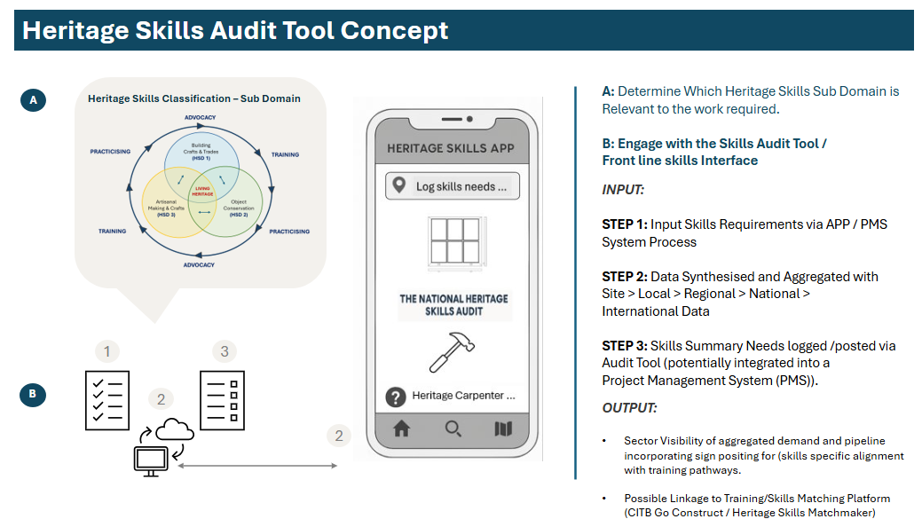
The Heritage Skills Audit Tool will Support Regional Clarity in relation to:
- Identifying priority skills based on live projects.
- Mapping SOC/SIC codes to training needs.
- Aligning with local demand and procurement pipelines.
As part of the transformational proposal, securing future funding to develop this work will be critical. This aligns with the emerging ‘live’ Pipeline Development Research Tool (a CITB/HE engagement initiative arising from the initial recommendations of the CITB RMI Heritage Sector Skills Plan, with delivery proposed through HESF/HESCAPE in 2025/26). It also connects to the work being taken forward through the Heritage Trust Lincolnshire Knowledge Transfer Partnership (KTP) application, developed through HESF/CITB/HE Routes & Recognition engagement via the London RHSN.
Proposal: To advance further Consultancy work in partnership with others to refine Research/Development Phase / Live Build of a Heritage Skills Audit Tool .
Partners: It is recommended that this is a Partnership Activity linked to the WW Heritage Skills Programme. Recommendations for strategic partners would include Historic England (HESF), Restoration and Renewal, ICON, Heritage Crafts, Historic Environment Scotland, Cadw, WMF AHF, CITB and other philanthropic funders. There is also potential to link this to partnerships with RIBA and RICS.

5.2 Linking WW Heritage Programme to Regional Skills Needs
Understanding the limitations and skills needed on site is helpful to plan forward, especially when linked to the wider regional picture as depicted in the audience profiling and skills gaps section to shape up a scalable opportunity for Wentworth Woodhouse and the sector. Key recommendations for driving change include:
- Traditional methods of passing on heritage skills, such as the master-apprentice model, are nearly extinct, with some surviving in the craft sector.
- Working across service providers is important to mainstream and upscale offer on site across time.
- Further education (FE) colleges, where such skills could thrive, face business models that favour large, uniform cohorts over the bespoke training heritage crafts require.
>> Invest in partnerships and collaboration with specialist vocational schools. To rebuild the heritage workforce, we must rethink vocational education. Small, place-based programs can provide the intensive training needed to master heritage crafts, ensuring they are both locally rooted and nationally recognized. Working with local colleges on glazing, joinery and stonemasonry skills pipelines can provide a more stable group of trainees on an annual basis for the site.
>> Enable FE and HE student projects aligned with site priorities that provide depth to professional training linked to real world needs, while enhancing the visibility of the skills offered at WW in the region. Existing models of on-site heritage education training suggest theoretical concepts are often introduced during on-site activities in direct contact with the instrument (laser scanner, total station, camera), so good practice is supported by adequate theoretical training. An indicative approach for activities distribution is structured, such that about 20% of the time is allocated to theoretical parts, 40% to field activities and the remaining 40% to data processing and technical outputs elaboration.
Courses that could benefit are those more focused on conservation, archaeology and planning or surveying, using advanced technology-supported techniques. Those benefit from enabling students to utilize surveying equipment (topographic, laser scanners and photogrammetric) to critically process the surveyed data and produce relevant documentation
>>Pursue volunteer led models with a follow up training programme aligned to enable entry to the professional market and target needs of homeowners in the region (eg. types of Grade II listed building needs). Those can also be targeted to NEETS and youth seeking employment routes and align to CIAG offers by WW.
>>Existing workers from construction skills certificates offered short-term tasters and pathways to specialised heritage construction skills. Collaboration with employed contractors may enable this as they hold the actual data on skills gaps on the ground and the ability to direct grant funding to enable not only apprenticeships but career development paths like those.
Alignment with Rotherham Council cultural strategy aims
The approach proposed for WW and the inclusion of cultural sector apprenticeships and crafts learning opportunities aligns well with the Rotherham Council achievements and future directions, including the following points included in the WW cultural strategy:
- Development of a hospitality and visitor experience training facility at Wentworth Woodhouse.
- SYMCA-supported research into creative & cultural industries.
- Delivered 12 Kickstart apprenticeships within Arts and Heritage Services at the Council.
- Youth focus: Placed skills and talent development central to Children’s Capital of Culture 2025, enabling 121 young people aged 16 – 25 to find employment with some of our area’s most exciting cultural organisations. Of the former trainees, 70% went onto further employment or training. Across the latest cohort, host organisations have made seven trainee contract extensions, and a further four trainees have gone on to be offered new alumni roles within the programme. Additional paid opportunities include nine Young Artist Residencies across a range of disciplines, and two visual art internships being delivered in collaboration with Rush House, to support care experienced Young People.
- Over 1,000 young people have engaged with “Fun Palaces”. The annual celebration of culture sees local communities come together to co-create free creative and cultural experiences and activities in the heart of their neighbourhoods, enabling people to showcase their skills and hobbies across Culture, Sport and Tourism services. (Source: Siddal and Hamilton, 2025)

5.3 Skills Audit Specific to Wentworth Woodhouse

Over the last year, a pilot format for a National Skills Audit Tool has been built using an Excel spreadsheet, which it has been possible to apply as a Pilot in the context of mapping skills needed at WW. Skills have been mapped through both a site-wide lens, and through the lenses of the specific buildings that it is proposed to use as live sites, including the Ostler’s House and Carriage House for Heritage Skills Training and the proposed stable building that will be refurbished to be used as the Heritage Skills Centre of Excellence for Carpentry and Joinery and the Regional Heritage Skills Hub.
An extract from the Skills Audit is provided below for reference and also highlights under which Heritage Skills Domain the Skill is most relevant (Ref Section 3 - Figure 2).
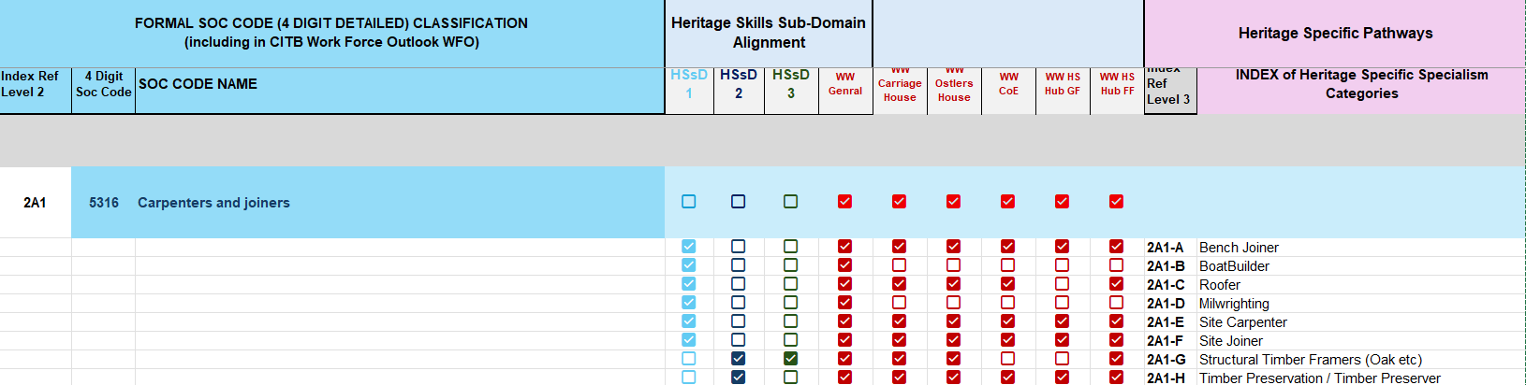
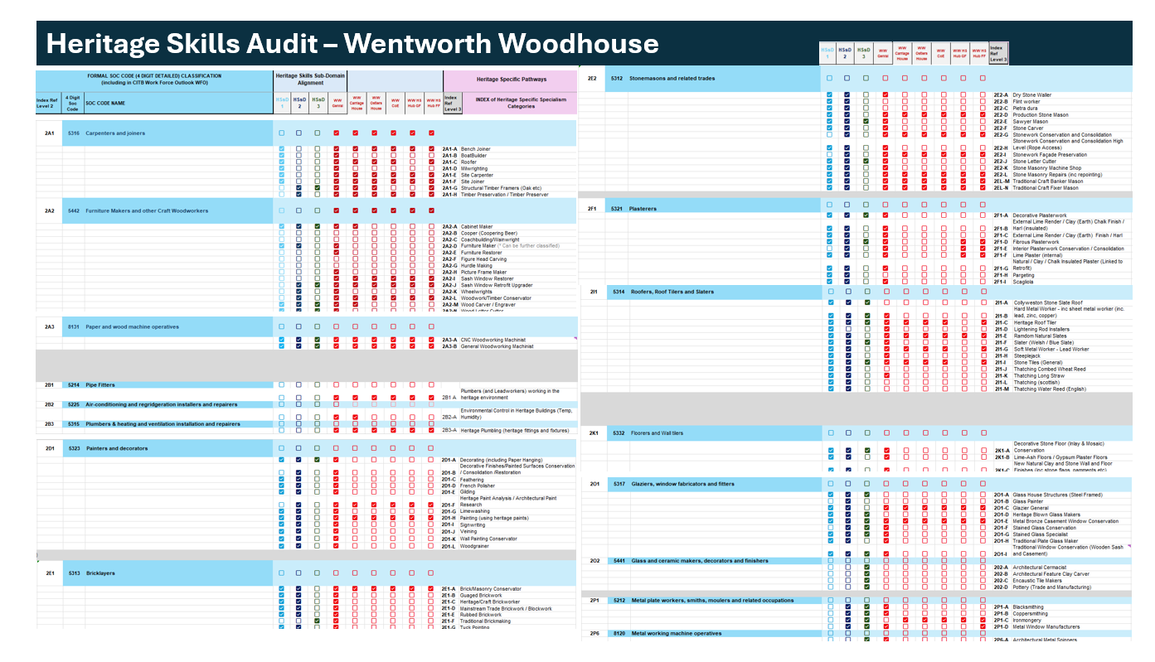
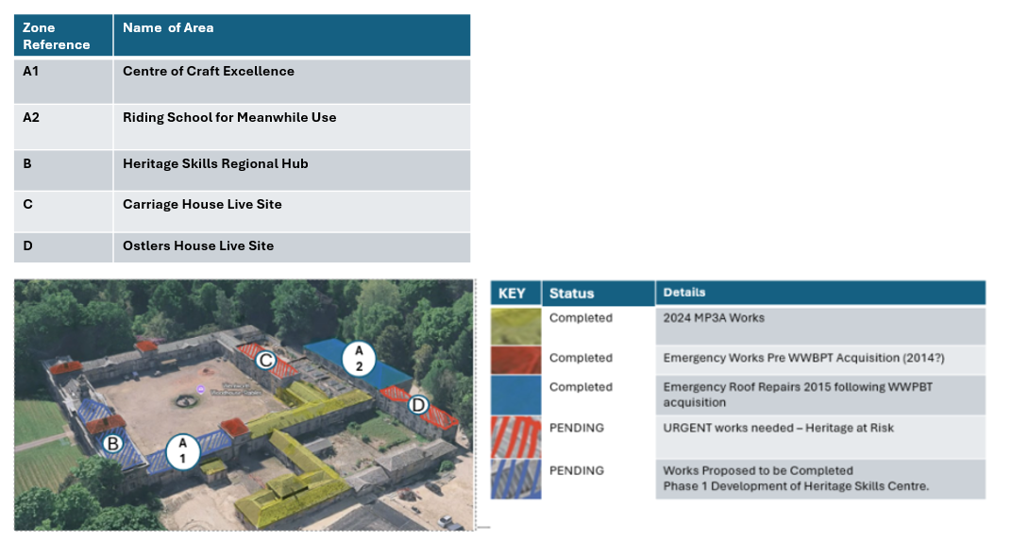
Figure 14: This figure shows the layout of the Stable block area with their status of works to date and identifies A1 and A2 areas aligned to ‘Meanwhile’ uses.
The application of the Heritage Skills Audit in WW aims, at this stage, to showcase an example of how assessment of the plan of works together with types of skills required can provide a base for linked heritage skills training options. This section briefly describes the initial assessment of plans of works in the Stables space and surrounding locations across the site to match them with the training opportunities on site and then discuss models for delivery.
The approach can also inform the resourcing requirements, including internal contracting and use of external expertise, for delivering skills training across time on site. Three key areas of skills roles are included in this planning process: (a) safety and space supervisors, with training skillsets (b) trainers and instructors with educational leadership roles (c) skills and partnerships coordinator(s) linking trainees with providers and communicating opportunities across both. The resourcing is proposed as aligned to the scenarios for development (transformational, gradual development, BAU) described later in the proposal.

5.3.1 Skills and Materials Fabric profiles across works in Stables area

The floor plans included in Report C (section 5) indicate areas in the MP3A area and proposed uses, together with the legends with capacity in numbers that dictates possible ‘Meanwhile’ uses and training participants that can be hosted. This is a preliminary assessment and input from the architectural conservation team and capital works management team would be required to ensure planning permissions for ‘Meanwhile’ uses and safety requirements are kept as necessary for the transformation of the spaces to the required uses.
We provide here short descriptions of materials across the Stable Block and Carriage House, where a variety of skills training is feasible, mainly including lime plastering, carpentry and joinery on windows, but also fittings, insulation, roofing slates and structural timbering). We also provide descriptions of the more limited focus on interiors in Bedlam Wing, where work on plastering and joinery may be prioritised. This still provides an incremental conservation benefit as each course delivered there could contribute to the phased restoration of the Bedlam Wing, turning training into tangible site improvements. Moreover, the seasonality aspect is an important factor to take into account in delivering training across a whole year: the Bedlam Wing can offer space for interior works during the winter months
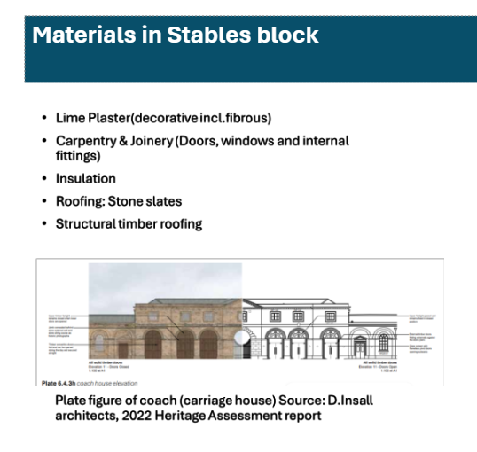
Material in Stable blocks cover a range of works and possible training links, from lime plastering to carpentry and roofing work (including timber roofing). The external/internal envelope allows for lime plastering and mortars repairs as well as insulation and fitting works to take place.
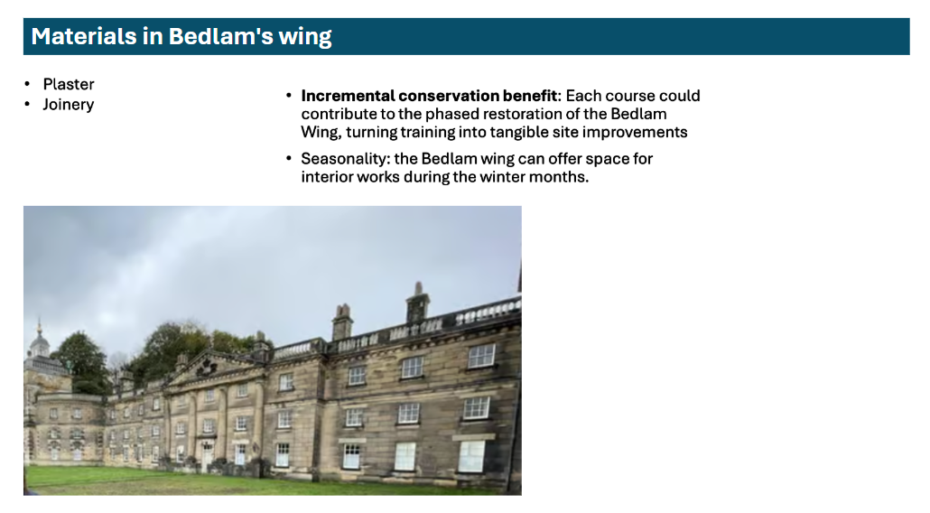
Bedlam wing view with short reference to materials in this part of the building, allowing for winter-time interior work and training provision,
We also identify the opportunity to work on the new entry gates as part of the initial development phase, on a lower risk type of activity, where new stonework, groundwork and decorative Ironwork (gates) are possible tasks.
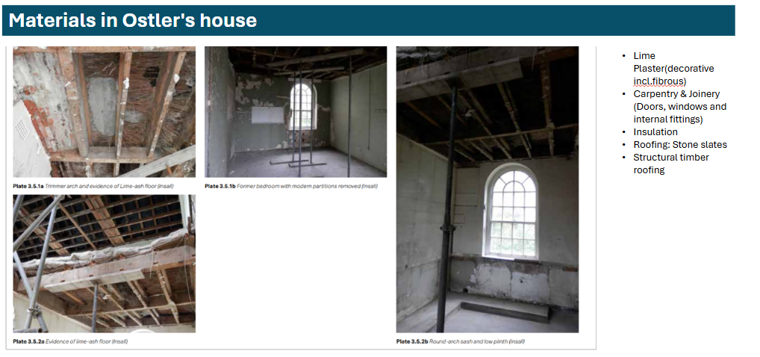
Materials in the Ostler’s House include lime plaster, wood linked to carpentry and joinery work, new insulation and roofing materials as listed in the figure above. Photos are credit of Donald Insall Architects due to inability to access the spaces now.
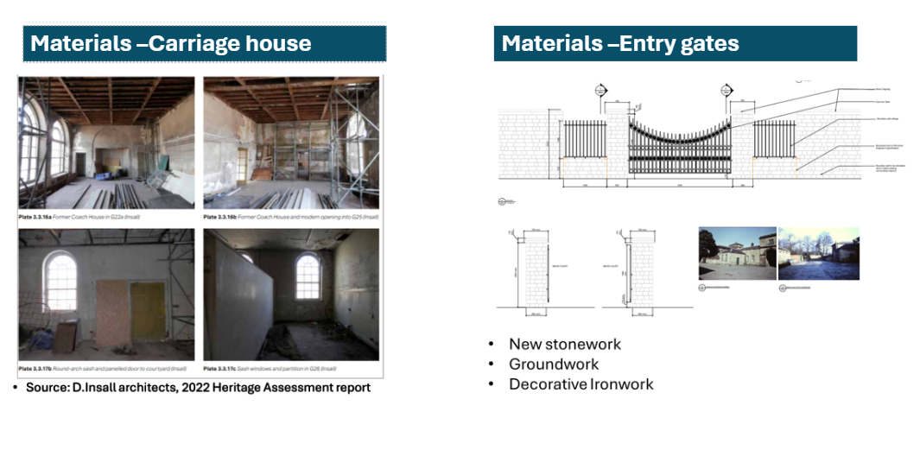Materials in the Carriage House are similar to those present in the Stable Block. Materials in Entry Gates offer space for new stonework, groundwork and decorative ironwork.
We also offer a rapid assessment of works, skills and occupational categories alignment, indicatively for spaces A2 and A1 where ‘Meanwhile’ uses are proposed to support with a pre-view of full auditing results. Those indicate a rich diversity of tasks and training opportunities across a selection of works on the whole building envelope with focus on both interiors and external facades.

5.3.2 Indicative alignment between works, skills and occupational categories engagement: Riding School and events breakout spaces

Space A2. Proposed use: Riding School Meanwhile Use Skills Hub Training Space
- Health & Safety readiness works - insulation, electrical switches work
- Focus for Training would be Stonework, Plasterwork, Joinery. Ventilation will need to be managed at the individual working stations, using site based mobile extraction units or wearing personal PPE (face masks).
Space A2 hosts a kitchen area including toilets which can be potentially used for the public or users.
The Riding School has a timber sprung floor and there may be challenges with intensive use. Summary of works for this space includes:
- Internal compartments: plasterboards, joinery works and fire protection layering (between all floors and new walls)
- Stonework and mortars
- Insulation and walls (general construction, bricks and mortars/walls/ sustainability consultant for thermally efficient glazing)
- Ventilation and HVAC, electrical (electrical and mechanical)
Space A1. Proposed use: workshop Centre of Excellence (see appendix for floor plan coding)
Space A1 summary of works
- Envelope Roof, Exterior works
- Fit out and workshop provision
- External Envelope - Main Contractor internal Fit out
Image 15: Roof-Structural repairs (Indicate structural woodwork example) 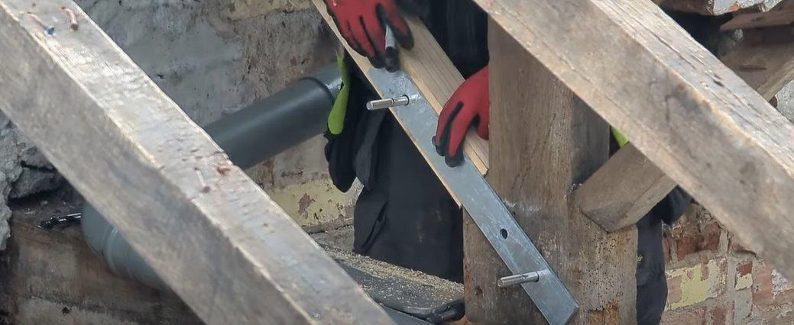
Image 16: Roof- Lead and metal work for waterpipes (indicative roof elements detail) 
List of Works
- Roof - Structural repairs (wood)
- Roof - Lead and metal work for waterpipes
- Exterior wall-scaffolding
- Exterior wall - Façade deterioration/Salt removal strategies/waterproofing masonry and wooden elements (remediation/conservation specialist)
- External wall-stonemasonry and replacements
- External glazing/windows
- Lime mortar and plaster finishes work /pointing (mortar)
- Internal walls/removal of modern fabric divisions and woodwork for workshop provision
- Internal fit out including electrical, plumbing works for reuse, internal panelling and finishes, plastering etc (multiple painter and decorators)

Occupations list
- Wood occupations
- Roof occupations
- Masonry and stone occupations
- Decorative occupations
- Trowel (bricks, mortars,)
- Electrical
- Plumbing
- Scaffolders
- Surveyors
- Electrical installations
- Plumbing
- Other construction skills
- Metalworkers
- Glaziers
In this context, it will also be essential to position Wentworth Woodhouse as a future national beacon for training in planned preventative maintenance and heritage estate management. There is likely no better place in the UK to deliver this specialism. The need for shared apprenticeship models focused specifically on the repair and maintenance of heritage buildings was identified as a priority in an unpublished report commissioned by English Heritage in 2024, entitled Heritage Skills Development: Next Steps, authored by Cultural Associates Oxford (available via the HESF Steering Group).

6.0 Heritage Skills Need & Training Opportunity: The Wentworth Woodhouse Context and Profile of Skills Need

6.1 Summary of Skills Training Categories at WW
The Wentworth Woodhouse Preservation Trust (WWPT) is actively engaged in heritage skills training through various initiatives aimed at preserving and restoring the historic Wentworth Woodhouse site in South Yorkshire. By capitalising on the experience and the strategic role of the Trust for developing heritage skills leadership in the region, those programs not only contribute to the conservation of the site but also address the national and regional shortage of skilled heritage craftsmen. Some of the activities and initiatives delivered by WW are summarised below so that lessons learnt and impact recommendations can be deducted for the future of HS on site.
Legacy has been improved and commitment has been demonstrated, but progress remains limited by the project-based nature of the work, which has not yet created the sequential or intersecting opportunities needed to strengthen legacy or connect fully with the wider traditional skills landscape.
This section provides a summary of existing models of training that have been adopted at WW to date and their alignment with training approaches according to the HE model of HS development. Figure 14 (below) provides a summary of the thematic categories (1-5) of skills training pathways, based on HE latest conceptualisation of activities and audiences targeted activities for HS training provision.
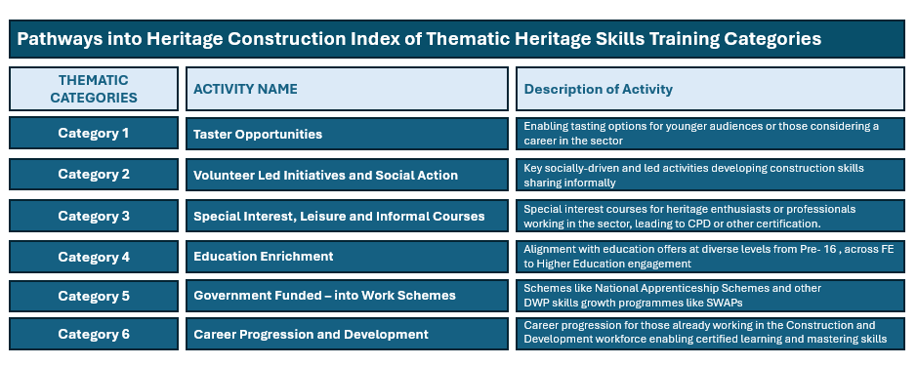
Figure 14: Thematic categories (1-6) of skills training based on HE conceptualisation of activities and audiences targeted for HS training provision. Source (Authors based at HE latest conceptualisation of skills training categories, personal communication with HE skills team, not published yet)
Mapping the current experience in WW revealed that Heritage Skills engagement at the site to date has primarily spanned between Thematic Categories 1- 5. In summary:
Existing work covers Category 1-Taster opportunities (General crafts tasters and SPAB-led taster sessions) though more profitable or better VFM models of delivery can be developed.
Existing activity includes Category 2 /4 (Volunteering and Education enhancement) offers, for example a set of non-targeted activities for schools that form part of the Culture and Education strategy and schools outreach activities, as seen in the recently commissioned impact report.
Programming includes Category 3, 4 activities by SPAB volunteers, targeting public or amateurs, but SPAB has a rather limited role for CPD for professionals, as it does not lead to formal routes or accredited qualifications (which can support Category 6 activities, currently lacking from the offers). Such activities offer general awareness & open doors type access, and can be further targeted to owners of historic buildings locally Category 3.
Category 5 (Government schemes- Apprenticeships) include participation in Swaps and bootcamps (See SWAP case above). The apprenticeship experience has been successful overall, as demonstrated in the case study of masonry contracts and apprenticeships featured in the recent Impact Report for WW. However, these opportunities currently offer relatively niche skills and could have a much wider impact if scaled up. Greater sustainability would also depend on enabling apprentices to remain in roles that are relevant to their training.
6.2 Widening Access to Skills Through Education Partnerships (Category 3+ Education Enrichment)
Wentworth Woodhouse has developed strong partnerships with educational institutions at local, regional and national levels. In 2023 alone the Trust supported:
- 8 x secondary school work-experience placements
- 10 x internships
- 3 x apprenticeships
- 1 x traineeship
- 9 x placements for students with additional needs
- 1 x T-Level placement
- 4 x location marshal placements
These placements successfully bridged classroom learning and practical experience, ensuring that a wide demographic of learners accessed opportunities in the heritage sector.
6.3 WW opening up to community knowledge: Boosting Careers Information Advice and Guidance (CIAG) Events and Conservation guided tours (Thematic Category 2)
Previous Guided tours of Scaffolding and Works - Conservation in Action (CIA). Wentworth Woodhouse’s restoration has been dubbed ‘the most challenging restoration of a generation’. On this behind-the-scenes Guided Tour one can discover the craftsmanship and skill that has gone into creating, and now restoring and conserving, this special place’.
Audiences: all visitors but mainly adults. Open to heritage enthusiasts or conservation-interested adults who want to understand more about skills and craftsmanship.
Strategic implication: Volunteer time needs to be considered and planning/coordination of such activities in tandem with access to actual works on site is required. If more audiences are to be approached, market interest/visitor surveys can provide further insight.
Impact and future reflections: Due to limited data (beyond ticket sales data) being collected during the period when Scaffold roof tours were live the ability to assess the impact of this initiative was limited and it was not possible to assess which audiences were mostly attracted to those tours. To ensure financial viability, review price ranges to make those more accessible and open up to educational establishments and partners to support pipelines and career engagement activities. Evaluate and assess popularity of tours or on-demand topics with core visitor segments.

CIAG and Career signposting events
‘Sky’s the limit for Girls’ event focused on raising awareness for women in construction and engineering roles linked to heritage regeneration works. Connections with both vocational and academic career pathways were sought, building on the success of women working already in the WW regeneration programme.
Audience: A total of around fifteen Year 9 to 11 girls from four schools in the area joined the information events together with companies involved in the design of the activity on the day. RDG engineering, Fore Consulting and WW Preservation Trust were represented as well.
Impact and future reflections: Delivering CIAG focused events more often and covering a variety of careers would make a significant difference for linking actual works with job opportunities. Engaging colleges and students in later years of school education with vocational pathways, students in minority groups like those with disabilities or neurodiversity can support a more inclusive recruitment. Demonstration of skills in action can make a significant difference in influencing career choices.
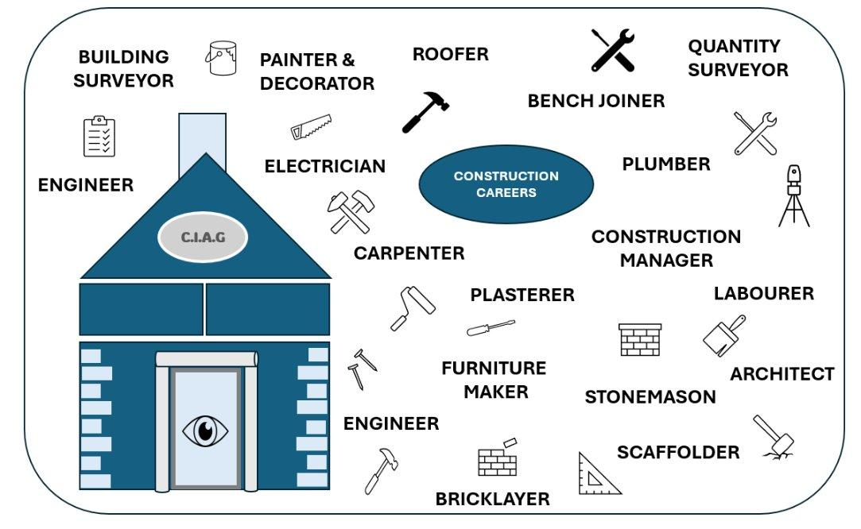
Figure 15: CIAG careers around construction and intersected with the heritage sector
6.4 WW in Flagship National Programmes: Apprenticeship and Skills Training leadership (Thematic Categories 4 & 5)
The Trust launched its first formal Heritage Skills Apprenticeship in 2022, funded through a partnership between The Radcliffe Trust and The Leche Trust. Apprentice Dan Nicholson has been acquiring traditional skills essential for maintaining the estate, supported by Trust staff and heritage contractors. This initiative forms part of a wider apprenticeship scheme developed in collaboration with Historic England to address skills shortages in key trades such as stonemasonry, carpentry and plastering.
The programme targeted young adults interested in apprenticeships. The trades represented included stonemasonry, bricklaying, painting and decorating, carpentry and joinery, plastering, roofing and slate roofing, stained glass restoration, mosaic restoration and millwrighting.
Capital works projects also provide live learning environments for apprentices supported by contractors. For example, Site Manager Trainee Archie Walsh gained heritage project experience while working on the Camellia House regeneration at Wentworth Woodhouse. Heritage Masonry Contracts Ltd also contributed to workforce development by training two local apprentices during major restoration phases.
Strategic implications
Apprenticeships were integrated into capital works. For example, within the heritage management team, an early-stage electrical apprentice was recruited and took part in the Historic England Summer School. However, he did not complete his training and chose to leave the apprenticeship programme, highlighting the ongoing challenge of retaining trainees within the sector. The National Apprenticeship Scheme, supported by the Government, has otherwise been a successful route for bringing young talent into the team.
Reasons for leaving included a lack of alignment between on-site experience and the apprenticeship syllabus, as well as reported financial pressures and the availability of better-paid opportunities elsewhere. A second electrical apprentice was subsequently recruited and is now close to completing his apprenticeship, with plans for him to progress into a permanent role within the Wentworth Woodhouse Maintainance Team.
Impact and scale reflections
The programme’s multi-disciplinary training model introduced trainees to plastering, joinery, earth masonry, and brickwork, enriched with classroom learning and heritage-focused certifications. These activities not only delivered tangible conservation outcomes but also provided trainees with vital hands-on experience in heritage construction.
The scale of impact and numbers of people are low: this initiative took place in the context of the construction project management of a £10 million reroofing project, and was delivered through the main contractor. Overall, we can see that it is possible to work within the ‘shared apprenticeship’ (HE model), with the process being streamlined and easier to onboard.
On-site training provision can be a fruitful experience for participants but requires significant planning and resources to deliver even in small numbers. Understanding critical health and safety concerns and working from the procurement phase with construction and conservation specialist providers can help scale up the model and increase its impact. The upcoming MP3A plan of works provides significant on-site training opportunities.
6.4 WW Summer school (Historic England programme) - building further on success (Category 4/5)
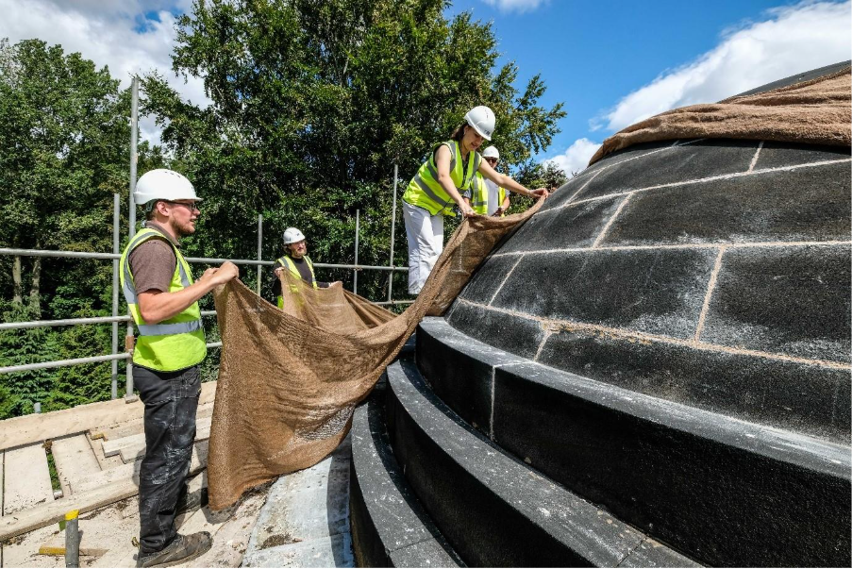
Figure 16 (see section 6.4)- Trainees using hessian to protect the lime mortar repointing on the dome of the Ionic Temple.
In 2022, Historic England’s heritage skills programme partnered with Wentworth Woodhouse for a 1-week April Spring School and a 5-week July to August Summer School. Further information can be gained from: https://storymaps.arcgis.com/stories/8b19608579c3422d946a78f16be850da
Delivery approach
One-week Spring School: The one-week school enabled the trainees to become familiarised with the site. They met representatives of the Trust and discussed the site’s significance with Historic England’s architect and Donald Insall’s conservation architect. They looked at the Masterplan and various ongoing repairs and participated in survey work. They visited a forge and plastering workshop and took part in a few practical workshops, including gilding and leadwork. During the 5 week programme, these sessions enabled the trainees from multi-disciplinary backgrounds to learn about different materials outside of the craft they are usually engaged with, including plastering with Gaches Plastering, joinery with Simon Dunn, earth masonry with Alex Gibbons, and brickwork with Emma Simpson.
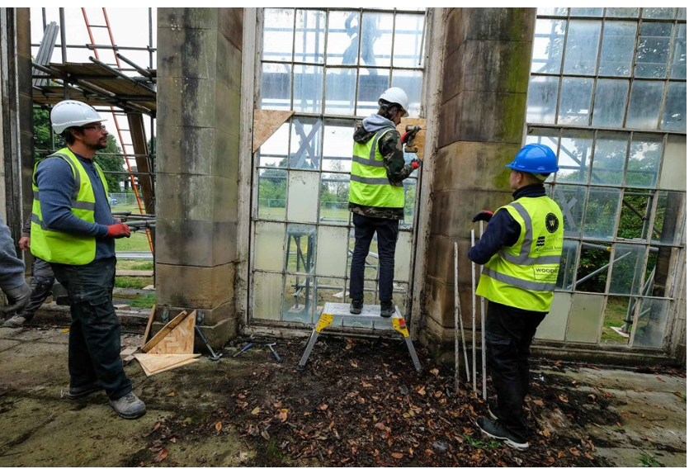
Figure 17; Trainees preparing the window frames for removal from the Camellia House. (https://historicengland.org.uk/education/training-skills/work-based-training/heritage-apprenticeships/the-heritage-building-skills-programme/cs-wentworth-woodhouse)
Strategic implications
The blended format of activities worked well but required resources in the classroom to be combined with those onsite. Delivery included: classroom learning on topics such as assessing significance and running a business, a Level 3 award course on the 'Repair and Maintenance of pre-1919 Buildings', and a visit to a Cathedral’s Workshop. Nineteen Heritage Building Skills Programme participants attended the Summer School across locations (not only in WW) and this pipeline is considered critical for keeping people engaged. The parts of the estate chosen were important for allowing types of work and practice: the Camellia House was included to allow trainees to observe different types of works and for off-the-job test pieces. The South Pavilion and Clifford’s Lodge provided survey work opportunities.
Agile and positive collaboration between the WW Site Team, Historic England (the organisers), the Project Contractor, and the project architect, Donald Insall Associates (DIA), was a critical factor in the success of the Summer School. The engagement of TYWI, an independent specialist Heritage Skills Training Provider based in Carmarthen, Wales, was also invaluable. TYWI attended the site to deliver a Level 3 Award in Understanding the Repair and Maintenance of Heritage Buildings, a qualification endorsed by the National Open College Network (NOCN).
Impact and reflections for future
Attendees actively contributed to the restoration work - partially funded by the Programme's site works grant - at Wentworth Woodhouse's Grade II* Ionic temple and Grade II* Camellia House, both of which are now restored. The Camellia House has since been removed from the Heritage at Risk Register and is now in use as an income-generating tea house.
The Summer School can support the delivery of training in local colleges when absence of work on site may occur (i.e. can be delivered also during other times of the year). This Summer School can benefit from support from the Council and community of volunteers.
Activities and learning like woodwork or wood carving workshops can benefit from woodworking workshops being available for hire, for example at local college construction training facilities. Casts of decorative elements found in WW can be used to support linked activities. By linking up with regional trainees, supported via the programme, WW can lead the alumni and connect them to develop a network and inspire the next generation of apprentices while following up on the condition and needs of HAR assets in the region.
6.5 Digital Heritage Skills Training & University Partnerships
WWPT launched its first formal Heritage Skills Apprenticeship in 2022, funded through a partnership between the Preservation Trust, the University of Sheffield Advanced Manufacturing Research Centre (AMRC, part of the High Value Manufacturing Catapult network) and PES Scanning, part of Performance Engineered Solutions (PES) Ltd. Using reverse-engineering technology, PES created a highly accurate 3D scan of the statue of Germanicus. This digital blueprint was then used by AMRC design specialists to 3D print three miniature replicas of the statue. WWPT can now use the 3D scan to monitor any future deterioration and could produce an exact copy if the statue were ever seriously damaged.
AMRC Training Centre apprentice Harry Howson, who works for PES Scanning, helped to scan and digitise the statue using a hand-held 3D laser scanner. The scanner captured every detail to an accuracy of 0.020 mm, with a resolution capability of 0.01 mm, taking up to 1.6 million measurements per second.
Such partnerships have high value for the Trust but need to be linked to current conservation priorities to be sustained and expanded. Building relationships with digital skills providers and partners in the region can help support a steady flow of new talent and create a pipeline for future development.
Looking ahead, heritage skills could be broadened to include object preservation through advanced technologies such as 3D scanners, spectrometers, and other high-accuracy scanning tools. Developing open days, showcases, school career events, and taster days may further increase interest in these apprenticeships and help promote wider public understanding of heritage, technology, and data science.
Source: www.wentworthwoodhouse.org.uk and https://wentworthwoodhouse.org.uk/news/new-technology-re-creates-historic-germanicus-statue/
6.6 Informal partnerships for volunteering and social action - hosting SPAB Summer working party activities
Collaborative Heritage Learning Events
In 2025 the Society for the Protection of Ancient Buildings (SPAB) hosted their annual Working Party at Wentworth Woodhouse. This partnership initiative showcased Wentworth Woodhouse’s capacity to convene heritage learners and professionals and provide short term accommodation via a pop-up on site camping provision. Over 70 participants engaged in tasks such as timber repair, masonry repointing, and archaeological exploration. The event promoted accessible, hands-on learning for all skill levels, reinforcing the Trust’s role as a facilitator of grassroots heritage skills development.
On-site Craft and Volunteer Contributions – linked to WW’s Core Operational Model
An active joinery workshop and a committed group of conservation volunteers further reinforce the heritage skills infrastructure at Wentworth Woodhouse. Volunteer contributions to date include wood restoration, sash window repair, and maintenance, exemplifying community involvement in conservation practice.
Audiences: adult focused, amateur builder and heritage enthusiasts. Job seekers seeking to develop skills through volunteering.
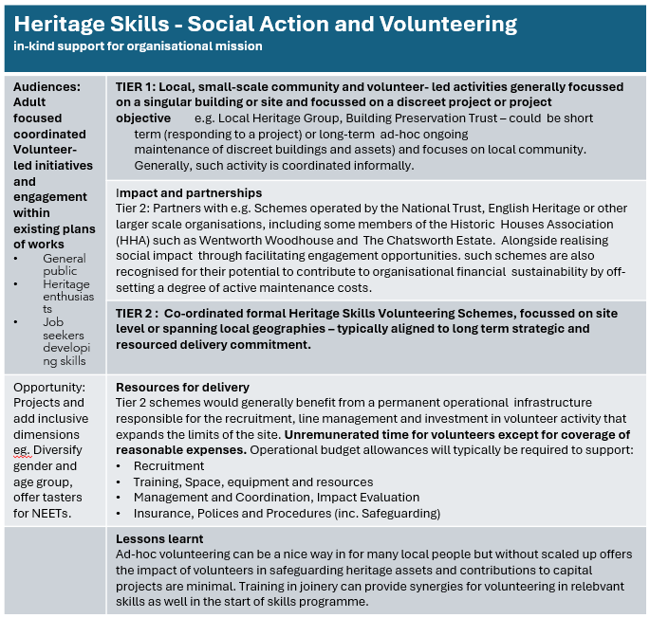
Impact and scale reflections for the future:

See lessons learnt in the table above. Overall, for SPAB-type activities quality assurance factors are important in the model: it needs a strategic partnership with a more active role for WW to be sustainable. The current delivery approach (with SPAB making a token contribution to WW hosting the event on the site) doesn’t reflect the whole life hosting cost for WW.
The concept behind the SPAB Working Party was for the works completed by the volunteers to contribute actively to the incremental conservation of WW itself. From interviews with the WW Management Team, it is noted that higher levels of supervision would likely be required in the context of such volunteer-led work to ensure that the effort and energy expended result in direct improvements to the fabric. For example, it was noted that the windows that were repaired will likely require significant additional re-working in order to render the repairs of a quality and standard that would result in the longevity required at the property.
The availability of materials to support high quality conservation works is also flagged as a challenge with existing volunteer working models. Ideally WWPT will therefore strive to form commercial partnerships with the regions through which a level of donation of materials for volunteers to work on projects could be realized as part of the social value commitments of some relevant companies and organisations.

7.0 Defining a targeted future audience for Heritage Skills Training at WW and Wider South Yorkshire
Introducing the intergenerational Arc of Skills training Concept
7.1 Audiences for heritage in SY and lessons for WW
Defining Thematic /Target Audiences secondary to WWPT's Primary Educational strategy focus (UK Curriculum Aligned) and engagement with Pre-16 Students is helpful at this stage to set expectations and structure a programme of offers.
A general appraisal of opportunities and informed by existing experience will be presented here in relation to key Age Profiles to define four discreet audience segments specifically relevant to the future Strategic Heritage Skills offer to be outlined and detailed in Report C.
Recommendations here have been informed by WWPTs Existing Audience Segmentation Data shared by WWPT’s Head of Culture and Engagement. South Yorkshire Demographic Segmentation data drawn from The Audience Agency and the Skills England Local Skills Dashboard has also been reviewed where available, alongside other open-source data on skills from the Construction Industry Training Board (CITB).
Current offers and under 16 audiences: Current offers include adult learning on a limited and project-based basis, focused more on young people and under-16 programmes, with some ad-hoc community-driven elements targeting local families and aiming at shaping links with the site, as described in the Culture and Education strategy document (2023).
Cultural participation and Audience Data: The Audience Agency have conducted work in the region, for example, a "Place-Based Insight Session" for West Yorkshire, including data about the local population and audiences that are helpful to consider in relation to paid courses and opportunities with fee entry to be developed under heritage skills training. Those may be more relevant to training sessions for local heritage enthusiasts and day-long tasters which also need to be cost-effective in the long-run.
Data are from a range of sources (inc. Audience Finder Data Tools, Audience Spectrum segmentation, Area Profile Reports and more). Those suggest:

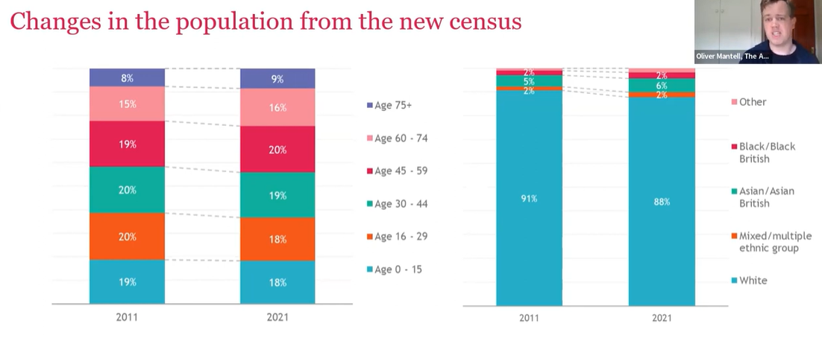Figure 18 (above): changes in population demographics from new census data (diversity) tends to be more diverse in younger groups. (Data for South Yorkshire only). Source; Audience Agency, West Yorkshire, Place-Based Insight Session. (Data for South Yorkshire only) Available here: https://youtu.be/DcnOLas8aKM?si=WIRu0iPSkQ1CWD9a

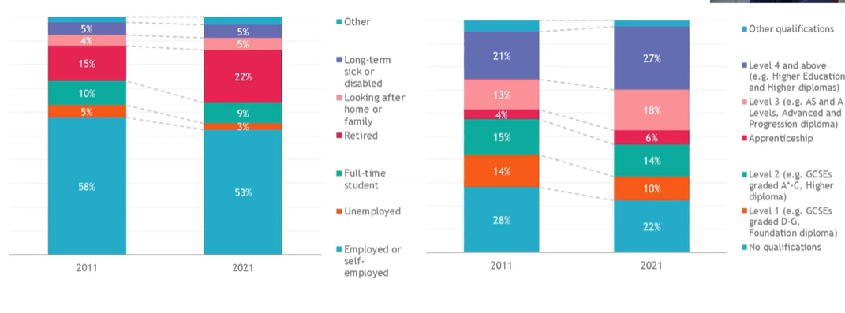Figure 19 (above): changes in employment status (increase in retirees, small reduction in unemployment across the 10 year period since last census). Working to move people into jobs and markets is still key for the region. Source: Audience Agency, West Yorkshire, Place-Based Insight Session. (Data for South Yorkshire only) Available here: https://youtu.be/DcnOLas8aKM?si=WIRu0iPSkQ1CWD9a

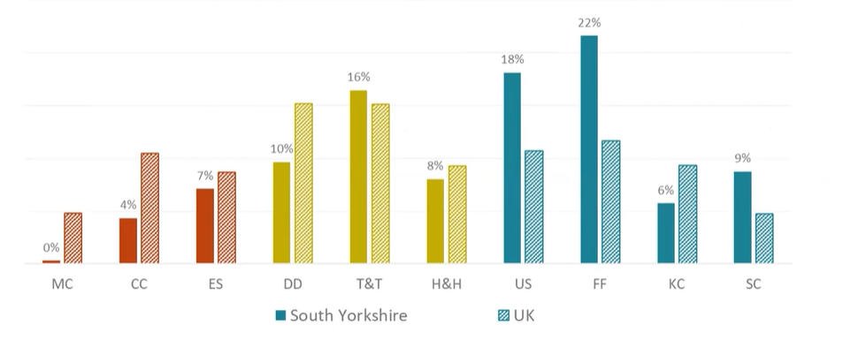Figure 20 (above): Local audiences (lower and larger engagement across audience segments, spectrum types by AA) in South Yorkshire, tend to be more inclusive in engagement compared to other areas in the UK overall (in blue). For the segment categories used in horizontal axis see Audience Agency spectrum page.
Source: West Yorkshire, Place-Based Insight Session. (Data for South Yorkshire only) Available here: https://youtu.be/DcnOLas8aKM?si=WIRu0iPSkQ1CWD9a

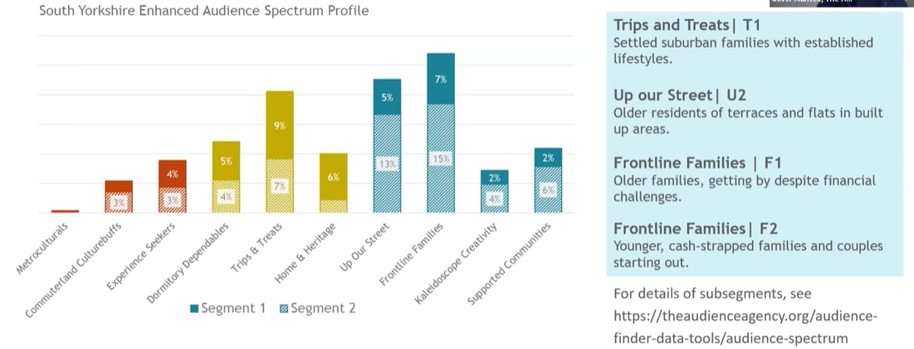

Figure 21 (above): ‘Up our street’ is the typically younger group and ‘trips and treats’ has relatively more sub-urban type users. Frontline families are the most important group in numbers for the area. Audience Agency, West Yorkshire, Place-Based Insight Session. (Data for South Yorkshire only) Available here: https://youtu.be/DcnOLas8aKM?si=WIRu0iPSkQ1CWD9a

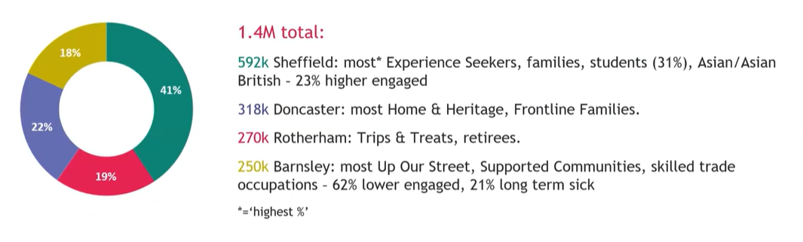Figure 22 (above): High proportion of least engaged people in Barnsley but more skilled trade occupations can guide the strategy recruitment across geographies. Sheffield shows the highest percentage of engaged audiences, especially amongst student groups. Audience Agency, West Yorkshire, Place-Based Insight Session. (Data for South Yorkshire only) Available here: https://youtu.be/DcnOLas8aKM?si=WIRu0iPSkQ1CWD9a

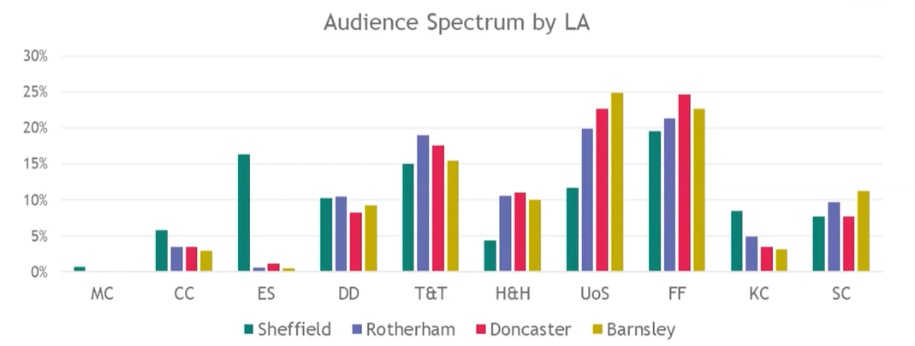Figure 23 (above): Audience spectrum categories distribution by Local authority in SY. T&T, FF and UoS have the highest representation across most LAs. Source (as above)

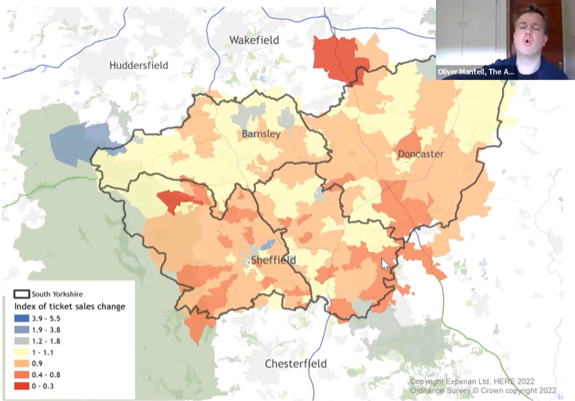

Figure 24 (above): Local bookers data and index of ticket sales in the area, visible changes in grey in some areas in Barnsley from Covid period onwards. Source: Audience Agency, West Yorkshire, Place-Based Insight Session. https://youtu.be/DcnOLas8aKM?si=WIRu0iPSkQ1CWD9a
According to the data from AA, three quarters of local visitors to local art/heritage venues in AA survey are from South Yorkshire.
Digital engagement and targeting groups: Audience Finder data benchmark for onsite audiences, Dormitory Dependables and Commuter land Culture buffs (both segment types defined by Audience Agency) are the best represented Audience Spectrum groups in the Digital Audience survey. This is likely linked to the fact that their in-person attendance is perhaps limited, relative to their levels of interest, because they live away from urban centres. So digital activity allows them to engage in higher proportions when geography is removed as a factor.
Key principle and learning from this approach and rich data, is the monitoring of diversity variables in existing audiences to support diversity and expanding offer to include SEND (Special Educational Needs and Disabilities) audiences for example.
7.2 Local skills dashboard insights (LSIP & SYMCA wide skills and employment data)
Another key learning aspect of these datasets is the differentiation between visitor segments and learner profiles for heritage skills that relies more on the work experience and workforce profiling in the region than the visitors alone. To capture those we provide some data from the bespoke, Local Skills Dashboard for South Yorkshire, making it quick and easy to access local data for the WW leadership team within geographical areas like Local Skills Improvement Plan areas (LSIPs), Combined Authorities and Local Authorities.
- The FE achievement rate per 100,000 in South Yorkshire LSIP is higher than the national average. It is ranked 21st of the 42 areas (38 LSIPS and 4 sub-London LSIP areas). It is highest in Barnsley and lowest in Sheffield.
- South Yorkshire LSIP has a lower FE achievement rate per 100,000 in Community Learning than the national average.
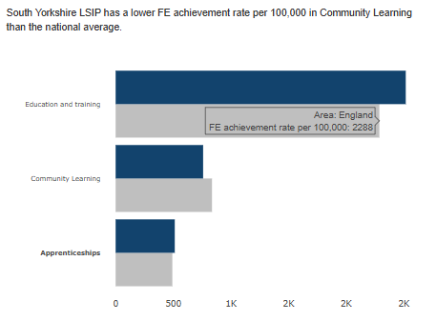
Figure 25 (above): South Yorkshire LSIP has a lower FE achievement rate per 100,000 in Community Learning than the national average. Link to dashboard
- Unemployment rates are highest in Rotherham and lowest in Doncaster within the SYMCA (5 and 3% overall). Within the LSIP, unemployment is highest in Sheffield and lowest in Barnsley. Unemployment in South Yorkshire LSIP has decreased slower than the national average in the last 4 years.
- Self-employment rates are highest in Sheffield and lowest in Rotherham. The self-employment rate in South Yorkshire LSIP has increased faster than the national average in the last 4 years.
Additional graphs and data are provided in the Appendix.
The list of qualifications is matched to occupational categories managed through Skills England, which holds a national database that provides 52 Construction and the built environment qualifications, filtered on qualification types T Level and HTQ (levels ,3, 4 and 5) with matched providers across England. An appendix with training providers in the region (more within HE or FE is provided with the report).
In 2025 The Department for Education also Published Skills England: Sector skills Needs assessments for Construction, although this contains limited references to work on pre-1919 Buildings outside of retrofit.
With the publication of the Strategic Economic Plan 2021-2041 for the South Yorkshire Mayoral Combined Authority (January 2022)1, a 20-year plan focusing on creating inclusive economic growth across South Yorkshire, there is a drive to align offer to employment and skills gaps in support of economic development and market gaps.
However, those plans contain few references to heritage skills specifically and this can be explained due to the niche character of the latter and their small representation in the skills market. Key priorities for SY set the tone for the heritage skills development though:
- More investment in vocational education infrastructure and apprenticeships
- Targeting adult vocational education skills funding towards provision that explicitly meets the needs of employers & learners and links to areas of employment growth
- Stimulating the development of bespoke training and upskilling packages to employers
The report highlights creative and digital but also specialist construction as sectors with potential and growth for the area.
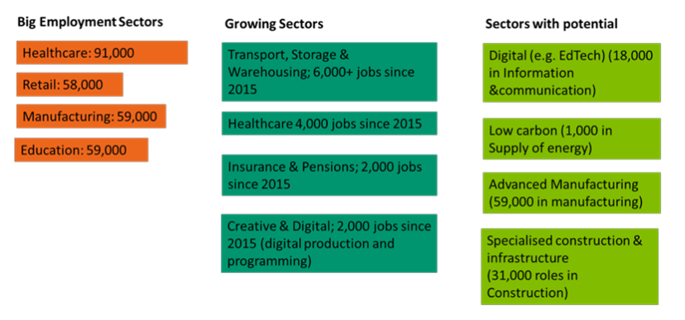Figure 25 (above): The sectors with potential highlighted here are sectors which can bring a multiplier effect. For example the specialised construction infrastructure and the Low Carbon sector will not only provide jobs for residents but it will also help the region to become carbon neutral and innovate. The overlap of the job opportunities created by WW with those areas is significantly positioning the organisation to make a shift within Rotherham and lead wider heritage assets to follow. Source: SCR local skills Report https://www.southyorkshire-ca.gov.uk/getmedia/5be5936d-35ab-445a-a4e5-bc9a811867b6/SCR-Local-Skills-Report-(FINAL).pdf

7.2.1 Further evidence on diversifying audiences for skills training (across SY)
Based on 2019 data, Rotherham is ranked 44th most deprived district in England by average IMD score, which places it among the most deprived authorities in the country. The 2025 IMD also highlights that one of Rotherham’s Lower Layer Super Output Areas (LSOAs) (Rotherham 017D) is among the 10 most deprived LSOAs in England. Rotherham East ward (which includes areas like Eastwood, East Dene, Herringthorpe) is the most deprived ward in the borough: it ranks Decile 1 nationally. According to Rotherham Council, some of the most deprived SOAs (small areas) in the borough include East Herringthorpe, Masbrough, Ferham, Canklow, Eastwood, East Dene, Dinnington, and Rotherham Town Centre.(Rotherham council, 2025)
The key domains driving deprivation in Rotherham are Health & Disability, Education & Skills, and Employment. Economic inactivity is relatively high: as of the year ending December 2023, 28.7% of people aged 16–64 in Rotherham were economically inactive.(ONS, 2025)
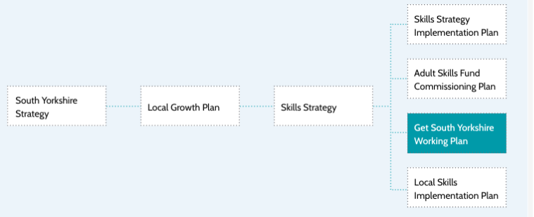
Figure 26 (above): The Get South Yorkshire Working Plan (GSYWP) sits within a broader landscape of regional strategies that collectively support inclusive economic growth, health and employment integration, and workforce development. The diagram here illustrates how the GSYWP aligns with several of these frameworks, highlighting shared priorities and strategic coherence.
Youth employability in the region
239,000 working age residents in South Yorkshire are either unemployed or inactive. Of these, 44,000 are inactive but want a job, and around 81,100 are inactive because of temporary or long-term sickness, a rate of more than 1 in 3 locally compared to 1 in 4 nationally
Those with long-term health conditions, ethnic minorities, and young people with Special Education Needs and Disability (SEND) are all significantly more likely to be economically inactive. For students with SEND, the NEET rate is higher - 13% of Sheffield’s 16-17-year-olds are classified as SEND compared to 8.6% across England.
Attainment levels and youth in the region
At KS5, attainment levels of young people in Rotherham and Sheffield are similar to the national average, but they are lower in Barnsley and Doncaster. 18–24-year-olds in the City Region have higher unemployment rates than nationally, and are less likely to enter full-time education. Barnsley and Doncaster appear to have higher NEET rates.
FE and apprenticeships –numbers across South Yorkshire
The 19+ FE budgets - including the Adult Education Budget (AEB), ALL, apprenticeships and Community Learning (CL) - funded 77,000 learning-aim starts in 2018/19. These were delivered by a wide range of providers, 624 in total. Apprenticeships were delivered by 462 providers, of which 232 delivered fewer than five learning-aim starts. This refers to all sectors, not only the heritage sector.
Overall, the budgets appear to be funding provision in line with their intended aims and objectives. For example, apprenticeship funding predominantly supports younger learners, while Community Learning supports older learners. This pattern is also reflected in the level of provision: 60% of AEB learning-aim starts are at Entry Level or Level 1, and 61% of apprenticeship starts are at Level 3 or above.
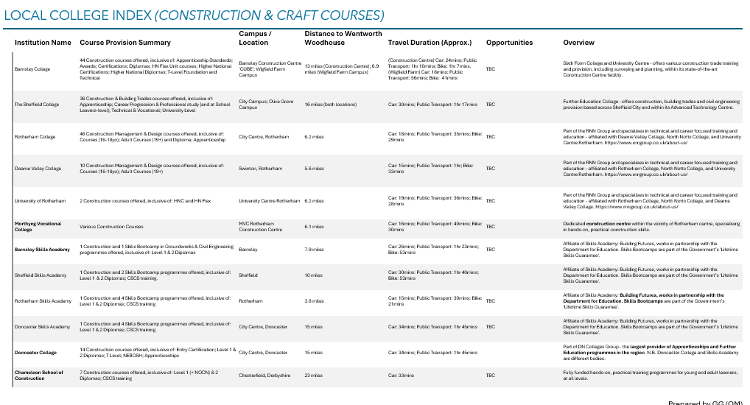Figure 27: Local College Index for Construction & Craft Courses
Higher Education Higher Education in South Yorkshire is delivered by two universities and five FE colleges. These two universities accommodated almost 61,000 HE learners in 2019/2020, a significant proportion of whom were studying STEM subjects. In the same year there were a further 969 starts at FE Colleges in ESFA Localism Dashboard according to the annual HESA Statistics (19/20) for South Yorkshire on provision at Level 4 (Degree Level) and above. Level 4 and above provision at FE colleges includes undergraduate and post graduate degrees as well as vocational qualifications such as Higher National Diplomas.
Upskilling and apprenticeships:
With around 14,000 new apprentices every year, many colleges and training providers deliver training to young people and adults, and thousands of employers are looking to upskill their workforce. This reflects the fact that the issue of skills is critical to all that the South Yorkshire Mayoral Combined Authority (SYMCA) do.
NEET And youth in skills offers
South Yorkshire’s 16–17 participation/NEET indicators have been consistently worse than national averages, and local strategy documents highlight young people as a priority cohort for skills intervention. Latest DfE/ONS releases show NEET rates among 16–24s remain a persistent policy concern nationally, while South Yorkshire Mayoral Combined Authority’s Skills Strategy notes NEET for 16–17s is “consistently higher than the national” in the sub-region.
A new heritage skills offer built around paid traineeships/apprenticeships, accredited progression, and inclusion targets (e.g., care-experienced youth, women in trades, disabled and racially minoritised young people) would directly tackle these gaps and open routes into stable work across conservation, traditional construction, and retrofit where employer demand is rising.
Embedding inclusion targets (e.g., care-experienced youth, neurodivergent, women in trades, racially minoritised youth) and coupling them with craft and creative training directly advances some key outcomes including: fostering diverse pathways into heritage professions; improving stewardship of historic asset itself; and amplifying underrepresented voices in heritage spaces.
We recommend a tri-partite focus on the following aspects:
- Inclusion and diversity as a focus for innovative training to offer provision and partnership
- Targeting youth employability skill gaps in the region, aligned to heritage skills audits
- Support crafts livelihoods and local economic development goals, through alignment with live projects defined by a project pipeline tool
7. 3 Introducing “Audience-targeted skills training” Recommendations for WW
As discussed above, the proposed focus for HS Priority Audiences consists of three paired groupings. These groupings are emerging and have been developed with reference to existing target audiences for culture and heritage training offers, lessons learned from evaluations of current sector and WW HST programmes, and opportunities identified through the evidence review of regional skills data and gaps.
While those form the basis of the offer, these priorities will need to be further ranked and prioritised by WW internal Team and WW Board of Trustees during the Development Phase and will be influenced by any additional data on capacity for delivery across all. Moreover, while those suggestions provide a starting point, it would also be beneficial for feedback on priorities to be sought from Development Phase funders, which may provide further focus.
Audience Segment PAIR 1 (Yellow):
Focus 1. Those with Special Educational Needs and Disabilities (SEND/SEMH)
Focus 2. Those Not in Education, Employment or Training (NEET)
A focus on SEND learners is already embedded within WW’s Culture and Education Strategy, making alignment with the Heritage Skills offer both natural and strategic. Similarly, prioritising NEET learners aligns the programme with identified regional skills gaps and areas of potential economic impact. This approach also supports SYMCA’s strategic priorities by helping to address labour market shortages and create pathways into employment for individuals currently not engaged in work or education, thereby contributing to socio-economic growth.
Focusing on neurodiversity and the associated opportunities to enhance impact and create new routes into the skills market is essential, not only for the region but nationally. An estimated 1 in 7 people in the UK are neurodiverse (NHS, 2023). Across the UK, only around 3 in 10 working-age autistic adults are in employment, compared with 5 in 10 for all disabled people and 8 in 10 for non-disabled people. Autistic graduates experience even poorer outcomes: just 36% are in full-time work 15 months after graduation, with many underemployed or working on zero-hours contracts, and earning on average around one-third less than non-disabled graduates (GOV.UK).
In South Yorkshire, programmes such as Autism Plus’s SEND Youth Hub in Sheffield and its new specialist support services in Rotherham and Barnsley are helping to expand employment pathways for neurodiverse individuals. Additional local support is available from organisations including Spectrum-e, RANSS, Stride Yorkshire, and Autism Plus (see list of services) (South Yorkshire ICS).
A heritage-skills intervention that intentionally supports neurodivergent young people through job coaching, workplace adjustments, mentorship, and creative, strengths-based tasks suited to different neurotypes would address a significant inequality and open access to a valuable and currently underutilised talent pool.
Autism specific training offers: plan to provide a structured, supportive, and sensory-considerate introduction to construction skills, enabling autistic learners to thrive in practical, team-based environments.
ADHD specific offers: ADHD aligned offers, designed to harness their energy, creativity, and problem-solving strengths while supporting focus, executive function, and emotional regulation in a construction training environment.
Dyslexia: specialist construction training course designed for learners with dyslexia, tailored to support accessibility, confidence, and skill development in heritage and mainstream construction. This would use multi-sensory learning (visual, auditory, and hands-on methods), provision of clear, dyslexia-friendly materials and assistive technology
In preparing relevant training provider briefs for Wentworth Woodhouse such needs and learning objectives will be integrated in submission], for example to regional CITB Skills Academy or other providers.
Audience Segment PAIR 2 (Green):
Focus 3. Those Enrolled on Formal Construction Education Programmes
(FE Colleges Predominately 16-18y)
Focus 4: Those Already working in the construction Sector (Up-skillers, Retrain, Sustain the Sector).
Those enrolled on formal construction programmes provide an audience base with new skills in construction, applicable to heritage with further specialisms. Targeting younger audiences can support career pipelines and align with sector gaps presented earlier. Focus Group 4 suggests matching those with an experienced heritage skills workforce aiming at retraining but also sharing expertise with younger trainees, igniting an intergenerational knowledge sharing loop.
Audience Segment PAIR 3 (Blue):
Focus 5: Volunteers with Heritage Organisations (including WW)
Focus 6: Homeowners DIY / Special Interest Hobbyists etc
This pair includes existing audiences in models adopted by WW but also expanding them to heritage owners seeking practical maintenance skills development or hobbyists. This could support a bigger audience for DIY and showcase day offers and link to actual needs for repairs across the region, increasing impact.
The pathways embody the commitment to both 'Advocacy for Gender Equality & Inclusion' and 'Contributing Actively to Local Economic Growth' which run through all PAIRED Focus Group Recommendations.
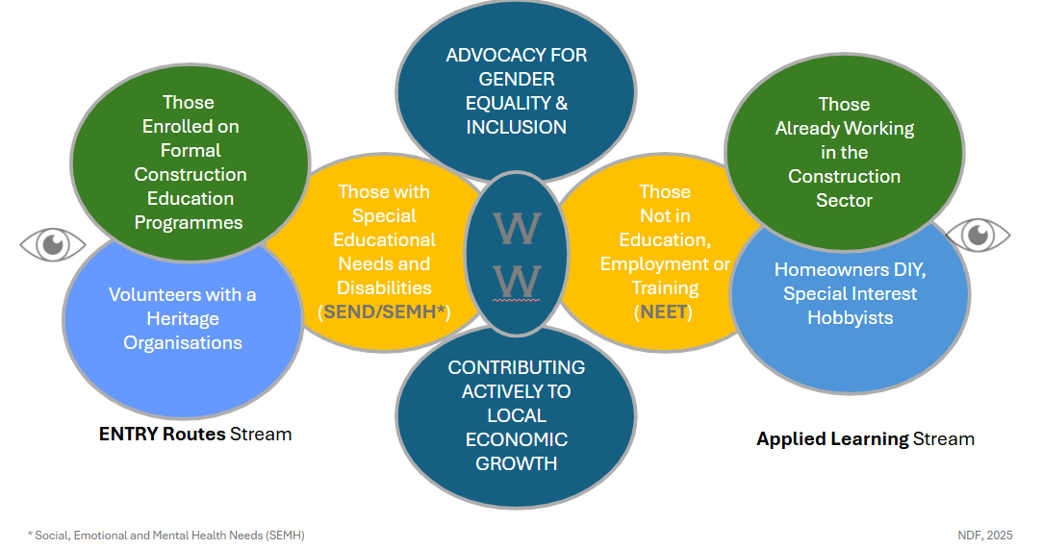Figure 28 : The three audience types (paired and colour coded and alignment with entry or applied learning streams at WW)
7.4 Formal Educational Engagement Programmes at WW: The Four Principal Strands of Education and Skills Engagement outside the Under-16 Curriculum Alignment
Specialist skills strategy strands at WW include:
1. Digital: digital skills volunteering and research partnerships already realised provide a good base for expanding those offers
2. Food and Beverage (F&B)/ Visitor Economy: those areas are key for local economic development and areas where WW can make a difference as a local employer at large
3. Heritage Skills: is integrated as an innovation and development skills opportunity area, building on the experience outlined in earlier sections
4. Horticulture: the presence of historic gardens and the opportunity to integrate with maintenance of grounds activities, capitalising on strategic partnerships with organisations like RHS.
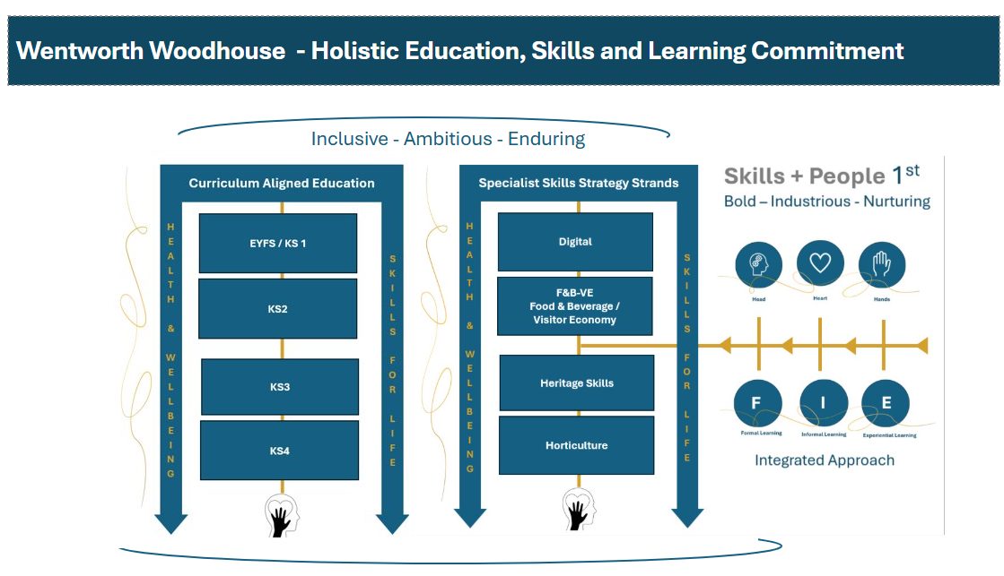
Figure 29: The golden threads of Health & Wellbeing and Skills for Life will run through all Education Strands. A strong emphasis on inclusion and wellbeing, particularly in creating new employment opportunities, promoting inclusive recruitment, and supporting individuals with neurodiversity and specific learning needs, will help shape a new and more accessible skills market at WW. At the same time, the Skills for Life approach supports the development of pathways that enable young people to explore and thrive in heritage careers, while also providing opportunities for experienced workers and craftspeople to pass on their expertise to the next generation at WW.
Current activities at Wentworth focus on curriculum-aligned education programmes for learners from KS1 to KS4 and form part of the organisation’s Culture and Education Strategy. These activities provide strong foundations and natural synergies for introducing young people to heritage careers and developing their interest in heritage skills training.
- A significant element running across the skills offering at WW is the approach of a ‘Skills and People First’’ approach where, by being bold, industrious and nurturing any offer development, we can target not just market gaps but actual people-centred approaches for lifelong learning and skills transmission.
- A focus on skills training needs can cover offers spanning from experiential learning, informal to formal training, qualification-linked, offers to sustain pipelines and links across the three areas.
To deliver effectively under these principles, skills engagement approaches at WW need to be guided by the development of an Intergenerational Arc of Heritage Skills Training (IAHST). This framework will create age-linked opportunities that foster intergenerational engagement and cross-generational knowledge exchange within the Heritage Skills agenda. It is based on a “cradle to grave” engagement model, offering a different way of thinking compared with mainstream approaches that typically focus on a single point in a learner’s journey.
Instead, the IAHST concept identifies engagement “hotspots” (points in time when specific groups are most receptive to skills interventions) and targets opportunities more situationally to increase impact. For example, this could include pre-16 engagement through skills-focused activities, or post-25 engagement for adults considering a career change, supported by groups of experienced craftspeople aged 55+ who are trained and enabled to act as assessors and mentors.
Recommendation for WW
- To actively develop and adopt IAST as a regional and national innovator
- To seek opportunities for intergenerational skills exchanges by offering workshops and trainer roles, while working with contractors and construction sector expert employees
- The visual framework model is currently in development by main author (Nicola Duncan-Finn) in consultation with the HE National Skills Team as well as Palace of Westminster R&R Project Team and some wider task group members in the Historic Environment Skills Forum (HESF).
8.0 Vision and Theory of Change
This section introduces a two-level Theory of Change for WW: one at the international and national level, positioning it as a beacon for heritage skills training and wider impact; and one at the regional and local level, aligned with the programme’s aims around skills, employability, and socio-economic growth. Applying a Theory of Change, particularly at the local level, helps us identify areas where WW can generate impact, based on the site’s specific needs. It also shows how these needs connect to opportunities for developing training offers at WW, ultimately enabling it to become a regional beacon for heritage skills.
8.1 National vs International Change
At the national level, a Theory of Change establishes a shared logic model that links the supply of skills with real project demand, ensuring that funding, training delivery, and conservation activity reinforce one another. It enables a shift from reactive, project-by-project responses to a strategic, evidence-based system that identifies skills gaps early, plans for future workforce needs, and strengthens the sector’s overall resilience.
At the international level, a Theory of Change allows the UK heritage sector to articulate its leadership in skills innovation and collaborative training models. It offers a replicable framework that other countries and networks can adapt, aligning conservation needs with education systems and community development goals. This supports sustainable capacity-building across the built heritage and cultural environment sectors.
8.1.1 Need
- Leadership - novel model for delivering collaborative heritage skills training through partnerships
- Role model for Heritage Skills regional engagement development

8.1.2 Inputs
- Collaborate with national heritage bodies
- Align with national strategies and momentum across sector
- Promote role of place-based craft for regional development
- Shape network of national and international partners to support research, innovation and knowledge sharing through formal education (FE/HE)
- Align with international direction (ICOMOS, UNESCO ICAMT and CHT Forum), WMF strategic directions and objectives on skills and training

8.1.3 Activities
- Mobilise strategically national to international skills ecosystem
- Gather labour market intelligence to bridge skills and workforce training needs in the sector
- Engage with regional, national & international advocates into network of national and global taskforces
- Develop and submit funding applications to diverse funders, to support accelerator model infrastructure with WW as national leader and global demonstrator
- Integrate ‘live training’ to address skill gaps in crafts, construction and conservation
- Enable synergies with other national pioneers and research innovators such as universities and innovation hubs.

8.1.4 Outcomes
- Blended Funding secured for integrating a scalable ‘Skills and People’ first model and providing leadership
- WW plays a strategic role in Skills accelerator programmes, bridging heritage skills & LMI. Creating a multigenerational legacy and intergenerational learning approach, supporting skills transmission & economic growth
- UK and Commonwealth-wide networks of innovation collaborative training partners developed, supporting knowledge transmission
- WW delivers a skills strategy aligned with sustainability, and regional socio-economic growth, acting as a model for the sector

8.1.5 Leading to Impact
- Instigate strong international exchange for collaborative training provision & Skills synergies
- Stimulate global research and innovation
- Build an international portfolio of cases studies
- Act as national beacon for heritage skills advocacy and place-based skills delivery models focused on socio-economic impact
- Eventually: Align with national and global funding priorities for advancing skills ecosystem development, responding to existing and forthcoming skills gaps and shortages.
Outcomes: WW establishing a strong programme of heritage skills development with regional, national & international alignment. WW offers internationally applicable model for delivery of place-based skills through live training and mixed/integrated model approaches, ensuring both heritage and social sustainability can be achieved
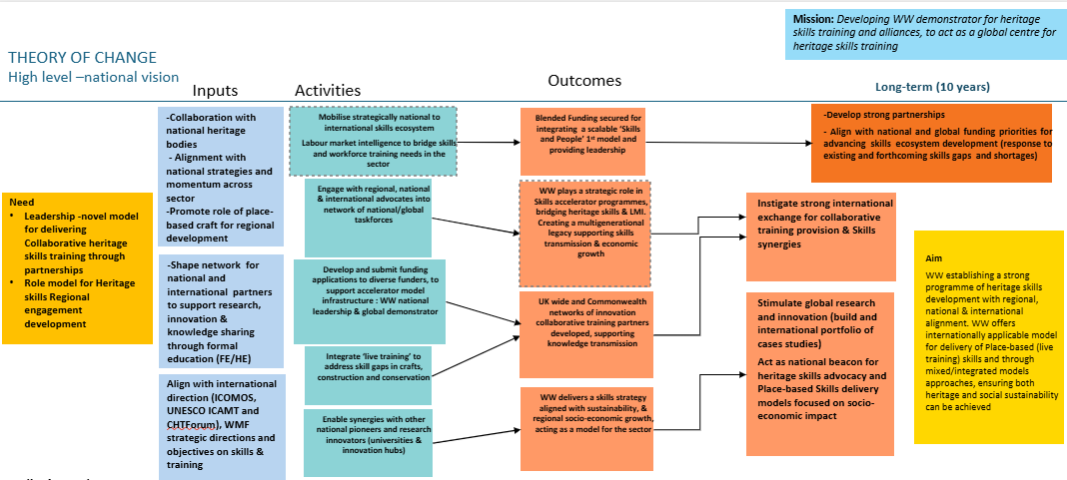Figure 30: visual representation of High Level (National) Theory of change for WW
8.1.6 Key Assumptions
1. WW’s offer is grounded in a strong regional understanding of skills needs and place-based resources.
2. Understand how this fits within the global demand for heritage skills training and aligns with strategic priorities for addressing skills gaps.
3. National and international funding can be secured to support long-standing sector ambitions and strengthen leadership, with the intention of creating intergenerational impact.
4. Commitment to overcome the limitations of local provision by working at a regional scale and forming national training partnerships with specialist education and training providers.
8.1.7 Risks & mitigation actions
- Networks underpinning the Skills Accelerator model require time for development: start with existing strategic links and map stakeholders’ interests
- Funding attracted can also be cross-sectoral (bridging mainstream construction and education to heritage skills, research and innovation, and social inclusion). This would require a systems level approach to support the strategic significance of the initiative and move beyond limitations of project level funding
- The sector’s mismatched resources may delay action, for example around skills/training leads or funding for innovation
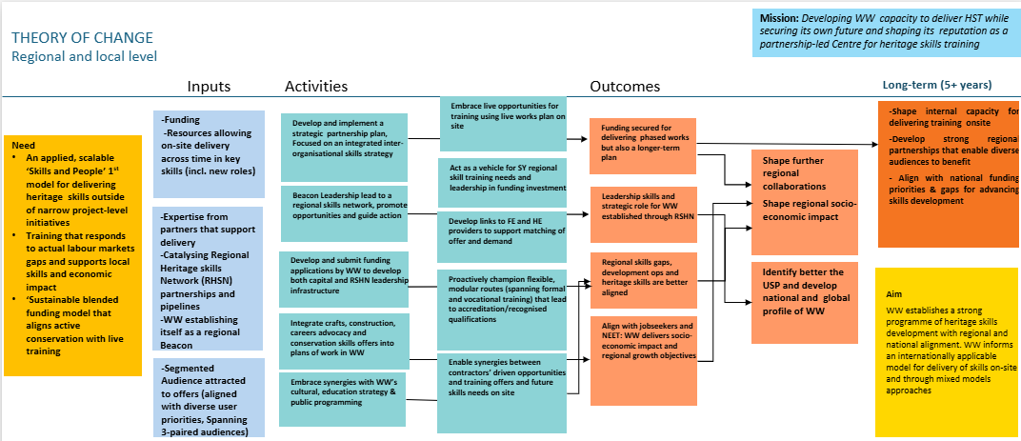
Figure 31: visual representation of Theory of Change (Regional/Local) for WW

8.2 Regional and Local THEORY OF CHANGE
Regional and local level Application of Theory of change helps us indicate the areas of local impact generation, aligned with the need for change on the site and links it with opportunities for activities in the training offer development at WW that will enable it to become a Beacon for HS in the region.
8.2.1 Need
Heritage training delivery is often disconnected from actual project demand.
A structured, scalable model is needed to align site-based conservation work with training provision.
Evidence on regional and national skills needs remains fragmented, limiting sector resilience and growth.
8.2.2 Inputs
Digital Skills Audit Tool/Project Management System (PMS) interface.
Data on planned and ongoing conservation works.
Engagement from heritage organisations, contractors, and training providers.
Access to existing platforms (e.g. CITB, Go Construct, Heritage Skills matchMAKER).

8.2.3 Activities
Determine relevant heritage skills sub-domains for each project.
Input data on skills requirements, work schedules, and contractor needs via the audit tool.
Aggregate and analyse data across local, regional, and national levels.
Generate summary reports highlighting gaps, demand trends, and emerging opportunities.
Link findings to training provision and funding opportunities.

8.2.4 Outputs
Consolidated, real-time overview of heritage skills demand and capacity using Skills Audit tools and approach.
Sector-wide visibility of upcoming conservation work and training potential through communication and networks
Shared database aligning live projects with skills development pipelines.
Enhanced coordination between employers, educators, and funders.

8.2.5 Outcomes (1–3 years)
Training delivery becomes strategically aligned with site-based work.
Regional and national skills gaps are addressed through coordinated investment.
Improved recruitment pathways and accreditation routes for heritage skills.
Strengthened partnerships between heritage organisations and training providers.

8.2.6 Long-Term Impact (5+ years)
A sustainable, evidence-led heritage skills ecosystem supporting economic growth and sector resilience.
Enhanced employability and retention in traditional and emerging heritage trades.
WW (and similar heritage hubs) recognised as regional centres of excellence in heritage training and innovation.

8.2.7 Key Assumptions
WW offer aligns with the national sector priorities for heritage skills gaps
National and regional funding can be raised to support long-standing positions for delivery
Training providers can be located in the regional scale to enable delivery

8.2.8 Risk and Mitigation Actions
Regional network requires time for development
Funding for innovative delivery model is not direct: align with priorities of multiple funders and identify the social and inclusion impacts of the programme of training offers
Lack of expert trainers in the periphery/affecting costings
Reduced demand for uptake: develop career tasters and change days and opportunities to promote gradual uptake and demand testing where needed

9.0 Core Delivery Principles
Core principles for delivery are key for the alignment of actions across the WWPT Heritage Skills Team and alignment with the vision in the theory of change. This section highlights key aspects of responding to the sector’s contextual challenges and innovating through a consistent commitment to the heritage skills training for people and impact that will support innovation and leadership for WWPT.
- Heritage Skills lay at the heart of Wentworth Woodhouse's existence, and it is only through their continued transmission to future generations that our legacy will be protected.
- Wentworth Woodhouse is NOT an island . We hold ambition and resolute commitment to look beyond our walls, embracing new partnerships across Local, Regional, National and International spheres, and establishing/Leading a Skills and People 1st Integrated Heritage Skills Training Model in South Yorkshire
- The depth of our gaze will be set to at least 300 years, at least as far forward as our history and skills continuity stretches back at Wentworth Woodhouse. Through our ‘WWPT 300 PLEDGE’, a commitment to sustaining Heritage Skills will sit at the heart of our future sustainable governance of the site.
- Our commitment to enriching the lives of our communities through inclusive skills and education engagement will be a golden thread through our work and will enrich all that we achieve.
Although a review of WWPT’s governance readiness for strategic engagement with heritage skills sits outside the scope of this work, it is important to note that delivering the four Delivery Principles, and meeting WWPT’s “We Will” commitments, will require consideration of how a future Skills and People First model aligns with WW’s core governance and management of the skills training agenda.
For example, while it is possible to embed this advocacy within the existing charitable structure (including Articles of Association, charitable objects, and Terms of Reference), in the longer term a governance review may be needed to determine the most suitable model for engagement - both for WWPT itself and for the South Yorkshire Regional Heritage Skills Network. One question is whether WWPT’s involvement in heritage skills should be delivered through a separate charity or social enterprise owned by WWPT. Such a model could allow WWPT to commit fully to the culture change required without revising its own Articles of Association. A CIC model, for instance, might provide WWPT with greater flexibility to engage in skills training, both in relation to internal estates and works team activity and to external Skills and People First advocacy and delivery.

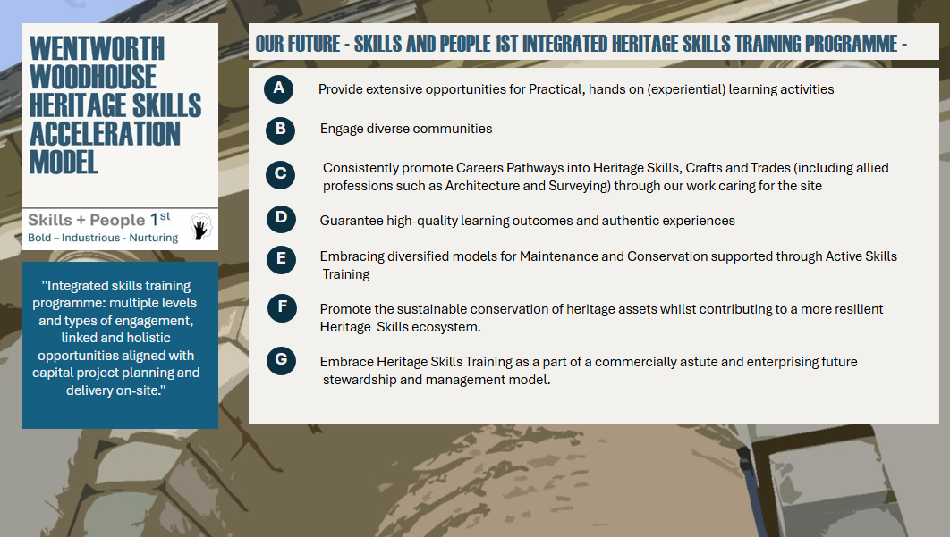Detailed skills and people first integrated HS training programme principles
10.0 Funding Leverage Points
1. Development and publication of local procurement charters that prioritise heritage skills, to be adopted and mandated by organisations that own or manage heritage properties.
2. Increased use of social value clauses tied to training, education, and skills in construction contracts or procurement awards, creating a funding stream that is project-driven and dependent on funding cycles.
This should be paired with a review of options for establishing a dedicated national or regional heritage skills training offset fund to support specific skills growth and resilience linked to the repair and retrofit of pre-1919 buildings.
The fund would be mobilised through a regional link to RHSN coordination, working in partnership with local education providers, local government and strategic authorities, and CITB employer networks and innovation funds. Large construction companies (Tier 1 and 2) in the region, as well as cooperatives of smaller employers (SMEs), will be important stakeholders. There is also an important relationship with CITB-prescribed organisations such as the National Federation of Master Builders (heritage group) and trade federations or associations connected to heritage skills, such as the Federation of Master Builders, the Institute of Carpenters, and others. Proactive engagement with organisations including the Major Projects Association, RICS, RIBA, ISE, IHBC, CIOB, and CIPS will also be essential.
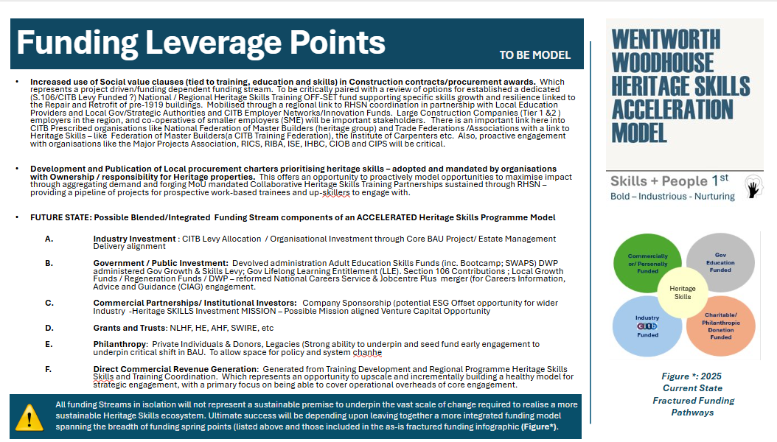
Figure 32: Visual of funding leverage points and actions for WWPT

11.0 Future State: Possible Blended/Integrated funding stream components of an ACCELERATED Heritage Skills Programme Model
1. Industry Investment
- CITB Levy Allocation
- Organisational Investment through Core BAU Project
- Estate Management Delivery alignment

2. Government / Public Investment
- Devolved administration Adult Education Skills Funds (inc. Bootcamp; SWAPS)
- DWP administered Gov Growth & Skills Levy
- Gov Lifelong Learning Entitlement (LLE).
- Section 106 Contributions
- Local Growth Funds / Regeneration Funds
- DWP – reformed National Careers Service & Jobcentre Plus merger (for Careers Information, Advice and Guidance (CIAG) engagement.
3. Commercial Partnerships/ Institutional Investors: Company Sponsorship (potential ESG Offset opportunity for wider Industry Heritage SKILLS Investment MISSION – Possible Mission aligned Venture Capital Opportunity
4. Grants and Trusts through NLHF, HE, AHF, SWIRE, etc
5. Philanthropy through Private Individuals & Donors, andLegacies, providing a strong ability to underpin and seed fund early engagement to underpin critical shifts in BAU. To allow space for policy and system change.
6. Direct Commercial Revenue Generation: Generated from Training Development and Regional Programme Heritage Skills and Training Coordination. This represents an opportunity to upscale and incrementally build a healthy model for strategic engagement, with a primary focus on being able to cover operational overheads of core engagement.
All funding Streams in isolation will not represent a sustainable premise to underpin the vast scale of change required to realise a more sustainable Heritage Skills ecosystem across the UK at a scale aligned to the number of pre-1919 buildings that require active future care. Ultimate success will be depending upon interweaving a more integrated funding model spanning the breadth of funding spring points (listed above and those included in the as-is fractured funding infographic
12.0 Risks and Dependencies and Mitigations of an Integrated and Blended (Multi-Component) Approach
This section provides a summary of risks aligned with phases of delivery and Governance Evolution at WW to support the delivery of the integrated training model and make use of the blended funding model to do that.
The role of collaborations, external actors and harnessing of partnerships is important but with agile internal adjustments and personnel hiring to manage the delivery of new training models the risks will be significantly reduced.
12.1 Phased Development Model for Heritage Skills Delivery
 | Phase 1: Controlled In-House Delivery (Wentworth Woodhouse | Phase 2:  Collaborative Expansion via RHSN
Risk Profile: | Low to moderate, with risks mitigated through direct control. | Higher complexity due to multi-partner coordination.
Governance: | Centralised under Wentworth Woodhouse’s leadership. | Requires a convening organisation (e.g. RHSN) to broker, coordinate, and align stakeholders.
Funding: | Managed through a single entity. | Potentially diversified across partners and programmes.
Pace: | Dictated internally, allowing for agile adjustments. | Influenced by external factors and partner readiness.
Benefits: | Strong quality assurance, clear accountability, and focused impact. | Broader social impact, regional reach, and integration with wider schemes (e.g. FE reform, levelling up, retrofit, apprenticeships).

12.2 Transitional R&D Phase – Building Mitigation against Identified
Purpose: To explore and mitigate risks associated with scaling and decentralisation.
Focus Areas:
- Partnership protocols and MOUs
- Shared delivery standards and QA frameworks
- Funding alignment strategies
- Data sharing and impact measurement
- Governance models for distributed leadership
12.3 Background
Heritage skills initiatives have traditionally relied on narrow, single-stream funding sources such as government apprenticeship schemes, philanthropic grants, or employment programmes. While administratively straightforward, these approaches limit flexibility, resilience, and scalability. In the context of Wentworth Woodhouse’s heritage skills programme, there is a strategic opportunity to develop a blended funding framework that enables long-term delivery, mitigates policy risk, and supports broader social impact.
Single-stream funding models:
- Are vulnerable to policy changes and scheme discontinuation.
- Limit the ability to map dependencies across programmes.
- Restrict the integration of diverse social, economic, and heritage outcomes.
Without a framework to manage multiple funding streams, initiatives risk fragmentation, duplication, and under-delivery, especially when transitioning from in-house delivery.
Collaborative development of this framework alongside key future funding partners is a priority for the development phase.
Guidance is provided here for the development of a blended funding framework and identification of key components to reduce and mitigate risks in execution of this approach.

12.4 Proposal: Development of a Blended Funding Framework
Integrate multiple funding sources into a coherent delivery model.
Map dependencies and risks across schemes.
Enable strategic alignment with regional and national priorities.
Support long-term programme stability and social impact.

12.4.1.Key Components
Funding Stream Mapping
Catalogue existing and potential sources: government schemes, philanthropic grants, local authority programmes, private sector contributions.
Identify eligibility criteria, reporting requirements, and timeframes.
Dependency and Risk Analysis
Model scenarios for funding withdrawal or policy shifts.
Develop contingency pathways and alternative funding options.

12.4.2 Governance and Administration
Create a unified reporting and monitoring framework.
Define roles for fund holders, delivery partners, and convening bodies (e.g. RHSN).
12.4.5 Financial Resilience Mechanisms
Advocate for multi-year tailored grants from SIMCA or combined mayoral authorities.
Explore pooled funding models or social investment partnerships.

12.4.6 Strategic Alignment
Ensure funding streams support skills pipeline needs, regional economic strategies, and heritage conservation priorities.

12.4.7 Benefits
Resilience: Reduces vulnerability to policy changes and funding volatility.
Scalability: Supports expansion beyond Wentworth Woodhouse to regional delivery.
Impact: Enables integration with wider social, economic, and educational programmes.
Efficiency: Streamlines administration and reporting across multiple funders.

12.4.8 Next Steps
Commission a feasibility study and stakeholder consultation.
Develop a prototype framework with input from funders, delivery partners, and policy leads.
Pilot the framework through the Wentworth Woodhouse programme and scale via RHSN-SY.

12.5 Alignment with Further Education Colleges and Training Providers
Independent training providers and related bodies in the area serve as key opportunity nodes within a wider system of trainers and educational partners, including those focused on post-16 education. Awarding organisations are also important stakeholders in the context of training provision, and any engagement strategy will need to include these groups. Specialist Post-16 Education Providers include:
Harrison College: specialist in post-16 provision for neurodiverse young people, offering a supportive, small-scale learning environment tailored to each student’s needs. The curriculum emphasizes employability, internships, social and life skills, preparing learners for adulthood and work. No evidence of specialisation on heritage skills.
Doncaster Deaf Trust: (Communication Specialist College, Doncaster). A long-established charity (dating back to 1829) providing specialist education and care for deaf and communication-impaired individuals. Its services encompass nursery, school, college, residential care, and employability support. It delivers practical construction training within real-work settings. Courses include bricklaying, plastering, carpentry/joinery, tiling, decorating, along with health & safety and CSCS card preparation. Qualifications offered include Level 1 & 2 City & Guilds diplomas and awards in these areas.deaf-trust.co.uk
Chameleon School of Construction: In close proximity with the WW, Chameleon offers hands-on, practical training in plastering, bricklaying, tiling and motor vehicle maintenance, helping learners of all ages gain the skills they need to succeed in the construction industry.(Example awards: short level 1 awards in plastering etc). Their short 6-week programmes provide upon completion a FREE CSCS test, a crucial step in obtaining Construction Skills Certification Scheme (CSCS) card—essential for working on construction sites in the UK. https://www.chameleonschoolofconstruction.co.uk/
Rotherham Council (with touch points potentially into the 3and other relevant councils ‘Barnsley, Doncaster and Sheffield). Rotherham Council is committed to supporting employee learning and development as well as apprenticeship training, as vital to have a flexible, innovative and high-performing workforce. The Council also offers a range of apprenticeship training across a range of professions and job roles for both new starters and existing employees. Additional resources and priorities for the ASF can be found in the Rotherham Adult Skills Fund Provider Directory 2024 - 2025
12.6 New Funding landscape & opportunities for WW
12.6.1 Adult Skills Fund: What is ASF funding?
Set up by the government, the Adult Skills Fund (which replaced the Adult Education Budget in 2024) funds a wide range of training and qualifications for adult learners aged 19+. The ASF is nationally managed in non-devolved regions by the Department for Education while over half of the budget is managed by regional combined authorities known as devolved regions. Adult funding to support delivery is accessed through local training providers, like Gateway Qualifications’ network of recognised centres and provides great adult learning opportunities to help individuals gain new skills to secure employment or advance in their current careers. See here which qualifications are funded and their funding rates:
The ASF can be used to:
- Fund anyone aged 19-23 to get a full level 2 or level 3 qualification (including level 3 free courses for jobs) if they do not have one already.
- For any course or qualification up to level 2, for individuals for whom English is not their first language, to improve their language skills up to level 2.
- Fund Level 3 Free Courses for Jobs
- Fully fund individuals aged 19 years and above for digital functional skills and essential digital skills qualifications up to level 1, where their existing digital skills are below level 1.
Additional to ASF, engagement with the Skills-Advisory-Network (SAN), is key for understanding skill gaps and matching opportunities. SAN is Sheffield City Region Mayoral Combined Authority’s version of Skills Advisory Panel (SAP). The South Yorkshire Skills Advisory Network (SAN) is an employer-led local partnership, established in 2020 to strengthen the link between public and private sector employers, local authorities, colleges and universities and to consolidate and improve knowledge on skills and labour market needs (see further specific information for WW linked in Report C).
12.6.2 Community Wealth Building - What is Community Wealth Building?
Community wealth building is a people-centred approach to local economic development, which looks to increase the flow of wealth back into local economies and places, by giving more control to local people and business. Ultimately influencing an economic development model where wealth is not extracted but re-directed back into communities underpinning a Generative economy.
The design and application of a Community Wealth Building model, capable of catalysing significant social impact is also noted to align particularly strongly with equitable procurement linked to small to the activities of medium sized enterprises (SME’s), co-operatives and Social Enterprises (CLES,20201).
This model therefore aligns particularly strongly with:
- The charitably premised governance of many of the nation’s significant collections of managed Heritage Buildings and sites where ‘achieving social impact’ is a primary driver, including those managed by Heritage Charities like English Heritage, National Trust, Local Heritage Charities, Historic Estates, The Nation’s Cathedrals etc.
- The known make-up of the Heritage Skills Workforce Segmentation in the UK that the SSNA 2024 indicated is made up of 99% SME businesses divided as detailed below in Pie chart (Figure 33)
- Place-based funding opportunities and local economic growth potential for the region and not just the site
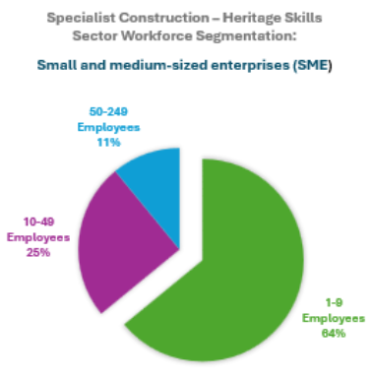
Figure 33: Specialist Construction-Heritage Skills Sector Workforce Segmentation
The Alignment of CWP with WW’s Core Values and Delivery Pillars/Priorities
Embedding the principles of Community Wealth Building into the future development of a WW’s Skills and People 1st Strategy is therefore a natural and purposeful ambition, aligning to WWBPT’s own guiding pillars for its engagement and work to be BOLD, INDUSTRIOUS and NURTURING, and centring its resources and activity outputs on fostering optimised outcomes for the local community.
Throughout the UK, community wealth building principles have been increasingly adopted as core ‘economic development’ practice principles embedded into Sustainable Procurement Strategies. The achievements within Preston are particularly noteworthy and have been evaluated authoritatively, spotlighting the relative potential for transferability and replicability of Preston’s successes in achieving a generative economic development model.
Correspondingly, the success of applying Community Wealth Building Principles specifically to the LIVE ‘work-based training’ components of the proposed Skills and People 1st Model for South Yorkshire, launched at WW, will hinge upon having a consistent flow of work for learners and trainees to engage with. Whilst WW does have an estimated future project delivery requirement in excess of £150m and a vast array of works aligned to all Heritage Skills trade specialisms, the actual triggers for realising their capital project ambitions programme work delivery will be dependent upon WW securing third party funding commitment both for the capital costs of the work itself and the costs associated with mobilising the Heritage Skills and Training Programme itself. In reality the operational surplus of the property is unlikely to extend beyond the ability to sustain BAU and general maintenance requirements. For this reason, WW’s delivery principle is particularly relevant and WW must embrace collaborative working and the establishing of long-standing partnerships to deliver its ambition.
Recommendation: Heritage Skills Bridging Model as a Vehicle for Community Wealth Building
Working as a South Yorkshire Regional Heritage Skills Network Beacon Site Wentworth Woodhouse will commit to model and mobilise a bridging model to:
- Connect multigenerational learners to live heritage projects.
- Embed upskilling and inspiration into a Core skills training offer
- Embed ‘Positive Heritage Skills’ advocacy, inspiration and ‘hands-on’ practical learning opportunities into every phase of site regeneration and repair work (maximising social impact and £ return on investment).
- Promote continuity and legacy of Heritage Skills in South Yorkshire through embedding Place-based skills acceleration into procurement.
What’s the way forward? First thoughts …
It is recommended that steps are taken to develop and mobilise a regionally centred ‘Place-based Heritage Skills Acceleration Model’. This should be designed to integrate community wealth building principles, but adapted to the unique characteristics of the heritage construction sector, where demand for work and funding pathways is characteristically fragmented and projects and works involving heritage skills are not ‘under the current sector BAU model’ centrally commissioned or strategically coordinated
Whilst this approach aligns with the spirit of community wealth building, the design of the Bridging Model will require us to address and respond to the critical difference of the heritage sector, which is that it lacks a critical mass of the typical ‘public funded’ anchor institutions with predictable commissioning cycles. A balanced portfolio of engaged partners with blended funding models (public funding, grant funded, core funded, reserve funded works etc), will be a critical requirement.
The need to connect an aggregated (ideally geographically nucleated) pipeline of work) through a shared scheme has also been recognised as a key requirement to underpin a successful Shared Apprenticeship Scheme mobilisation with specific focus on Heritage (Cultural Associate Report Heritage Skills Development Next Steps, Commissioned by EH, 2022).
Therefore lessons learned through this programme, in relation to pathways and establishing machinery/organisational infrastructure to coordinate and embed this model in South Yorkshire will provide transferable learning applicability, relevant to unlocking potential for the Government-backed Apprenticeship Scheme to begin to have a meaningful impact on addressing the critical need to address imminent and in some cases already extant Heritage Skills Gaps and Skills shortages evidenced through the 2024 Skills Needs Analysis for the Repair, Maintenance and Retrofit of Traditional (pre-1919) Buildings in England SSNA,2024).
Reimaging Anchor Commissioning Practices in the context of Heritage Skills Engagement
Instead of relying on the previously detailed traditional anchors (NHS, universities, councils), a key piece of work is needed to define a new category of “heritage anchor commissioners” embracing blended ownership, and funding models for the delivery of Heritage works. procurement typologies:
Formation of an ANCHOR NETWORK for Heritage Skills
- Potential Heritage Anchor Categories:
- Local Authorities with heritage assets
- Historic Estates and Trusts
- National heritage bodies (e.g. Historic England, National Trust, CCT)
- Faith organisations with historic buildings (Church of England (CoE))
- Housing associations with pre-1919 stock
- Private owners of listed buildings receiving public funding
- Developers involved in heritage-led regeneration
- Funders of Heritage Skills could also advocate /mandate for inclusion of this model into their programmes.
These entities may not commission consistently like hospitals or universities, but aggregating their procurement needs into a shared pipeline could simulate anchor behaviour.
Alignment of Community Wealth Building Principles with an Aggregated Demand Pipeline Tool for Capital Works to Heritage Buildings
A Knowledge Transfer Programme (KTP) linked to the principles of applying Community Wealth Building models with Heritage Skills and Pipelines development is currently being prepared by the University of Lincoln in partnership with the Heritage Trust of Lincolnshire. This will seek to
- Map upcoming heritage projects across regions.
- Categorise them by skill demand, complexity, and timing.
- Link them to training opportunities and funding mechanisms.
- Enable strategic coordination across fragmented commissioners.
If developed this programme can provide inspiration for the infrastructure backbone for your community wealth building approach to be adopted in South Yorkshire.
An important function of the Heritage Skills Capital Projects Pipeline tool would be to embed Procurement Typologies: Harnessing untapped potential and attracting in Match Funding (S.106 etc)
To operationalise this, you could:
- Develop a taxonomy of heritage procurement types (e.g. conservation works, cyclical maintenance, emergency repairs, adaptive reuse).
- Align each type with training delivery models (e.g. bootcamps, apprenticeships, masterclasses).
- Use this to forecast skills demand and design responsive training interventions.
Potential Policy and Funding Levers specific to mobilising CWB relevant to Heritage Skills
To make this sustainable, you might explore:
- Local procurement charters that prioritise heritage skills.
- Social value clauses in heritage contracts.
- Blended funding models (e.g. CITB, NLHF, local growth funds).
- Regional heritage skills networks acting as commissioning consortia.
12.7 Monitoring, Evaluation and Learning
12.7.1 Monitoring & Evaluation (M&E) Framework for the Wentworth Woodhouse Heritage Training Skills Centre
A core Monitoring and Evaluation (M&E) framework for the Wentworth Woodhouse Heritage Training Skills Centre is proposed here, designed to ensure that the project delivers long-term value both to the conservation of the site and to the wider community. With the initial application of the Centre on-site a new set of evidence will be generated by sequential use of spaces and specific training providers will also provide data on user’s career progression routes and educational certifications.
The framework needs to establish transparent metrics, align with heritage-sector ESG principles, and provide a robust basis for reporting, review, and capture legacy impacts.

12.7.2 Objectives of M&E
Track delivery of high-quality heritage skills training (start and completion time, capacity for learners)
Evidence benefits for conservation of Wentworth Woodhouse and associated historic environment (e.g. conservation/regeneration completed through training, learning or methods used on site)
Demonstrate social and economic value for participants, local communities, inclusion and diversity objectives, and regional heritage employment pathways.
Align outputs with Environmental, Social, and Governance (ESG) frameworks for a complex heritage asset, seeking to set a paradigm for the sector.

12.7.3 Metrics for Evaluation
a. Conservation Impact
Number and type of heritage fabric interventions supported by trained staff.
Measurable improvements in condition and sustainability of the WW’s Contribution to long-term site management and reduced conservation backlog. (e.g. reliance on maintenance costs and longer-term spending projected, visitable spaces opened for users)
Adoption of traditional and sustainable conservation practices that enhance the value of site

b. Skills & Training Outcomes
Number of trainees enrolled, retained
Number of trainees successfully certified per level and skill type (Audit tool)
Diversity metrics (gender, ethnicity, socio-economic background or social mobility data)
Employment/placement and apprenticeship rates within heritage and related construction sectors.
Accreditation or recognition of training by professional bodies.

c. Social & Economic Value
Participant wellbeing and confidence gains (self-reported through surveys).
Engagement of local schools, colleges, and community groups
Volunteer hours contributed to the estate and community heritage activities.
Local procurement and supply-chain benefits: number of local SMEs engaged and benefits to them
Evidence of inclusive access policies and ethical partnerships

d. Environmental Metrics
Reduction in resource waste via training in sustainable materials use.
Energy/carbon footprint reduction in conservation works and thanks to interventions enabling new infrastructural changes

12.7.4 Reporting and Review: approaches to adopt
Quarterly monitoring reports capturing outputs, outcomes, and challenges regional significance of the model.
Annual impact review (can be including predictive modelling of legacy specifically on outcomes for conservation and skills pipelines).
External advisory panel of heritage, skills (and ESG experts) to review findings.
Publication of findings as open access reports and shared via heritage skills networks

12.7.5 Recommendations for Legacy Impact Prediction & Social Value Capture
The framework may draw on existing approaches for valuing skills development, such as Social Return on Investment (SROI) or wellbeing and learning outcome models used in DfE evaluation, to summarise and quantify benefits. These can be complemented by ESG reporting to capture wider social value
Legacy impacts can be assessed through scenario planning for workforce pipelines, including projections of the number of heritage professionals trained at different levels over a 10–15-year period and the anticipated reduction in skills gaps across the northern heritage sector. Additional metrics should also consider:
- Long-term conservation savings due to preventative skills being embedded at Wentworth.
- Ongoing community benefits, such as increased cultural capital, employability, and inclusive access to heritage.
By embedding this M&E framework from the outset, the Wentworth Woodhouse Heritage Training Skills Centre will not only safeguard one of England’s key heritage sites, but also deliver enduring social, environmental, and governance benefits that can be demonstrated and scaled nationally.

12.7.6 Metrics & Indicators to consider
The table below provides a quick overview of impact domains and some possible indicators that can be captured across each to support with evidence impact reporting.
Domain | Indicators | Measurement Tools | Frequency
Conservation Outcomes | Number/type of conservation tasks completed; condition surveys; reduction in backlog; use of sustainable materials. | Site audits; photographic records; conservation reports. | Annual
Training & Skills | Number of trainees enrolled/retained/certified; diversity profile; employment outcomes. | Enrolment data; exit surveys; alumni tracking. | Quarterly/Annual
Social Impact | Wellbeing/self-confidence gains; volunteer hours; school/college engagement; local employment generated. | Pre/post surveys; case studies; community feedback forms. | Biannual
Economic Value | Local procurement spend; supply chain involvement; SROI ratio. | Procurement data; economic modelling. | Annual
Environmental (ESG) | Carbon/energy savings in conservation work; waste reduction; biodiversity protection in grounds. | Energy audits; materials logs. | Annual
Governance (ESG) | Transparency in decision-making; stakeholder engagement; inclusivity policies. | Governance reviews; stakeholder feedback. | Annual
Figure 34: Domains and indicators to be considered in measuring impact and capturing data along delivery.

12.8 Risks Dependencies and Mitigations
Risk assessment for the development and offer of onsite training at WW can be divided at two levels:
- Strategic and organisational risks (incl. Financial for the development of training offers)
- Health and Safety risks related to types of field work and skills categories and
We summarise key considerations for both types of risks in the tables below accompanied by mitigating actions and some controlling actions for the H& S aspects of delivering training on site:

Annex – Summary of Key Recommendations (Report B)
1. Heritage Skills Audit Tool
The development of this tool will provide regional clarity by:
- Identifying priority skills based on live projects.
- Mapping SOC/SIC codes to related training needs.
- Aligning skills requirements with local demand and procurement pipelines
Securing future funding to continue this work will be essential to the transformational proposal. The tool also aligns with the emerging ‘live’ Pipeline Development Research tool (CITB/HE engagement arising from the CITB RMI Heritage Sector Skills Plan Initial Recommendations, as advised by HESF/HESCAPE for 2025/26 delivery). It is further connected to work progressing through the Heritage Trust Lincolnshire Knowledge Transfer Partnership (KTP) application, supported by HESF/CITB/HE R&R engagement via the London RHSN.
Additional aims include:
- Advancing consultancy work in partnership with others to refine the Research and Development phase and deliver the live build of a Heritage Skills Audit Tool.
- nPositioning IAST as an innovator for the region and nationally.
- Creating opportunities for intergenerational skills exchange through workshops and trainer-role development, working closely with contractors and sector experts.
The model is currently being developed by NDF in consultation with the HE National Skills Team, the Palace of Westminster R&R Project Team, and wider task group members within the Historic Environment Skills Forum (HESF).
2. Recommendation: to actively test engagement with actors across the stakeholders list in response to the paired audience segments for Heritage Skills Training.
This will be supported by RHSN and WW to act as a regional anchor institution for Heritage Skills Training in SY, whilst also coordinating significant wider impact through establishing itself as an outward facing Centre for Heritage Skills Excellence and Beacon for Heritage Skills.
Recommendation: to actively test engagement with actors across the stakeholders list in response to the paired audience segments for Heritage Skills Training.
Recommendation: To integrate lessons learnt from the assessment of current training models and sector-wide sustainability in the design of the Skills and people 1st strategy implementation.

3. Recommendation: Heritage Skills Audit Concept – Strategic Development Opportunity
The Heritage Skills Audit concept provides a structured mechanism to align live conservation pipelines with workforce planning and targeted training provision.
- Long-term conservation savings due to preventative skills being embedded at Wentworth.
- Ongoing community benefits, such as increased cultural capital, employability, and inclusive access to heritage.
By embedding this M&E framework from the outset, the Wentworth Woodhouse Heritage Training Skills Centre will not only safeguard one of England’s key heritage sites, but also deliver enduring social, environmental, and governance benefits that can be demonstrated and scaled nationally.
4. Recommendation: Heritage Skills Bridging Model as a Vehicle for Community Wealth Building
Working as a South Yorkshire Regional Heritage Skills Network Beacon Site, Wentworth Woodhouse will commit to model and mobilise a bridging model to:
- Connect multigenerational learners to live heritage projects.
- Embed upskilling and inspiration into a Core skills training offer
- Embed ‘Positive Heritage Skills’ advocacy, inspiration and ‘hands-on’ practical learning opportunities into every phase of site regeneration and repair work (maximising social impact and £ return on investment).
- Promote continuity and legacy of Heritage Skills in South Yorkshire through embedding Place-based skills acceleration into procurement.
5. Funding- the development of a Blended Funding Framework
- Integrate multiple funding sources into a coherent delivery model.
- Map dependencies and risks across schemes.
- Enable strategic alignment with regional and national priorities.
- Support long-term programme stability and social impact.

Bibliography
English Heritage Climate Action Plan: https://www.englishheritage.org.uk/about-us/our-priorities/ sustainability/climate-pl-22-2025/
Heritage Fund (2025). How Wentworth Woodhouse uses digital storytelling. https://www.heritagefund.org.uk/videos/how-wentworth-woodhouse-uses-digital-storytelling
Historic England (2025). Case Study: Wentworth Woodhouse, Rotherham, South Yorkshire. https://historicengland.org.uk/education/training-skills/work-based-training/heritage-apprenticeships/the-heritage-building-skills-programme/cs-wentworth-woodhouse/
Historic England (2025). Wentworth Woodhouse: Skills for Restoring Heritage https://historicengland.org.uk/advice/grants/culture-recovery-fund/uncover-more/wentworth-skills/
Historic Houses, (29 April 2022). Report highlights Wentworth Woodhouse’s community value. Education and inclusion. News from our houses. https://www.historichouses.org/news/report-highlights-wentworth-woodhouses-community-value/
Holkham Estate Holkham: https://www.holkham.co.uk/ The WONDER programme: https:// www.holkham.co.uk/about-us/wonder/
Siddall, C., Hamilton, P. (2025) /Rotherham’s Cultural Strategy, 2025. https://moderngov.rotherham.gov.uk/mgConvert2PDF.aspx?ID=152586
Construction Industry Training Board. (n.d.). GoConstruct: Helping people into construction careers. GoConstruct. Retrieved [date you accessed it], from https://www.goconstruct.org
Historic England. (n.d.). Apprenticeships in the Heritage Sector. Historic England. Retrieved [date you accessed it], from https://historicengland.org.uk/education/training-skills/work-based-training/heritage-apprenticeships/
Historic England (August 9, 2024). Traditional Building Skills Training Programmes. https://historicengland.org.uk/education/training-skills/work-based-training/traditional-building-bursaries/
The King’s Foundation; The Heritage Council; Historic Environment Division, Department for Communities (NI). (n.d.). All-Ireland Heritage Skills Programme [Programme overview]. Retrieved from https://www.heritagecouncil.ie/our-work-with-others/all-ireland-heritage-skills-programme
RDI Associates Ltd.; Forestry Skills Forum. (2021). Forestry Workforce Research: Status of employment, education and skills in forestry in England & Wales. Confor / Forestry Skills Forum.
Historic Environment Forum; Historic England; Peabody; The National Trust; The Crown Estate; Grosvenor. (2022). Heritage and Carbon: Addressing the skills gap. Grosvenor. https://www.grosvenor.com/getattachment/77042425-b1cc-4c45-b338-5193a1c93d32/Heritage-and-Carbon_Final_Digital_DPS.pdf
Historic Environment Skills Forum. (2024). Historic Environment Skills and Careers Action Plan for England (HESCAPE). Historic England / Historic Environment Skills Forum. https://khub.net/web/resiliencehub/resources?cur=1&displayStyle=grid
Historic England (2025. Heritage Building Skills Programme. https://storymaps.arcgis.com/stories/8b19608579c3422d946a78f16be850da
Historic England, 2017. Strategic Skills Partnership Agreement. historicengland.org.uk/content/docs/education/cadw-hes-he-citb-strategic-skills-partnership-agreementpdf/
Centre for Economics and Business Research. (2019). Skills gaps / needs in the Heritage Sector: A report for Historic England. Historic England. https://historicengland.org.uk/content/heritage-counts/pub/2019/skill-gaps-needs-in-the-heritage-sector-pdf
Forestry Skills Forum; RDI Associates Ltd. (2021). Forestry Workforce Research: Status of employment, education and skills in forestry in England and Wales. Forestry Skills Forum / Confor. https://www.confor.org.uk/media/2678188/forestry-workforce-research-final-report-august-2021.pdf
Grosvenor; The National Trust; Peabody; Historic England; The Crown Estate. (2023). Heritage and Carbon: Addressing the skills gap. Grosvenor. https://www.grosvenor.com/getattachment/77042425-b1cc-4c45-b338-5193a1c93d32/Heritage-and-Carbon_Final_Digital_DPS.pdf
Green Alliance. (2022). Closing the UK's green skills gap. Green Alliance. https://green-alliance.org.uk/publication/closing-the-uks-green-skills-gap/
Wentworth Woodhouse. A New Life. The Masterplan 2018 (2022?). https://wentworthwoodhouse.org.uk/wp-content/uploads/2022/01/WWH-Masterplan-vol1_Compressed.pdf
Wentworth Woodhouse. Official Youtube channel. https://www.youtube.com/c/WentworthWoodhouse1?app=desktop
Wentworth Woodhouse (2023). Cultural strategy 2023. https://heyzine.com/flip-book/41232083e0.html
CSN Industry Outlook - 2024-2028. (15 May 2024 ).https://www.citb.co.uk/about-citb/construction-industry-research-reports/construction-skills-network-csn
Construction Industry Training Board. (2025, June 17). Construction Workforce Outlook 2025-29. CITB. https://www.citb.co.uk/about-citb/news-events-and-blogs/citb-publishes-construction-workforce-outlook-2025-29/
CITB (2008); chttps://www.citb.co.uk/media/duqhchyc/nhtg_skillsresearch_professionals_2008_fullreport_tcm17-6859.pdf
Conservation apprenticeships ( standards). Work based training to support your career in conservation. https://www.icon.org.uk/careers/conservation-apprenticeships.html#Conservation%20apprenticeship%20standards
Industrial Heritage Conservation Skills - A plan for action. (2023) https://www.icon.org.uk/resource/icon-publishes-industrial-heritage-skills-report.html
Hertiage Crafts. Categories of risk. The Heritage Crafts Red List. (2025).https://www.heritagecrafts.org.uk/categories-of-risk/
More digital opportunities at Wentworth Woodhouse thanks to a National Lottery grant.(December 4, 2025). https://heritagetrustnetwork.org.uk/more-digital-opportunities-at-wentworth-woodhouse-thanks-to-national-lottery-grant/
Heritage Network (2025).Digital Heroes. Connecting volunteers aged 18-30 with our members across the UK to provide digital support. https://heritagetrustnetwork.org.uk/digital-heroes-project/
Society for the Protection of Ancient Buildings. (n.d.). SPAB Scholarship . Retrieved [15 September 2025], from https://www.spab.org.uk/learning/scholarship
Society for the Protection of Ancient Buildings. (n.d.). SPAB Courses and workshops. Retrieved [15 September 2025], from https://www.spab.org.uk/learning/courses-and-workshops
The Schools’ Observatory. (n.d.). STEM Clubs [Resource/booklet]. Retrieved [date accessed], from https://www.schoolsobservatory.org/stem-clubs
Reference projects
York Minster. (n.d.). Centre of Excellence for Heritage Craft Skills and Estate Management. Retrieved September 15, 2025, from https://yorkminster.org/discover/centre-of-excellence-for-heritage-craft-skills-and-estate-management/
St Paul’s Cathedral. (2025, June 18). St Paul’s to launch a world-class heritage craft training centre on the Cathedral's 350th anniversary. Retrieved September 15, 2025, from https://www.stpauls.co.uk/news-article/st-pauls-to-launch-world-class-heritage-craft-training-centre-cathedrals-350th
St Paul’s Cathedral. (n.d.). The Wren International Centre of Excellence. Retrieved September 15, 2025, from https://www.stpauls.co.uk/wren-international-centre-of-excellence
Historic England Webinar (n.d). Industrial Heritage Webinar 5: Elsecar, Barnsley, South Yorkshire.
Regional reports documents- Bibliography
Note: For Colleges and FE actors:see stakeholder excel for detailed hyperlinks
SYMCA- supported South Yorkshire Apprenticeship Hub. https://www.southyorkshireapprenticeships.org/employers
Dickinson, P., & Cardenas Rubio, J. (2022). Green jobs and skills in South Yorkshire. https://wrap.warwick.ac.uk/id/eprint/179628/3/WRAP-SYMCA-green-skills-Final-Report-July-2022.pdf
SYMCA, SEP (n.d) https://www.southyorkshire-ca.gov.uk/explore/strategic-economic-plan
SYMCA (n.d) .https://www.southyorkshire-ca.gov.uk/explore/education-skills-employability
SYMCA (2022) Our Strategic Economic Plan 2021-2041. https://www.southyorkshire-ca.gov.uk/getmedia/4256c890-d568-42c8-8aa5-c8232a5d1bfd/SCR_SEP_Full_Draft_Jan_21-(accesssible).pdf
South Yorkshire Mayoral Combined Authority and Local Enterprise Partnership (n.d) https://governance.southyorkshire-ca.gov.uk/mgCommitteeDetails.aspx?ID=143
South Yorkshire Providers Network (SYPN) (SYPN) (n.d) https://www.southyorkshireprovidersnetwork.com/
South Yorkshire skills (n.d). https://southyorkshireskills.org/
Skills advisory network (SAN) https://sheffieldcityregion.org.uk/skills-advisory-network/
SYMCA, SKILLS ADVISORY NETWORK.(n.d) https://www.southyorkshire-ca.gov.uk/Explore_Skills-Advisory-Network
Sheffield region Local skills report (2021). https://www.southyorkshire-ca.gov.uk/getmedia/5be5936d-35ab-445a-a4e5-bc9a811867b6/SCR-Local-Skills-Report-(FINAL).pdf
Dickinson, P., & ..et.al (2021) Skills Analysis - Executive Summary to Sheffield City Region Report. Warwick Institute for Employment Research University of Warwick. https://www.southyorkshire-ca.gov.uk/getmedia/4ae7009d-8938-490e-bb34-c7182073bd28/SCR-Skills-analysis-Final-Report-Exec-summary-to-SCR-110521.pdf
Skills for Recovery in South Yorkshire Report (2021).https://www.southyorkshire-ca.gov.uk/getmedia/e5ab9222-7601-42a8-b958-536f4d7c832e/SY-Skills-report-(1).pdf
Useful heritage career websites
Heritage Careers Guide 2023-2024. Built Environment Forum Scotland (BEFS) and The Heritage Alliance (THA) and Herriot-Watt University. https://www.theheritagealliance.org.uk/wp-content/uploads/2023/04/Heritage-Careers-Guide-2023-24.pdf
Baxter, IWF 2024, Heritage Careers Guide 2024-2025. 3rd edn, Heriot-Watt University, Edinburgh. https://doi.org/10.17861/RCHS-ZK69 https://researchportal.hw.ac.uk/files/138365163/Heritage_Careers_Guide_24-25_240708.pdf
The Heritage Alliance’s Heritage Update newsletter https://www.theheritagealliance.org.uk/news-and-events/news/?#vacancies Jobs listing adverts from fortnightly Heritage Update bulletin
Heritage Trust Network – Career Opportunities https://www.heritagetrustnetwork.org.uk/jobs/ Network representing local heritage groups and preservation trusts around the UK, also including voluntary/board positions
COTAC – Council on Training in Architectural Conservation https://cotac.global/ Works to advance conservation education and training, including e-learning resources
Skills for Life https://www.gov.uk/government/topical-events/skills-for-life UK Government skills and training hub
ICON – Institute of Conservation https://www.icon.org.uk/careers.html Conservation jobs and careers resources
Links to case studies websites
Sussex Heritage Trust: https://sussexheritagetrust.org.uk/bursary-scheme
https://sussexheritagetrust.org.uk/endangered-crafts-fund
South Coast Roof training : https://southcoastrooftraining.co.uk/
Foundation degree in Applied Historic building Conservation (CWF): Prospectus Foundation degree in Applied Historic Building Conservation and Repair | Cathedrals’ Workshop Fellowship
Abbreviations
AA- The Audience Agency
HE- Historic England
HESF- Historic Environment skills forum
RHSN- Regional Heritage Skills network
CITB- Construction Industry Training Board
SSNA Strategic Skills Needs Assessment
NT- national Trust
ASF- Adult Skills Funding (Scheme)
SYMCA South Yorkshire Mayoral Combined Authority
SAP
SAPs specialist applied-skills programmes
SYPN- South Yorkshire Providers Network
...

This report has been produced with the support of our partner The World Monuments Fund.

